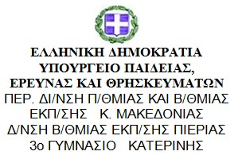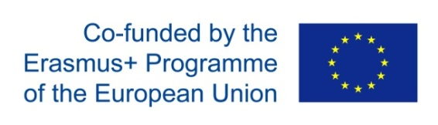

5th Panhellenic E-twinning Conference
23-25 November 2018, Ioannina

Members of the Greek pedagogical team attended the 5th Panhellenic E-twinning Conference, held in Ioannina city.
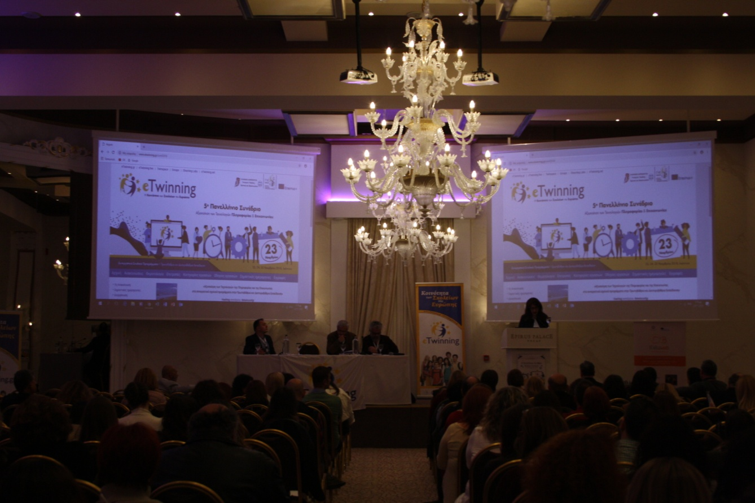

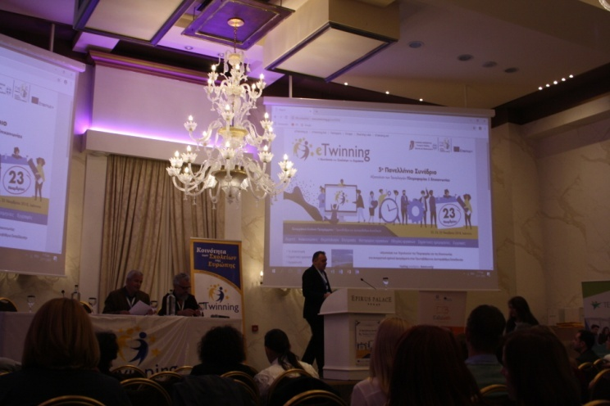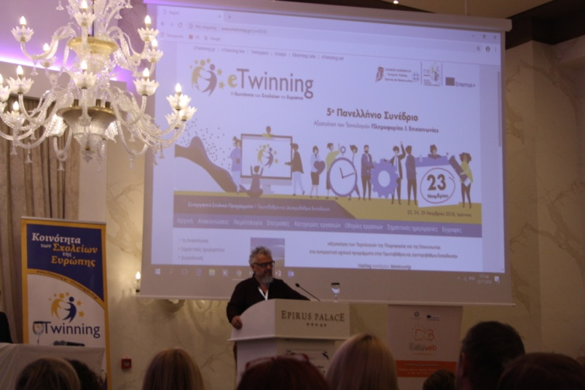

The Conference opened with the enlightening talks of two representatives of the Greek State Scholarship Foundation (IKY), which is the National Agency for Erasmus+ projects.
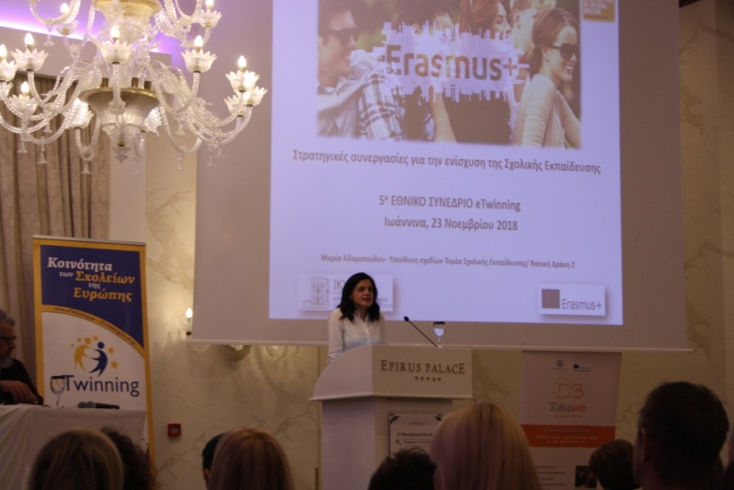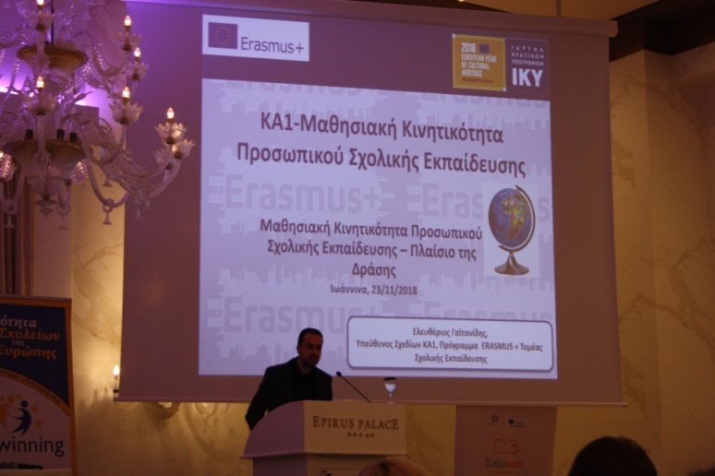

We attended many interesting E-twinning projects and got inspired from them. It has been a very fruitful weekend that gave us ideas that will help us in the progress of our project.
