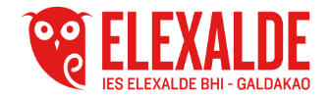
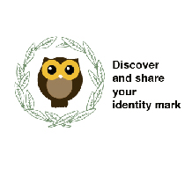

Each personalised letter has a meaning

1) S for Bilbao pavement tie
it is a square of 30x30 cm and it is also divided and it has a flower in the middle.
This design was because as it rained in Bilbao a lot, it was the perfect design.
Now it is part of Bilbao's souvenir. You've got them as chocolate and many things.
2) Y is for Mari Jaia
Mari Jaia is the protagonist of Bilbao's festivities. They say that her hands are raised into the air as a sign of optimism and to symbolize dancing. But maybe it’s also because she ends up being set on fire.
3) O for Puppy
The flower statue guarding the Guggenheim museum. It welcomes everyone in their visit to the museum. They change their flowers twice autumn-winter, spring-summer. It was created by Jeff Koops
4) V for lauburu
The lauburu or Basque cross (Basque: lauburu, "four heads") is a traditional Basque cross with four shaped heads. Today, it is a symbol of the Basque Country and the unity of the Basque people.
5) I for Basque and Greek dancers.
Typical dances are an important part of both countries' heritage.
6) H for txistu and tamboril
A kind of flute typical of the instruments of the Basque Country is used in all the Basque festivities. It is accompanied by the tamboril.
7) R for the ikurriña the flag of the Basque country and the flag of the Greek country
8) is for Lamiak
Mythological character from the Basque mythology. It is also common in the Greek mythology
9) E is for Erasmus+ our project is within this programme
10) T is for amphora. An anciet Greek jar
11) K is for Zeus is the god of the sky, lightning and thunder in Ancient Greek religion and myth, and king of the gods on Mount Olympus.
12) M is for Greek columns
Basque cross with
14) U for Laurel wreath
A circle of leaves that, in the past, was worn on the head by an important person or the winner of a competition.
In Greek mythology, Apollo is represented wearing a laurel wreath on his head.
15) D for Greek harp
A musical instrument of ancient Greek.
16) A for Mount Olympus.
Katerini is at the bottom of the Mount Olympus. In Greek mythology Mount Olympus wad the home of the Greek gods.
17) A for Mount Gorbea
Gorbea Natural Park is a protected area that is located between the provinces of Alava and Vizcaya in the Basque Country (Spain), it is the largest Basque natural park. At the top of the mountain you can find a cross.
18) N is for Bizkaia Bridge. This bridge units Portuhgalete and Grtxo and it World Heritage. It is built in iron.

