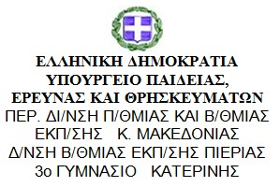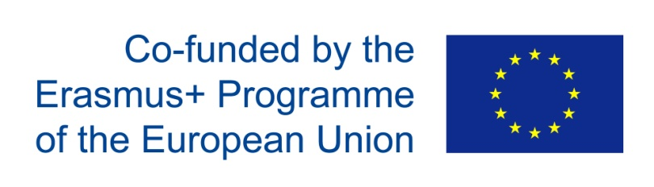

Date: 3rdOctober 2018

Meeting with the parents whose children will participate in the project (P52 / minutes)
The parents’ meeting took place on the 3rd of October in the evening and included briefing about the project. That is to say, the identity of the project, its duration, the schedule of activities, the parents’ contribution, the students’ visit to Spain as well as the coming of the Spanish students. Along with this briefing, came a new set of problems. Although all parents agreed on their children’s participation in the project, some of them doubted on whether they are going to allow their children to visit Spain and put up the Spanish students. Their concern was if he hospitality they are going to offer will be satisfactory and if their children will be safe in Spain. At the end of the discourse, more parents were convinced to give their permission. The details of the project were clarified to a satisfactory level.

