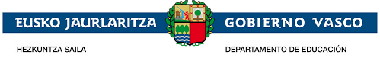
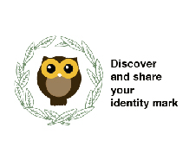

DIDACTIC UNIT P 19

Galdakao historical heritage
Subject: ENGLISH
Issue:
Students are discovering the historical heritage of their town Galdakao. This activity has been carried out by the History teacher. With all the information given by the teacher, students will create a virtual tour of it. They will present it to the rest of students in class. At the same time, they will prepare a dossier translating all the information from Basque into English to be shared with Greek students. A video is also designed.
Individual work:
Students have decided the information they will choose for the guide tour. They will fill up the sheets of the History teacher. Then they will see how to prepare the virtual tour, organise the information, present it to the class and share it with the Greek students.
Justification of the proposal:
As the project "Discover and share your identity mark " is a project between Elexalde school in the Basque Country and Katerini school in Greece, knowing the history of their town enriches students´ interest on their town, making them aware of the history behind their town and at the same time it makes Greek students participate on it. It is also a way to strengthen links between both schools.
Problem situation
Context:
Our town history is part of our heritage. Students have discovered it and now it is time to share it with Greek students.
Problem:
Will students be aware of the importance of knowing the historical heritage of their town as an identity mark and part of our heritage?
Organise all the information given by the History teacher to design an activity in the English class.
Competences
Basic competences:
Competence in linguistic and literary competence (communication skills)
Technological Competence.
Art Competence.
Transversal competences:
Communication competence: The English language will be used as the communication vehicle.
ICT competence: Use of you tube to create the presentations.
Didactic objectives:
-Grow students' interest in the discovery of the history of their town and motivate them to learn how to create a digital tour.
-Make them aware of the importance of discovering their town history, share them with the Greek students and discover the Greek ones.
-Connect the history subject with the English one.
- Learn the historical heritage of Katerini town.
- Build bridges between both schools through the history of their towns.
-Promote interest in their town.
- Translate the material given by the History teacher into English and create a dossier.
- Interaction between schools through the history of their towns.
Contents:
Romanesque- Gothic sculpture.
Sculptures on Church doors and capitals
Developmentalism
Shooting Range
Ironworks
Our forests
Task sequence:
Initial stage
History class
-A school trip organised by the history teacher through the relevant places related to the history of the town.
- Students take notes of this trip
-Fill up the sheets given by the History teacher.

- Middle Stage
This activity takes place in the Basque class
- Divide students to organise the information they have.
-Create a dossier with all the information in English.
Final Stage
- Organise the different groups to create a dossier.
Methodology:

Cooperate and participate in the groups to create the dossier.

Follow the explanations of the History teacher through the tour around the town

Assessment:

Oral presentations will be part of the assessment.

