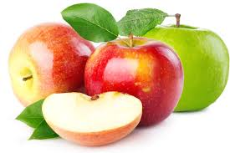

DAN JABUKA 2020.
TJEDNI PROJEKTNI ZADATAK

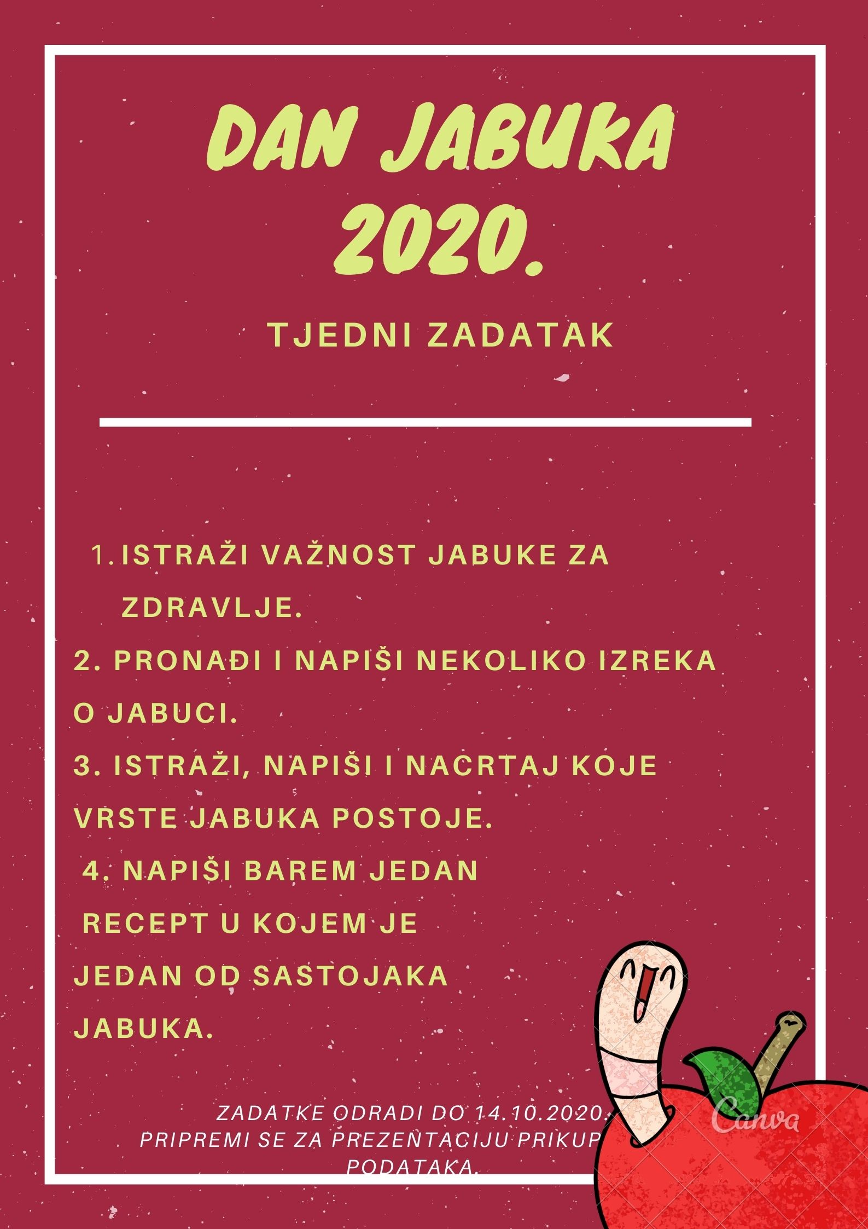

- ISTRAŽI VAŽNOST JABUKE ZA ZDRAVLJE
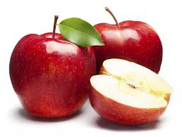
_________________________________________________________________________________________________________________________________________________________________________________________________________________________________________________________________________________________________________________________________________________________________________________________________________________________________________________________________________________________________________________________________________________________________________________________________________
- PRONAĐI I NAPIŠI NEKOLIKO IZREKA O JABUCI

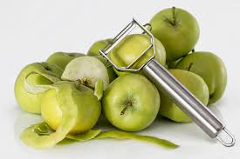
___________________________
___________________________
___________________________
___________________________

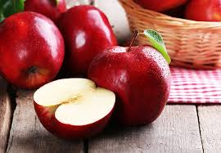
____________________________
____________________________
____________________________
____________________________

____________________________
____________________________
____________________________
____________________________
- ISTRAŽI, NAPIŠI I NACRTAJ KOJE VRSTE JABUKA POSTOJE

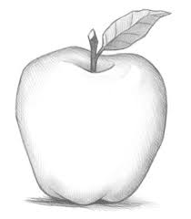

VRSTA:__________________
BOJA:____________________

VRSTA:__________________
BOJA:____________________

VRSTA:__________________
BOJA:____________________

VRSTA:__________________
BOJA:____________________

- NAPIŠI BAREM JEDAN RECEPT U KOJEM JE JEDAN OD SASTOJAKA JABUKA.

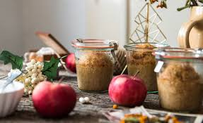

_________________________________________________

SASTOJCI:
___________________________________
___________________________________
___________________________________
___________________________________
___________________________________
___________________________________
___________________________________
___________________________________

PRIPREMA:
________________________________________________________________________________________________________________________________________________________________________________________________________________________________________________________________________________________________________________________________________________________________________________________________________________________________________________________________________________________________________________________________________________________________________________________________________________________________________________________________________________________________________________________________________________________________________________________________________________________________________________________________________________________________________________________________________________________________________________________________________________________

