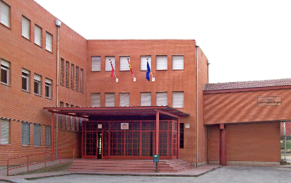L.E.S. Gabriel Garcia Marquez- Madrid
Ecological cookbook
How to eat in a good way for our planet

Fast food, meat, fruits which aren’t seasonal ... We’re not very kind for Mother Earth with our eating habits. A huge deal of global warming is caused by the production of meat and the transport of certain vegetables by ships to remote countries. However, a lot of people don’t like vegetarian or local dishes, so they just keep eating the “bad” stuff.
-> Criteria for ecological cooking: The recipe should only have products which are produced here locally. If it had to be transported from another country or even continent to here, the CO2-emission of the ships is huge. It is also very important to limit the amounts of meat in the dish. The production of meat (cows etc.) pollutes very much. Finally, we should make sure our products were made biologically, with respect for our environment.
Wouldn’t it be nice if there was a way for us to eat nicely and ecologically at the same time? Well, there is one! We chose a couple of delicious dishes with local ingredients for you to prepare. Have fun and Smakelijk! / Bon appétit! / ¡ Que aproveche!

Contents list

Page 3-4 | Belgium  WAP
Page 4-6 | Belgium  Brussels Waffle
Page 6-8 | Belgium  Apple pie
Page 8- 10 | Belgium  Chicory Soup

WAP
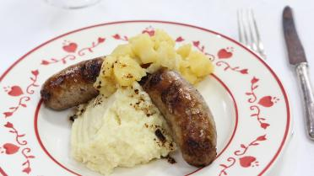
Country: Belgium
Description
WAP stands for “worst, appelmoes en puree” which translates to “sausage, apple sauce and mashed potatoes”. It’s a very simple, but delicious dish anyone can prepare. You probably won’t find it on a menu in a restaurant, but every Belgium grandma will know how to prepare it. Since we wanted this recipe to be ecological, we pay attention to a couple of things. For example, we buy our products at local farms. Moreover, apples and potatoes are organic. The sausages are bought @ http://www.meikensvlasvarken.be/ . This traditional farm takes care of the wellbeing of pigs. They get fed by locally grown flax and cereals. The milk is provided by a local farmer http://www.moeninckhof.be/ . Our own chickens were so kind to offer us their eggs 😉

For (how many people?) 30
Cooks in (how long?) ?
Difficulty: Easy
Ingredients
- 30 sausages
- 8 kg apples
- 8kg potatoes
- 3 l milk
- 7-8 eggs
- 7-8 glasses of water
- Some butter
- Some pepper and salt
- Some nutmeg

Materials
- Knives
- Cutting boards
- Cooking pots
- A glass
- Stirring spoons
- Pans
- Measuring cup
- Potato mashers

Method
- Peel the potatoes and cut them into pieces of about 2cm. Put them in a bowl of cold water, drain and steam until tender in 10 to 15 minutes from the water boils.
- Peel the apples, remove the core and cut them into pieces.
- Put them in a pot. Add a glass of water and a tablespoon of butter. Cook under a lid on a low flame. Stir occasionally in the pot. Please note that it does not cake. Crush coarse or fine to applesauce.
- Warm up the milk. Season with a knife point of nutmeg, pepper and salt.
- Warm up a pan and melt a bit of butter in it. Fry the sausages in the sizzling butter. Turn them regularly.
- Mash the potatoes until puree. Then add the warm milk, the eggs and the butter. Stir together until it’s smooth. Taste and season to taste with salt, pepper or nutmeg.
- Put the puree on the plate. Serve with a sausage and applesauce

Brussels Waffles
Country: Belgium
Description
We are going to make Brussels Waffles, easy and local. The ingredients are basic and mostly not from animals. We only use milk and yes indeed you can say it’s not good for the environment, but you have to know we can’t be better than the Pope. So that’s why we use milk. The eggs are from chickens that we received from friends and connections.
For (how many people?) 25
Cooks in (how long?) ?
Difficulty: Easy
Ingredients
- 7eggs
- 1,75 l milk
- 875 ml water
- 875g self-rising flour
- 350 g butter
- 7 portions vanilla sugar

Materials
- Waffle maker
- Sieve
- 2 Whisks
- Scale
- Pan
- A pot

Method
- Take 2 mixing bowls and part the eggs.
- Melt the butter.
- Mix flower and sugar and add some milk.
- Add the yolks one by one.
- Add the rest of the milk and the water. Batter.
- Add the melted butter and stir.
- Whisk the egg-white until it becomes foamy. Gently add it to the batter. Be careful and make sure as much air as possible stays in the batter.
- Preheat the waffle baker and after a while, put the batter in the waffle maker

Apple Pie
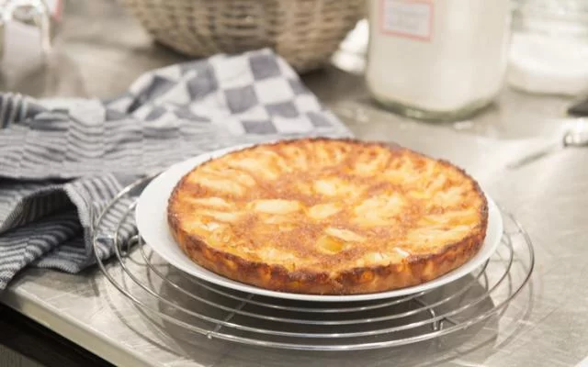
Country: Belgium
Description
What’s more traditional then grandma’s apple pie? It’s ecological because we use apples, which are fruits that are grown in Belgium and we will again use the eggs from someone we know.
For (how many people?) 6
Cooks in (how long?) ?
Difficulty: Easy
Ingredients
- 3-4 apples
- 2 eggs
- 6 soup spoons of sugar
- 3 bags of vanilla sugar
- 190g self-rising flour
- 4.5 soup spoons of milk
- 4.5 soup spoons oil
- A snuff salts

Materials
- Baking mould
- Mixing bowl
- Soup spoon
- A whisk
- Scale

Method
- Preheat the oven on 200° C
- Take the mixing bowl and stir the flour, sugar, vanilla sugar, eggs, oil and the milk together
- Smear the baking mould with butter and powder the edges with regular flour
- Put the dough in the baking mould
- Cut the apples in 4 pieces and remove the kernel
- Cut the apples in half moons
- Lay the apples on the batter (in a circle): do not push them to deep into the batter!!
- Bake the pie in the oven for 20-25 minutes

Chicory Soup
Country: Belgium
Description
This is ecological because we use chicory and chicory is typically for Belgium so this means that we don’t have to import products from far away, so that’s why we make chicory soup. We bought the chicory at a local farmer. The onions and the patatoes were also bought at a local farm and are organic.
For (how many people?) 15
Cooks in (how long?) ?
Difficulty: Easy
Ingredients
- 20 heads of chicory
- 4 onions
- 8 small potatoes
- 4 liter of water
- 8 cubes of chicken broth
- 4 knobs of butter
- 2 leaves of laurel
- 4 sprigs of thyme
- pepper and salt
- 8 slices of stale bread
- Some dashes of olive oil

Materials
- Stirring sieve (passe-vite)
- Knives
- Cutting board
- Pan for soup
- Pan for simmering

Method
- Clean the chicory
- Remove the bitter part and cut the bushes into 1 cm pieces.
- Clean and wash the remaining vegetables and cut into pieces.
- Melt the butter and simmer the chicory and other vegetables.
- Season, pour over the stock and let it cook.
- Pour the soup through a sieve and add the chopped chervil

Calendar of seasonal products / country

http://www.westcountryfoods.com/West-Country-Foods-Ltd-Seasonal-Calendar.pdf

Eramus: voor- en achterflap aub > namen scholen, inhoudstafel (na afloop)

