The name of the dessert we will make today is Rice Pudding

- Necessary materials to make rice pudding (250 ml water glass measure)
- 1 cup Rice, 2 cups Water, 1 cup Sugar, 1 pack of Vanilla, 5 cups Milk, 2 teaspoons of Starch (dissolved in a quarter cup of water)
- 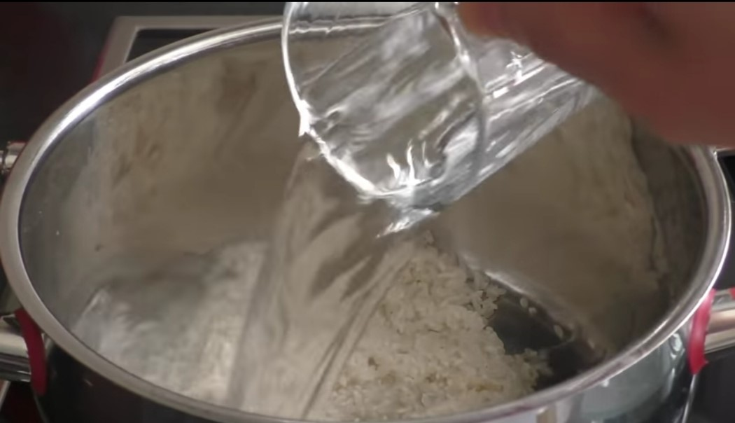

- After washing our rice, we add it to our pot. We add two glasses of water and stir it occasionally at medium temperature to make the water absorb. We do not rush in high temperature, otherwise it may hold the bottom.
- 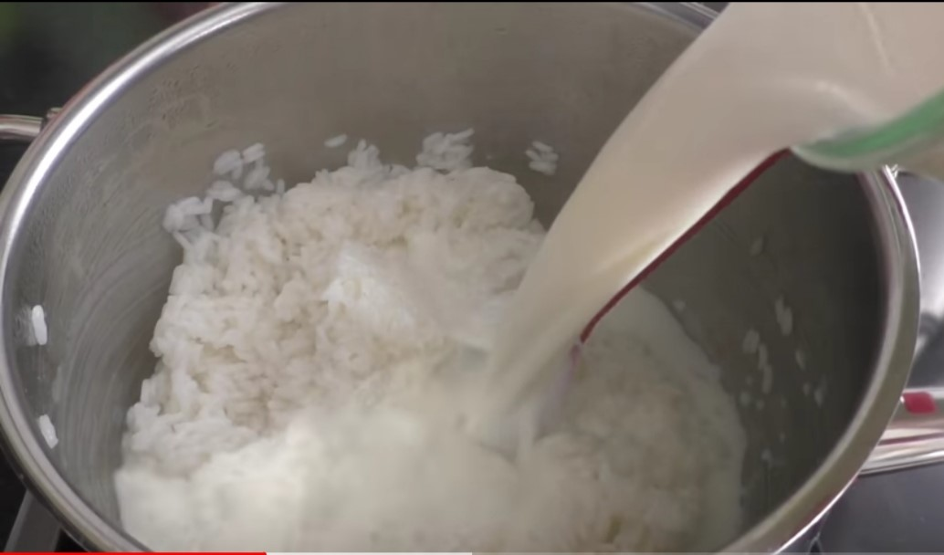
- Our rice is completely dehydrated. I add five glasses of milk and let it boil, stirring occasionally for fifteen or twenty minutes.
- 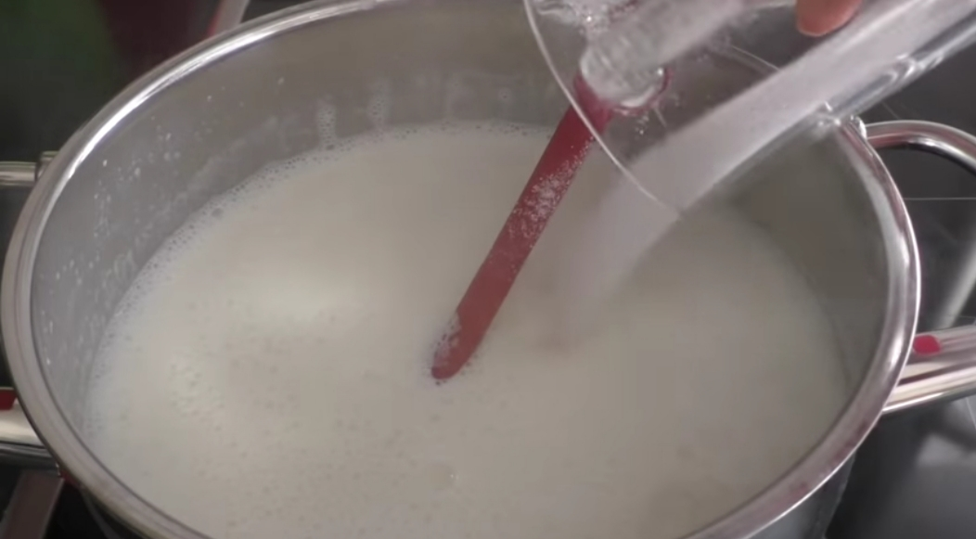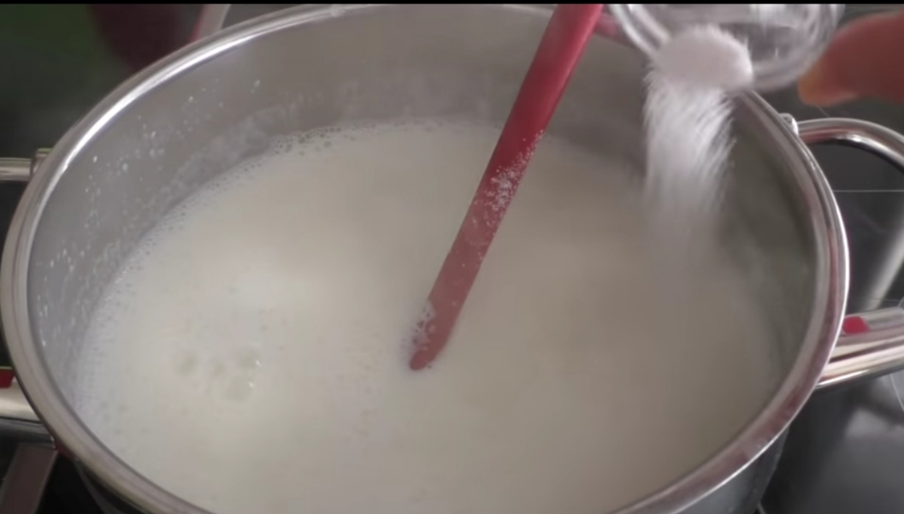
- We dissolve two teaspoons of starch in a quarter glass of water and add it to the pot.
- 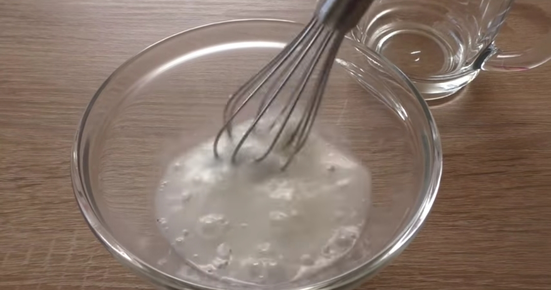
- 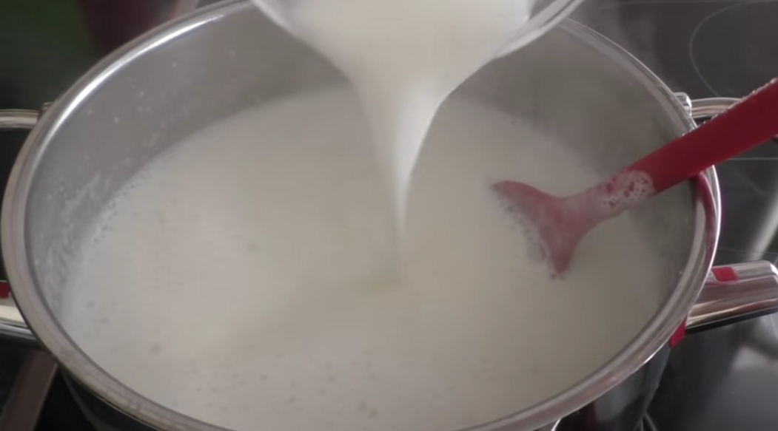
- We cook it on low heat for a few more minutes (we stir it occasionally) and put it in the containers that we will serve, sprinkle sugar on it and throw it in the oven for five minutes to make it square.
- 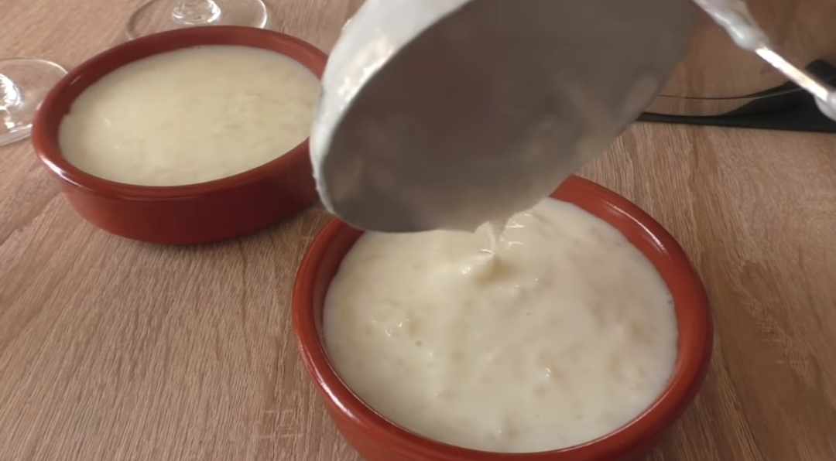
- We cook it for a few more minutes on low heat (stir occasionally), put it in the containers we will serve, sprinkle sugar on it and throw it in the oven for five minutes and caramelize it.
- 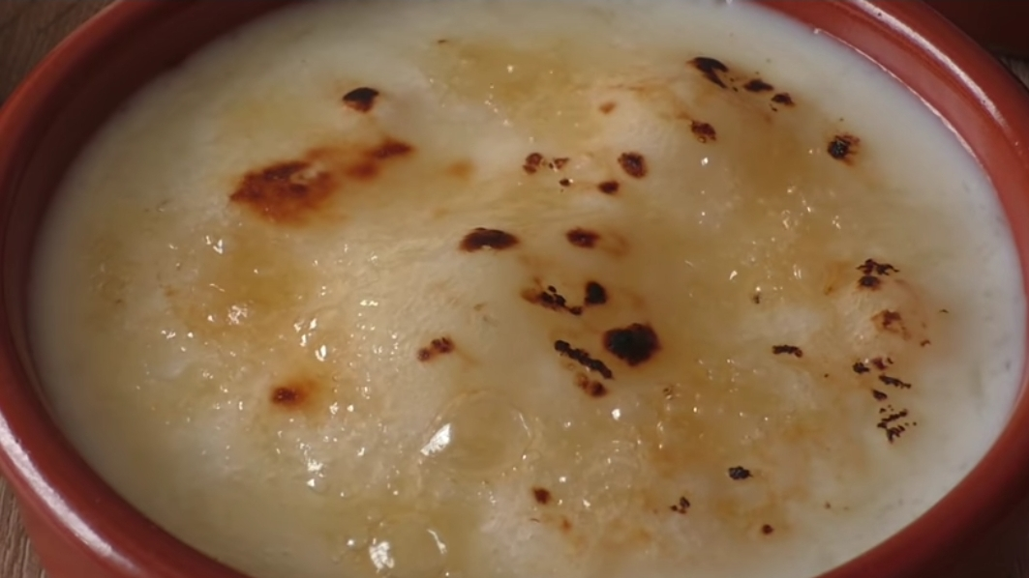
- After that, you can decorate as you wish.
- 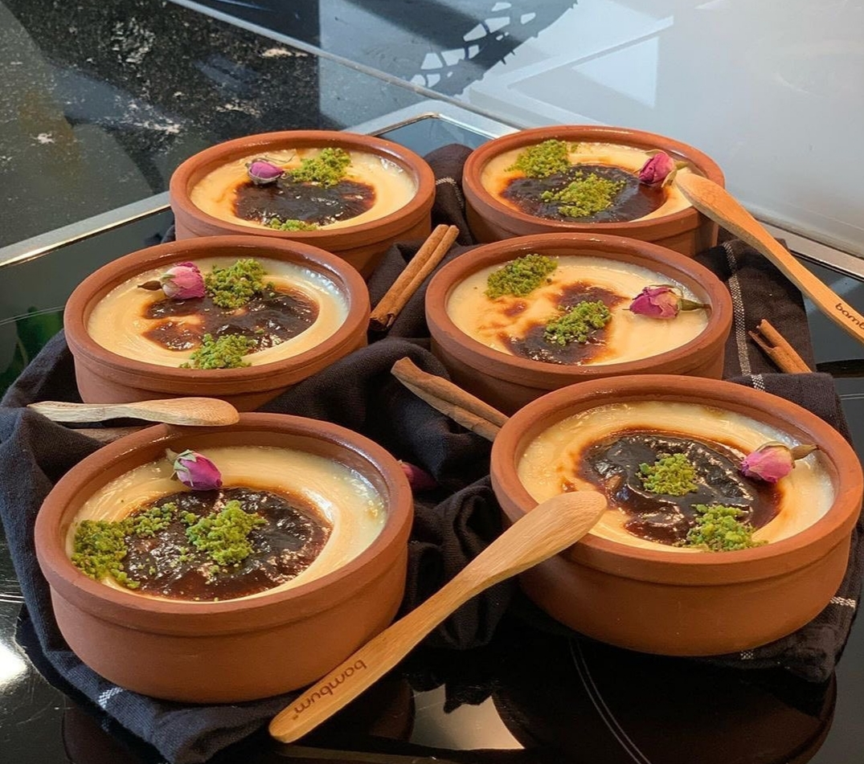
- Bon Appetit ❤

