Blanquette de veau
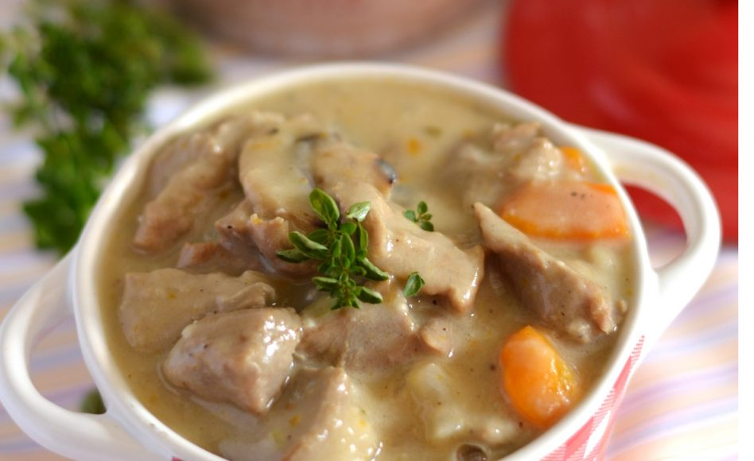
Put the steps in order :
- Cut the carrot, chop onions, add the meat and chop mushrooms.
- Add 2 or 3 cup of water, wine and mix. Put a lid.
- In a bowl, mix the cream, yolk and lemon juice.
- Let cook softly 1h30 or 2h.
- Cook the meat in butter and leave gilt them.
- Add water if needed.
- Add 2 spoons of flour and mix.
Jumble words:
Ingredient:
- toscarr 2 - roulf (1 spoon)
- 1 Noino - white wine 25cl
- 200g Morusohm - tals (pinch)
- macre 50cl - repppe (pinch)
- 1 nemol
- geg (loky) 1
Ustensils:
- pna - lobws
- talupas - fnikes
- dli

