Faworki cookies

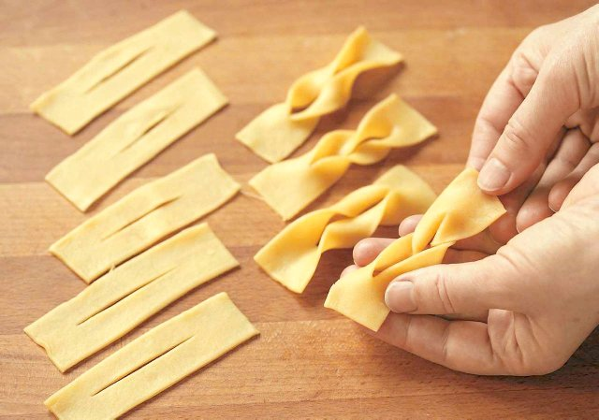
Ingredients for about 60 pieces
- 400 g of wheat flour
- pinch of salt
- 1 teaspoonful of baking powder
- 1 egg
- 5 yolks
- 1 spoonful of icing sugar
- 6 - 7 spoonfuls of thick sour cream of 12% fat or the yoghurt
- 1 spoonful of spirit or vinegar
- 1.5 kg of lard or 2 litres of oil
- icing sugar, jam

Preparation
Sieve the flour into the bowl, add salt, baking powder and mix. In another bowl beat the egg and yolks with the spoonful of the icing sugar for 8 minutes into fluffy and thick foam .
Add to the flour, next pour the cream and the spirit, mix everything. Knead smooth dough. Form the bullet, wrap up in the food foil and put away for about 30 - 45 minutes in the room temperature (after this time the cake will be simplier to roll out).

Knead the dough for about 7 minutes, next roll up to the pie, fold in half and then again roll up, again fold and roll 2-3 times up still, In the meantime you also can hit the dough with a roller. This way we make the cake more flexible and we force the air into it.

Divide the dough into 4 parts and roll up one by one for the thinnest pies (the thinner the better). Hold the rest of the cake wrapped up in the food foil.

Cut strips out (rectangles cut at endings) with the knife or the tracing wheel. They should be smaller than the diameter of the pot. In the centre of every belt do the cut, by which you can move one end of the strips. Grab by ends and shake gently so that each piece has pretty shape. Put aside and hold under the cloth while cutting next pieces out.

Heat up oil for 180 degrees in the wide pot and put to it for a few pieces simultaneously (they will grow quickly and will be covered with air bubbles). Fry to the golden colour for about 30 - 60 seconds on every side.
Lay cookies on paper towels. After chilling sprinkle with icing sugar. You canserve them with marmolade or jam.

