Rolls Crêpes with ham and cheese

① Ingredients :

- 4 rapec
- 40g tertub
- 30g uorlf
- 40g kilm
- 80g hfrse marec
- 1 malsl mca fo sotemato tepas
- 140g mha
- Peperp mad gemtun
- Last

② Utensils :

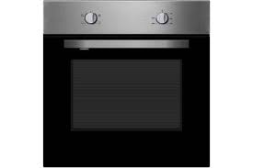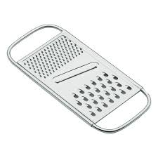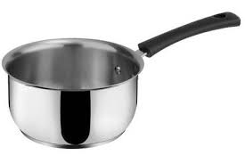

● ● ● ● ●
Grater ladle oven bowl saucepan
③ Listen the instructions:
Step 1: Mix the flour with butter melted until coloring.
Step 2: Add the milk and thicken at low heat. Add salt, pepper and nutmeg.
Step 3: Add sour cream, a small can of tomato paste and diced ham.
Step 4: Warm the crepes (thin pancakes) and garnish with bechamel and hot ham.
Step 5: If you want warm crepes put in the oven or grill with grated cheese.

By Lenny, Alexis, Henrique

