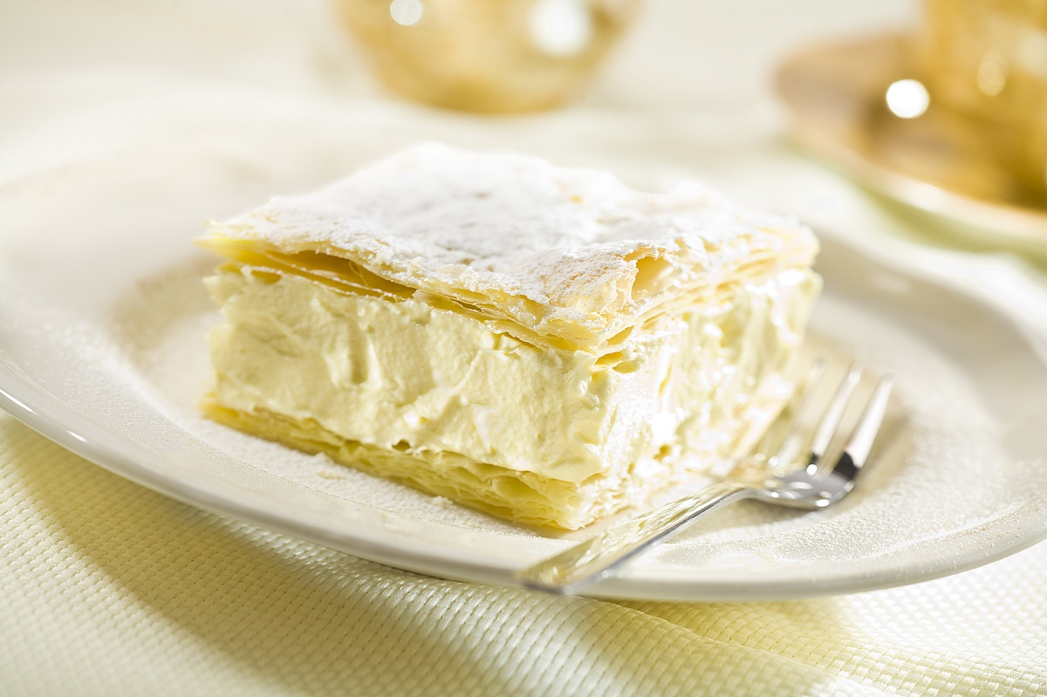
Papal cream
*Ingredients for the dough:
- 1/4 kg of butter
- 1/4 kg of flour
- 1egg yolk
- 1 pinch of salt
- 1/2 cup of water
*Ingredients for whipped cream:
- 1/2 liter of cream (36% fat)
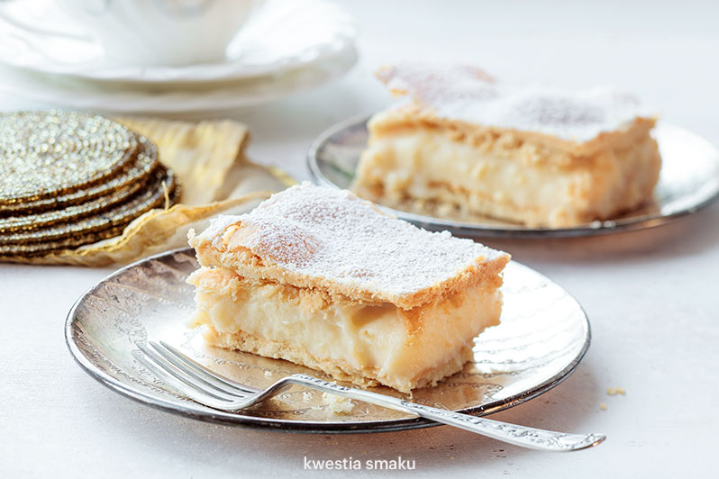
- 2 tbsp of powdered sugar
- 1 item of vanilla sugar
*Ingredients for vanilla cream:
- 2 glasses of milk
-r 3/4 cup of sugar
- 3 eggs
- 3 egg yolk
- 1/2 cup of wheat flour
- 2 tbsp of butter
- 1 item of vanilla sugar

Making a vanilla cream:

Boil the milk with vanilla sugar.
Add sugar, whole eggs and egg yolks to the flour, mix thoroughly, pour the boiling milk, stirring and boiling constantly. After cooling completely, add the butter and stir until a homogeneous mass is obtained.

Making whipped cream:

Highly cooled cream beat with sugar and vanilla sugar until fluffy mass.

Making the dough:

* Knead butter with 1/5 flour, form the cube and cool. Knead dough with the remaining flour, yolks, water and a pinch of salt, with a density such as butter and flour. Cool for 20 minutes. Roll the cold dough into a rectangle. In the middle put a cube of butter and flour, cover with opposite sides and roll out a rectangle of 2 cm thick. Fold the opposite sides in and then in half and roll out again. Repeat four times after each fold. Put the dough for 15-20 minutes in the fridge. Finally, roll out in the shape of a rectangle with a thickness of 0.5 cm and lay on a baking tray.
*Bake at 200 degrees for a light brown color. Cut the baked puff pastry into two equal parts, spread one half with a vanilla cream, then a layer of whipped cream. Cover the whole with the other half of the dough, sprinkle with powdered sugar. Cut into rectangles of any size. https://smaker.pl/przepis-kremowka-papieska,118130,tradycyjna-kuchnia.html

