lemon pie for 6 people

For short pastry
250g lufro flour
130g btetur butter
70g grsau sugar
2 okyls-gegs yolks eggs
5cl etraw water
1 pinch of lsat salt
For lemon crud
4 mloens lemons
150g grsau sugar
3 gegs eggs
1 soupe spoon satrhcocnr cornstarch

For meringue
2 ihtwe -gegs white-eggs
100g cigin gegs icing sugar

cake tin |  | 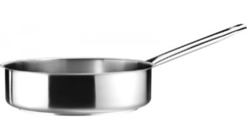
bowls 3
whisk |  | 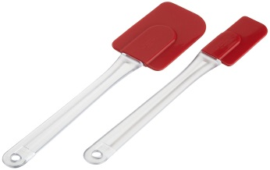  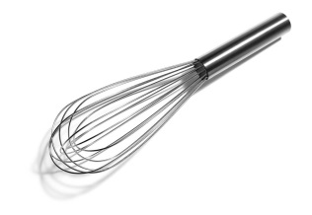  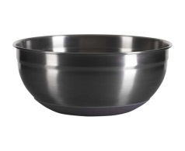
spatula
knife
cutting board
sauce pan |  | 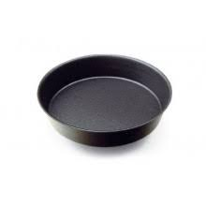
rolling pastry |  | 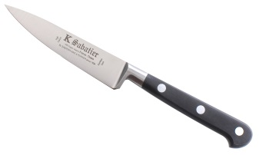
oven |  | 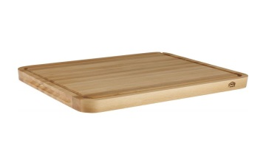
geaseproos paper |  | 