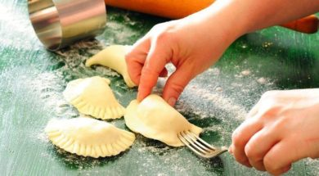
Ingredients for dumpling dough;
- 3 glasses of flour
- 1/2 teaspoon of salt
- glass of boiling water
Ingredients for filling;
- 400 g of the curd cheese
- yolk of the egg
- 2 spoonfuls of sugar

Preparation
Put the flour and the salt into the bowl. Pour boiling water. Mix the elements with your hands (clean, of course☺) until it is merged. Next form the cake into a bullet. Cover with the bowl or wrap up with food foil and leave for one hour and a half. Now prepare the filling. Mince the curd cheese and mix precisely with the yolk and the sugar. Form the dough into the flat pie, put on the floured pastry board and roll the c 2 mm up to the thickness. Cut circles from it, put stuffing in the middle and join the edges of the dumplings together. Boil water In the big pot with a bit salt and a spoonful of oil. Cook the dumplings by parties about 2 minutes since they come to the surface. Take out with spoon and put on a plate. Serve them e.g. with some cream and sugar, with the grated roll and butter or with the fruit sauce. Tasty :)

