Eclair au chocolat
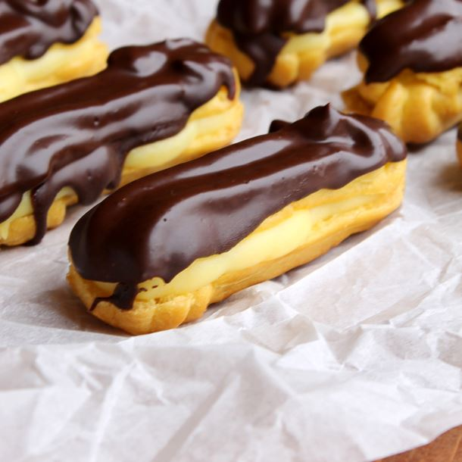
Ingredients:
CREAM DOUGH
- 2 spoons of flour - 150g of flour
- 30cl of milk - 25cl of water
- 50g of butter - 75g of butter
- 210g of black chocolate - 1 spoon of sugar
- 1 egg - 4 eggs
- 3 spoons of sugar - 1 pinch of salt
- 2 yolks - 1 yolk
Ustensil
- Oven
- Saucepan
- Spatula
- Pastry bag
- Brush
- Whisk
- Bowl

