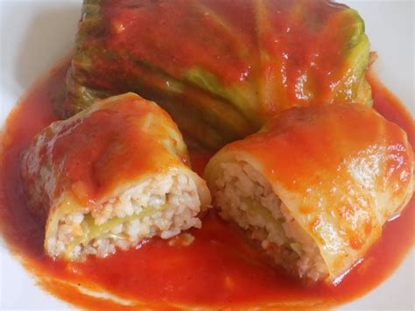
Recipe for stuffed cabbage.
Ingredients:
-head of medium-sized cabbage,
-half a kilogram of minced meat,
-1 sack of rice (100 g),
-1 onion,
-salt, pepper and marjoram to taste,
- a small jar of tomato concentrate
-stock cube
-frying oil

Actions:
Put the rice in boiling salted water. Strain after 15 min of cooking. Fried in fat finely chopped onions, add the minced meat. Fry for about 30 minutes. Mix it in a bowl with rice and spices.
Leave cabbage in boiling water (about 5 min), next separate cabbage leaves and cut the thick leaf nerves. Put the filling mass over the spread leaves. Roll up the leaves, forming the balls.
Put the unwrapped leaves at the bottom of the saucepan. Next put the cabbage balls.
Pour the broth, boil the soft stuffed cabbage and add tomato sauce. Cook for about 5 minutes.
That’s all. Bon appetit !

