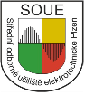

Erasmus+ KA229 - School Exchange Partnerships
Project: 2019 – 1 – RO01 – KA229 – 063163 “Different but together“

Traditional arts and crafts in the Czech Republic
Traditional arts and crafts are an inseparable part of Czech folklore:
- Cornhusk dolls: among the most popular traditional products. These dolls made of cornhusk and a few strings are nowadays used as decorations but in the past children used them as toys. Cornhusk dolls are also great souvenirs tourists can buy in the Czech Republic if they are looking for something truly traditional.
- Pottery: Another popular traditional artistic product. Bohemian and Moravian pottery is painted with various folklore patterns, simple or floral ornaments. The pottery serves for both decorative and practical purposes.
- Bobbin lace: also one of the popular traditional items. The most famous Czech bobbin lace products are made in Vamberk, a city in Eastern Bohemia.
- The Czech Republic is also renowned for its production of glass: crystal glasses, bowls, vases, and other products contribute to the richness of heritage of the Czech Republic.
- Indigo print products: hand-made textile goods. Tablecloths, toys, and other accessories are made of this material.

The title “Bearer of the Tradition of Folk Crafts”
Since 2001, in the frames of the European Heritage Days and with the support of Ministry of Culture, the "Bearer of the Tradition of Folk Crafts" title is awarded to honour skills, knowledge of processes and technologies involved in traditional folk crafts. This project is based on a project that UNESCO has called “Living Human Treasures”. Usually, a maximum of five titles are awarded in one calendar year to citizens of the Czech Republic who engage in one of the traditional folk crafts. The award aims to appreciate the efforts to preserve, present them to the public and to pass traditions on to future generations. The bearers are presented with a diploma and a monetary award. At present, its holders include 4 dozen folk craftsmen from Bohemia and Moravia.
Sources:
http://www.nulk.cz/nositele-tradice/
http://www.lidovaremesla.cz/
http://historie.shscms.cz/ehd/en/bearers-of-the-tradition-of-folks-crafts-2006-1079.html
https://www.europeanheritagedays.com/EHD-Programme/Press-Corner/News/The-Czech-Republic-to-celebrate-European-Heritage-Days-in-September
http://www.folklorika.cz/en/index.php?s=remeslaen

Cornhusk doll
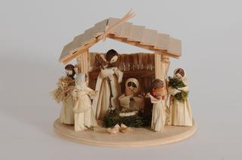
Corn lady is regarded a traditional product that comes from Slovacko region in the Czech Republic. Corn leaves are a traditional material, which started spread in the 17th century. Corn leaves were used mainly in poor families to make different kind of products, some of them were sold on markets.
Waste from harvested corn cob sis used in the production. The dried corn leaves are soaked in warm water with detergent. This process makes the leaves firmer, do they do not break during work. The modelling of a specific doll depends then of particular skills.
The skeleton of the figurine is made of wire, the body begins to be made from the head, which is filled with cotton wool and covered with a rustle.
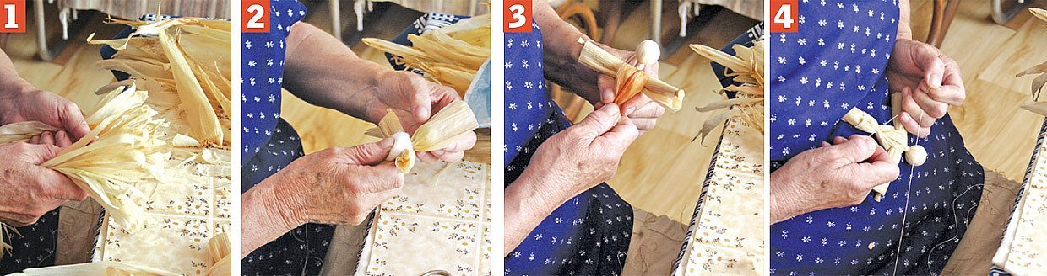
The finished shapes must be tightened very tightly with the thread, because the wet material will shrink after drying and the looser bond would then be released and the figure would fall apart.
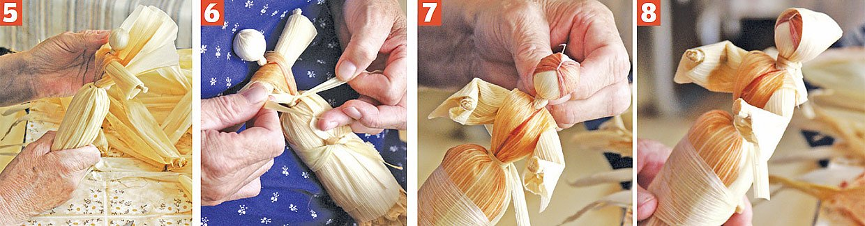

Typical products
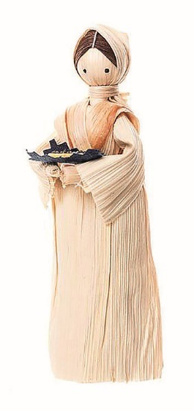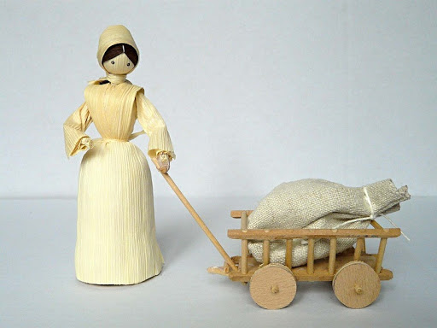
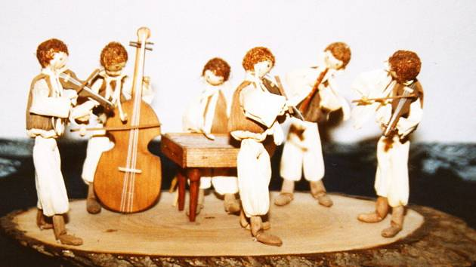
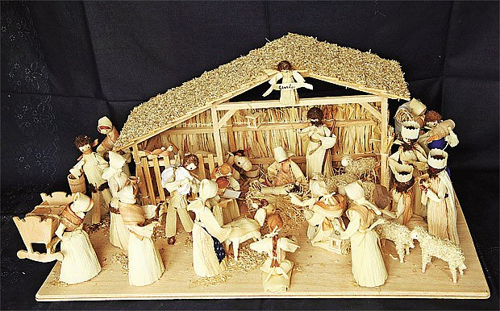

https://www.youtube.com/watch?v=3cEplVU3EWo
http://www.lidovaremesla.cz/files/nositele/2006/ludmila.kocisova.pdf

Indigo print products: hand-made textile goods

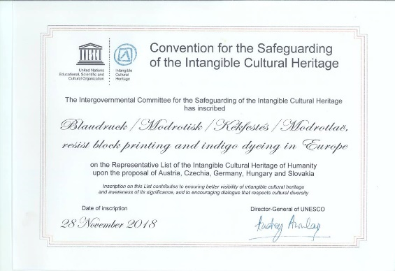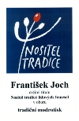

Blaudruck/Modrotisk/Kékfestés/Modrotlač, which is translated as blueprint or blue-dyeing, refers to the practice of printing a dye-resistant paste onto a cloth before it is dyed indigo. The paste prevents the dye from penetrating the design. To apply the designs onto the cloth, practitioners use hand-crafted blocks up to 300 years old, featuring regionally-inspired patterns, generic designs or Christian motifs. Nowadays, the practice is mainly conducted in family-owned workshops, run by the second to seventh generation of printers, and traditional knowledge is still based on (mainly family-owned) journals dating back to the nineteenth century. Country(ies): Austria; Czechia; Germany; Hungary; Slovakia.
Textile printing technology blueprint has been on the list of intangible cultural heritage of the United Nations Educational, Scientific and Cultural Organization (UNESCO) since 2018.
Blueprint is a traditional technique of textile printing and at the same time the name for a dark blue fabric with white patterns, which is produced by this printing technique. This is a negative print, where the fabric is printed in places that are supposed to remain white. The printing is done with a reserve - a covering mixture, which protects the required places from contact with the dye and which is removed after dyeing by washing. Wooden forms are traditionally used for printing, into which the required patterns are cut or created using embedded metal wires and sheets. Originally, domestic linen brought by customers was used for dyeing with indigo, imported natural dye, in the second half of the 19th century linen and cotton linen directly from factories.
From the end of the 18th century, blueprints penetrated into folk costumes, its popularity increased mainly in the 19th century. It has become a typical material for some areas such as Horácko or Wallachia. In the 19th century, there was a blueprinting workshop in almost every small town, in the 20th century they began to decline, to this day there are workshops in Olešnice and Strážnice in the Czech Republic.

Typical products:
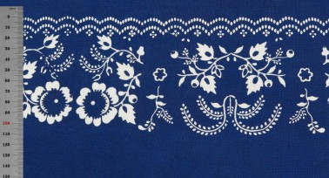
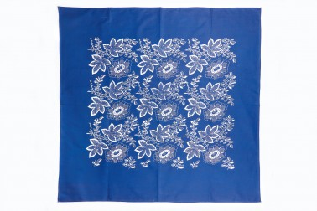
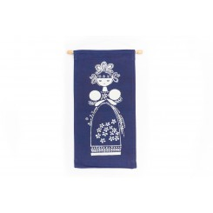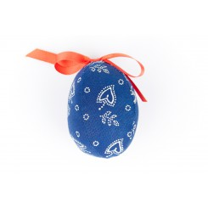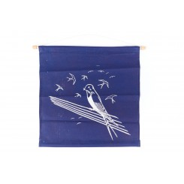
Representative List of the Intangible Cultural Heritage of Humanity - 2018 URL: https://ich.unesco.org/en/RL/01365
http://www.lidovaremesla.cz/files/nositele/2002/jiri.danzinger.pdf
https://www.youtube.com/watch?v=5FrDB_pJgk8

Modrotisk Danzinger - tradiční výroba modrotisku Olešnice:
https://www.youtube.com/watch?v=Q-L0phapf80
https://www.modrotisk-danzinger.cz/
http://www.lidovaremesla.cz/files/nositele/2004/frantisek.joch.pdf
https://www.straznicky-modrotisk.cz/
Puppetry in the Czech Republic
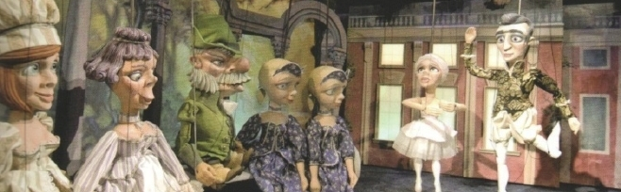
The joint Czech-Slovak nomination "Puppetry in Slovakia and the Czech Republic" was entered into the UNESCO Representative List of the Intangible Cultural Heritage of Humanity on December 1, 2016. The puppet theatre is an inseparable part of the theatrical tradition in Slovakia and the Czech Republic.
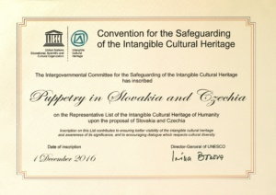
This originally artificial product of nomadic puppeteers who came to us from abroad has become widespread in the Czech environment. In the Czech environment, the puppet theatre, as an interpretive art, is inextricably linked with professional and folk art (carving, painting, puppet costumes, painting of decorations).
Czech puppetry is a phenomenon that has existed continuously since the second half of the 18th century. Nomadic puppeteers, whose greatest distribution dates back to the 19th century, played intensively throughout Bohemia, Moravia and Silesia and spread the Czech language, especially in the countryside. Since the last third of the 19th century, the federal puppet theatre has expanded, mainly due to the sports and cultural organization Sokol, and thanks to the massive expansion of the family puppet theatre (owned by almost every burgher family), the puppet theatre has become a folk pastime. The continuous tradition of Czech puppet theatre is evidenced by many scenes that have existed since its foundation to this day (e.g. the Spejbl and Hurvínek Theatre, founded in 1930). According to historical sources, the number of puppet theatres in the 1920s and 1930s was the highest in Europe. In the second half of the 1930s, there were more than 3,000 ensembles operated in our country. This was greatly aided by the world's first puppet magazine, the Czech Puppeteer (1912), which is still published today under the title Puppet.
Skupova Plzeň International Festival of Puppet and Alternative Theatre is the oldest professional theatre festival in the Czech Republic (Czechoslovakia). The festival is a show of Czech professional puppetry. The main program is always supplemented by a representative sample of foreign production (4-5 performances). Traditionally, the upcoming generation of puppetry from universities of theatre receives space here. The competition production is judged by a domestic or international expert jury, which awards individual prizes.
The story of puppets in our city Pilsen starts as late as in the 19th century when people in Pilsen could enjoy theatre performances of strolling folk puppeteers who travelled with their horses and carts through their favoured stands. At the end of the 19th century little family theatres, combined the worlds of children and adults. The main personalities were Josef Skupa and Jiří Trnka, whose joint work gave birth around 1930 to the probably most famous Czech puppets – father Spejbl (Spaybul and a son Hurvínek (Hurveenek).
Typical Czech puppets
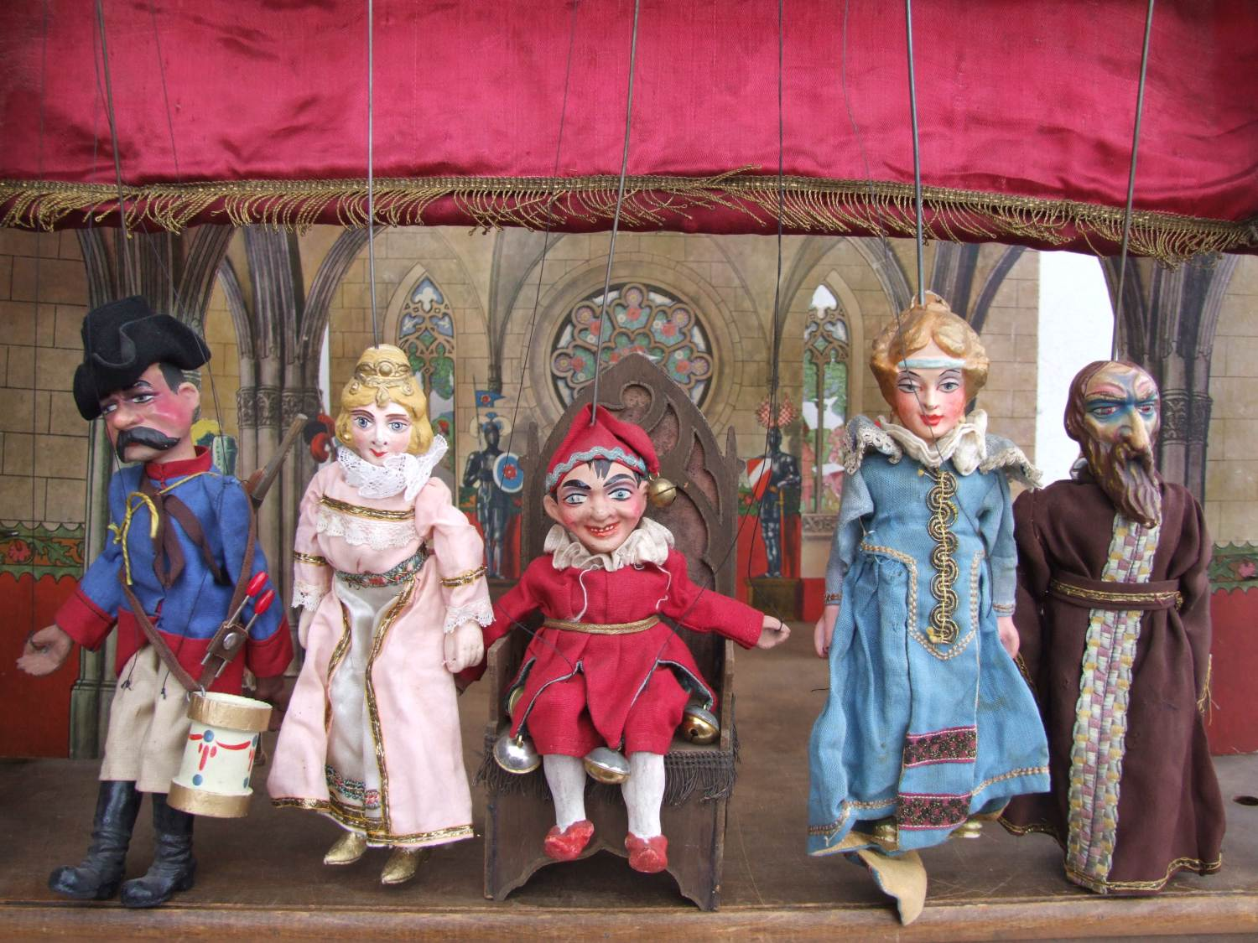
Kašpárek – Prankster and Čert - Devil
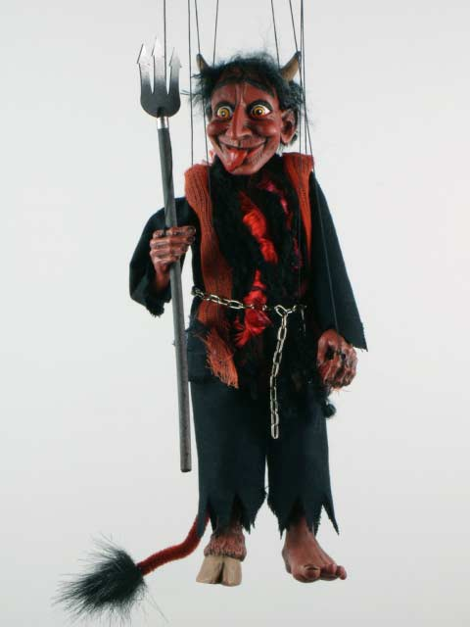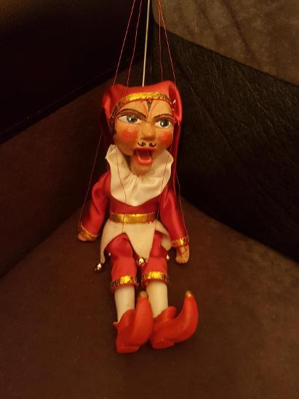
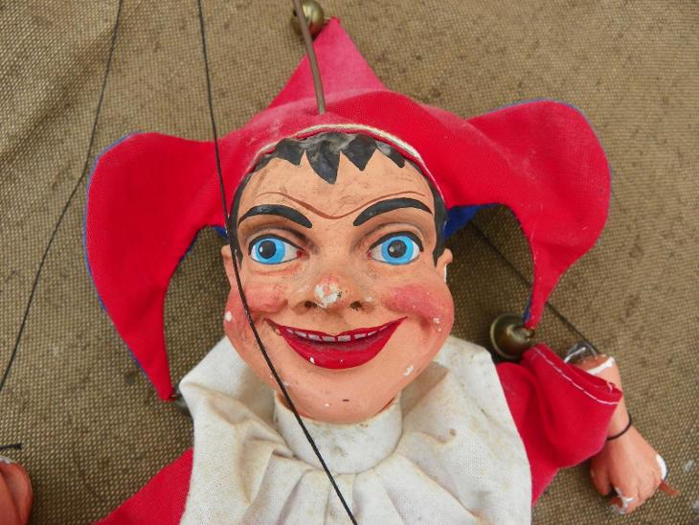
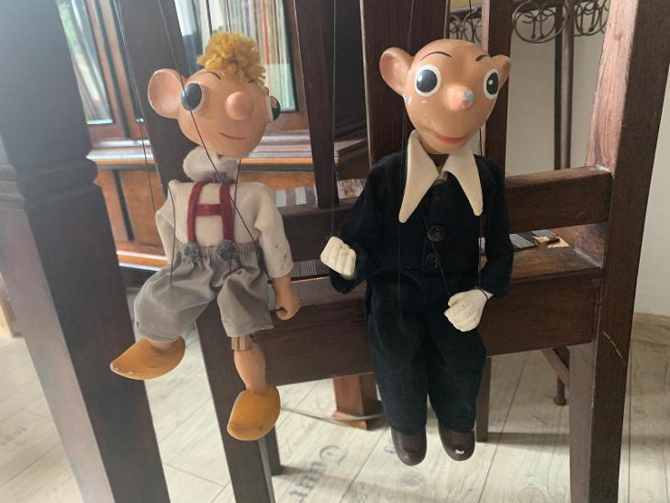
Spejbl and Hurvínek
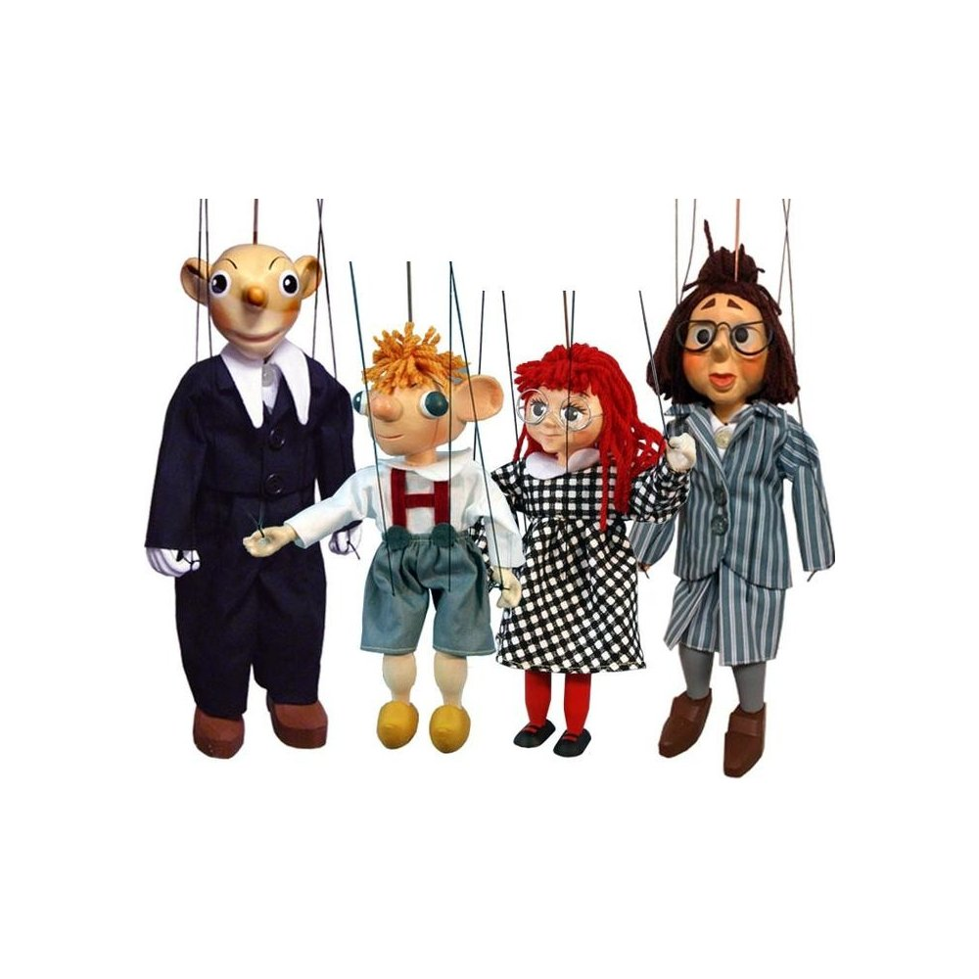
http://www.nulk.cz/2018/01/24/loutkarstvi-na-slovensku-a-v-cesku/
http://www.skupovaplzen.cz/index.php
https://muzeum-loutek.cz/en/
https://www.youtube.com/watch?v=aTVEjby6koc&list=PLux3V6G5BVe1t-wO-ztGqvt-fdyz5Wyu8
https://www.youtube.com/watch?v=sRoaqOoYJhI Spejbl and Hurvinek in English
https://www.spejbl-hurvinek.cz/en/

Bobbin lace from the town Vamberk – Eastern Bohemia

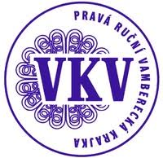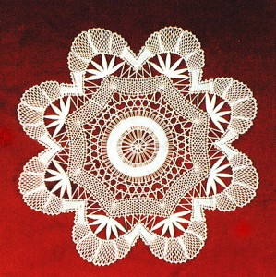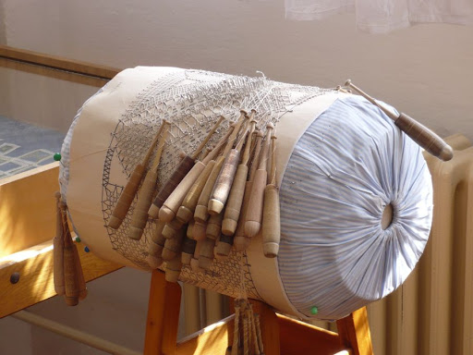

The town Vamberk is a special place for lace makers. This city has been known for lace production since 17th century. It was Magdalena Grambová, a Belgian owner of a local estate in Vamberk, introduced Belgian lace patterns and a new technique of hand bobbin lace making using a lace cushion or pillow. It is a multi-pair lace made of fine yarn.
Vamberk became a European centre of lace-making. At the second half of the 18th century the lace was made nearly in each household in the town Vamberk. In year 1899 first Czech lace making school was open and it was start of Czech traditional lace. In the school there were about 50 pupils mainly girls annually. Czech lace very soon became known and valued all over Europe. Manufacture factory of lace was running till so called Velvet revolution, after privatization this manufacture under new ownership fated.
First museum of lace was established in this town 1924. In the museum is retrospective exhibition of old Czech lacemaking to modern contemporary lace.
At present, the largest volume of orders consists of stylish jewellery with precious stones, beads, beads and other accessories, including tie clips, scarves and shawls. The imaginary icing on the cake is the supply of individual bobbin lace for luxury dresses.

Typical products
Traditional:
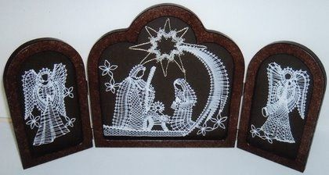
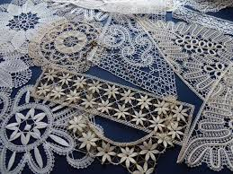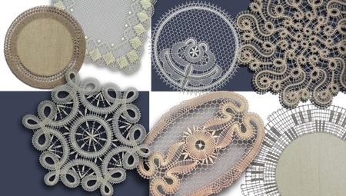
Modern:
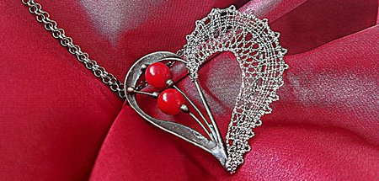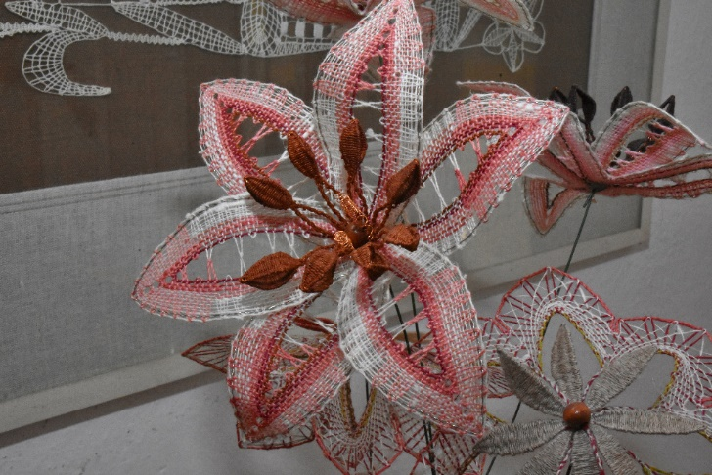
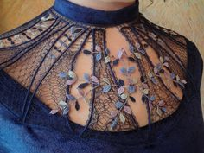

https://www.vkrajka.cz/
https://www.lacedesign.cz/en
https://www.youtube.com/watch?v=j59LJXBPr9o
https://www.moh.cz/muzeum-krajky

"The European Commission support for the production of this publication does not constitute an endorsement of the contents which reflects the views only of the authors, and the Commission cannot be held responsible for any use which may be made of the information contained therein."

