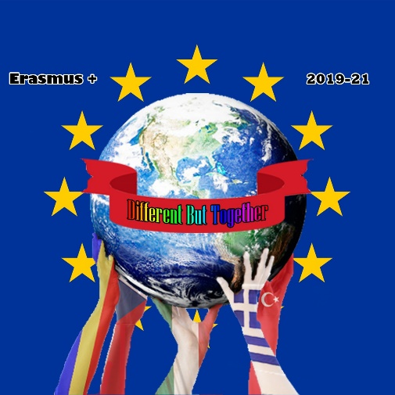

Erasmus+ KA229 - School Exchange Partnerships
Project: 2019 – 1 – RO01 – KA229 – 063163 “Different but together“

Traditional Czech board games
Board Game – “Člověče, nezlob se!”
In the Czech Republic, the very first board game that children learn to play is a variation of the original Ludo game. It’s similar to the English game “Sorry!” which is called “Člověče, nezlob se!” in Czech (literally “Don’t be angry, man!”). The game can be played by 2-4 players and it takes around 60 minutes. The only things you need are the game board, counters and a dice. Each player has got four counters of one colour (usually blue, green, red and yellow) and the goal of the game is to move all your counters from the starting point to the final “home” by rolling the dice and moving on the board. If you roll a six, you have one more throw. The more times you roll a six, the faster you’ll get to the final point. But be careful! If somebody steps on the same place as you, he can throw away your counter and put it back to the start.
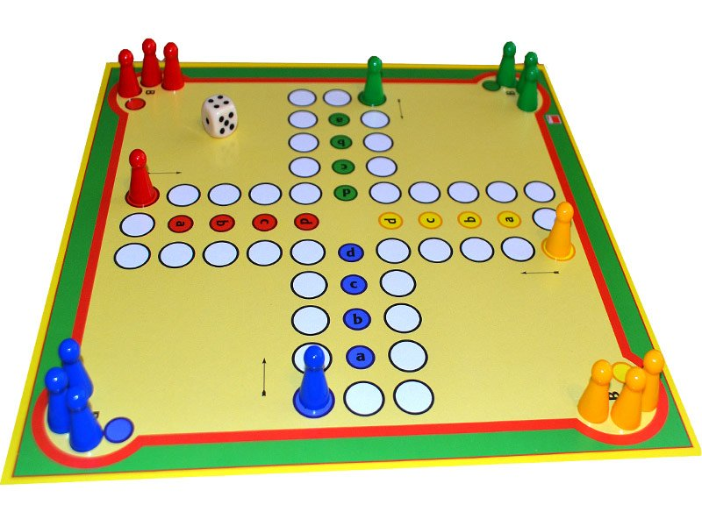
Picture source: https://blog.hubatacernoska.cz/pravidla-hry-clovece-nezlob-se
The history of the game dates back to the 7th century when it was brought from India to Europe, but it didn’t become very popular. In the 19th century, it appeared in Europe for the second time, when the English had taken it over from their colony in India. They launched the game under the name “Ludo” (from Latin “ludus” which means “a game”). However, the aim of making this game popular wasn’t much successful either.
Eventually, Josef Friedrich Schmidt began a serial line-production of the game in Germany. This board game inventor had made it in a small workshop in Munich. In 1914, the game was released under a new original name which was as well translated into Czech – Člověče, nezlob se. During the first year of production, Schmidt sold more than one million pieces! The game became popular mainly thanks to injured soldiers during World War I. They had got the board game as first to have fun during those hard times. As they shared the game, it was spread among all kinds of people all over Europe.
Card game – “Prší” (Raining)
There are more theories about how card games were introduced into Europe but all of them agree on Arabian origin. They could be presented either by pilgrims from the Far East, Mongols or gipsies travelling the world. At the beginning of 15th century the first card packs were created in Italy and Spain and at the end of the century, they were spread all around Europe including the Czech lands. They were played as well as dice or chess by rich people in castles but also by the poor in medieval alehouses and households.

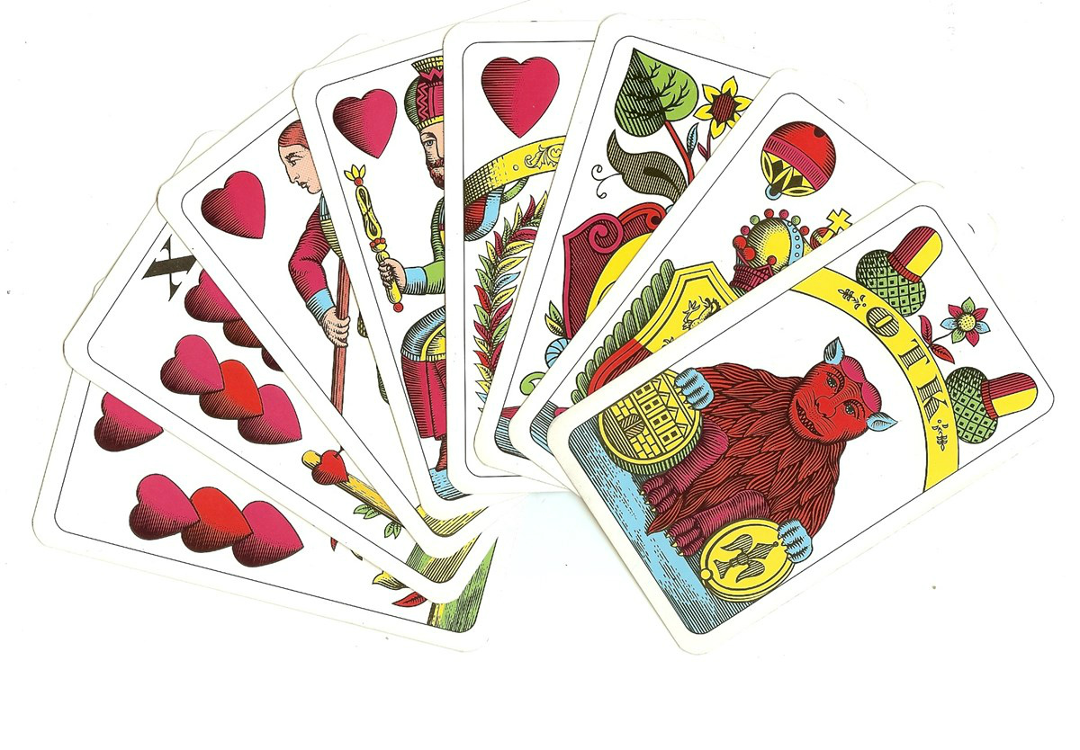
Picture source: https://www.anima-noira.cz/marias-vyklad-karet/?v=928568b84963

Until nowadays, the most popular of them is “Prší” which might be known in English as “Mau-Mau”. The rules of the game are really simple so it can be played by children from a young age. That’s why it became very popular with Czech families. We play Prší with a 32-card German pack. Each player has got four cards and one more card is put in the middle of the table – this is the main card which starts the game. The rest of the cards is faced down and put on the table too, that creates a talon (a stack). The goal of the game is to get rid of all the cards you have by putting a card of the same value or suit on the main card in the middle. The main card is constantly changed as the players take turns. If you don’t have any cards corresponding to the main one, you have to take one card from the stack.
Some cards even have a special value. If there is a seven and you don’t have one, you have to take at least two cards from the stack (this number is multiplied by the number of sevens thrown out in a row). A seven of hearts can even return you into the game!
If there is an ace as the main card and you don’t have one, you can do nothing but skip and wait for the next turn. Another important card is a queen which helps you change the suit of the main card and you can change it into whatever you need.
The player who gets rid of all his cards as first, wins.
According to the rules, it should be played in three rounds and the players should get penalty points (depending on the value of remaining cards) but we usually don’t keep these rules as we want to make the game simple for all family members, even the youngest ones.

"The European Commission support for the production of this publication does not constitute an endorsement of the contents which reflects the views only of the authors, and the Commission cannot be held responsible for any use which may be made of the information contained therein."

https://epochaplus.cz/hru-clovece-nezlob-se-proslavili-raneni-vojaci/
https://cs.wikipedia.org/wiki/Karetn%C3%AD_hra
https://karetni-hry.webnode.cz/prsi/

