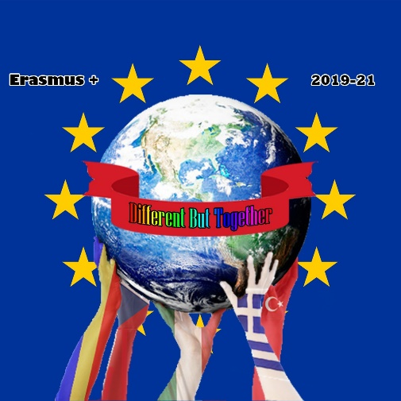

Erasmus+ KA229 - School Exchange Partnerships
Project: 2019 – 1 – RO01 – KA229 – 063163 “Different but together “

Czech outdoor games for children
Games have been always the part of our lives. They belong to the human behaviour. Children tend to copy their parents and other adults. Most of the games in the past were similar to hunting, working, cooking and fighting. Some of them have later developed into sports.
The aim of playing games was to improve speed, strength, endurance, perception, strategy and communication.

- Rybičky, rybičky, rybáři jedou Little fish, little fish, the fishermen are coming

This game comes from our childhood but nobody knows its origin. You could ask anybody in the Czech Republic and I am sure everybody would know how to play this game. It can be played either in a gym or outside. You need 10 to 30 players and something to mark the area with.

The rules:

One of the players is chosen to be a fisherman and he/she stands alone on one side of the area. The rest of the players are little fish and they stand on the other side of the area.

The fisherman starts the game with calling: “Little fish, little fish, the fishermen are coming! “
Then everybody moves and tries to get to the other side. While running against the fish the fisherman manages to catch the fish. He/she cannot move backwards. The caught fish become the fishermen. They hold their hands to make the net and continue playing the game. The game ends the moment there is no fish left.

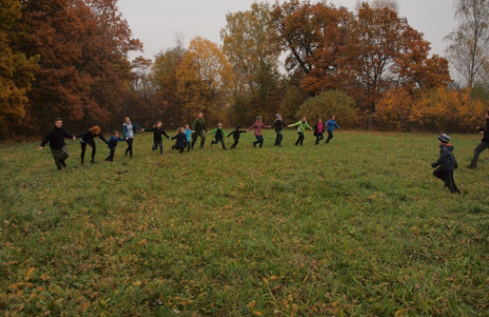

- Na jelena - Hit the deer (stag)

This simple ball game is known all around the Czech Republic. The origin is unknown. “Hit the deer„ belongs to the group of dodgeball games. In the past children imitated hunters. Instead of weapons they used a ball.
This game can be played in a gym or outside. You need 10-20 players and a ball.

The rules:
All players make a circle. One of them is a deer and stays inside the circle. The rest of the players are hunters and try to hit the deer with a ball. Players can hit the deer only if they get a pass from some other player. When somebody hits the deer, they swap the roles.
To make the game faster and more thrilling you can have two balls and another deer.

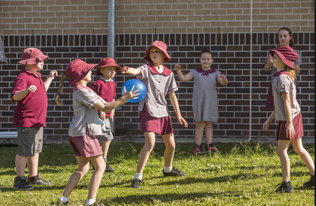

"The European Commission support for the production of this publication does not constitute an endorsement of the contents which reflects the views only of the authors, and the Commission cannot be held responsible for any use which may be made of the information contained therein."

