Project: 2019–1 – RO01 – KA229 – 063163_5
Event host organization: Střední odborné učiliště elektrotechnické, Plzeň, the Czech Republic

Program of the activity Czech Heritage

Střední odborné učiliště elektrotechnické, Plzeň, the Czech Republic
April 26-30, 2022
April 25
Arrival, accommodation in the hotel. Dinner not organised; group individual with the Czech accompaniment according to the arrival.
April 26
8:15 leaving the hotel, going to school by tram with the Czech teachers, students
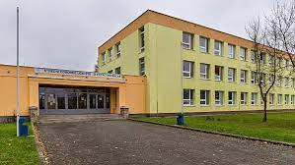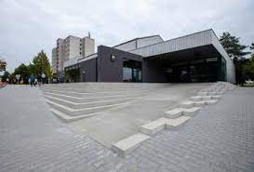
Speech of the school headmaster, introducing delegations, presents
Breaking ice - meeting and familiarisation of all participants
11:15 lunch in the school dining hall offered by school
12:15 presentations about traditional board and outdoor games for children (you all prepared the games last year) – up to 10 minutes per group. Please send the presentations by mail in advance.
13:15 workshop in international teams – games
15:30 Pilsen – city sights, town quiz – international teams (teachers coffee) – program finishes between
17-18:00
https://www.plzen.eu/
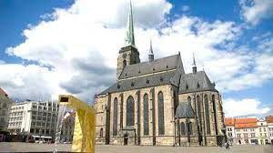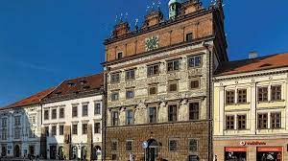
Evening program:
18:30 leaving the hotel
dinner
bowling etc.

April 27
8:15 leaving the hotel
A day trip by coach to the capital city Prague
https://www.praha.eu/jnp/
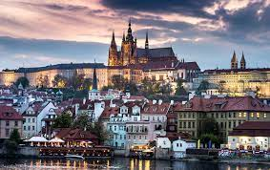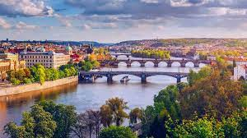
10:30 guided tour
13:30 Free time
17:30 leaving Prague, in Pilsen at about 19:00

Lunch and dinner not organised, group individual

April 28
8:45 leaving the hotel
A day trip by coach to the castle Velhartice https://www.hrad-velhartice.cz/cs
10:30 guided tour in the castle (castle is normally closed – it is not the season).
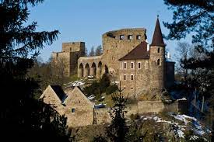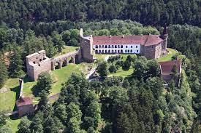

to the city Klatovy https://www.klatovy.cz/klatovy/
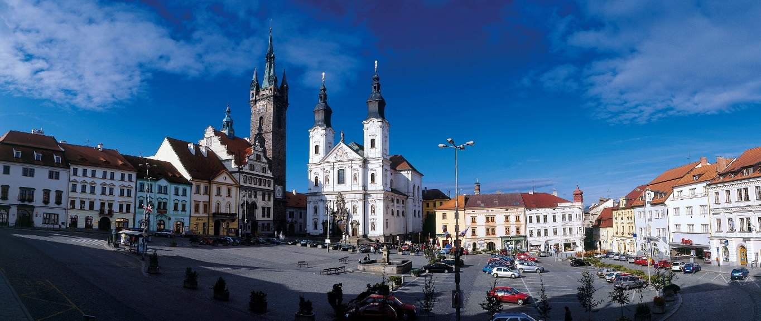
13:00 lunch in the local restaurant
14:30 one group, 15:30 second group Baroque pharmacy
Free time
Leaving Klatovy at 17:00, in Pilsen at about 18:30
Dinner not organised, group individual

April 29
8:30 leaving the hotel
9:00 Workshop in Franciscan Monastery http://frantiskanskyklaster.4fan.cz/
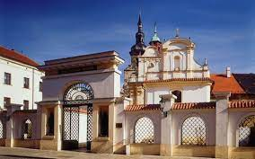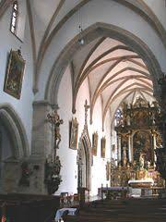
11:15 lunch at school
“What you have experienced during the week in the CR” – experiences, new knowledge, new friends – international teamwork at school – students
15:30 workshop finishes, our students will accompany your students for short shopping and to the hotel
For teachers:
Excursion to the brewery Pilsner Urquell
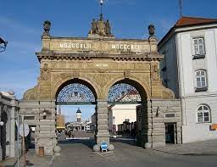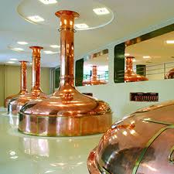
18:30 leaving the hotel, going to school by tram – our students will accompany you
19:00 Dinner at school
Social evening
We will take you to the hotel by tram.

April 30
Leaving the hotel at 9:00, going to school by tram
“What you have experienced during the week in the CR” – experiences, new knowledge, new friends – international team presentations
Kahoot
Evaluation of the learning activity
Certificates of attendance
Coffee, small refreshment
Teachers meeting – activity in Greece
Afternoon – free time, individual program, shopping
Lunch and dinner not organised, group individual

Ing. Jaroslav Černý, school headmaster

