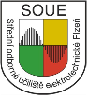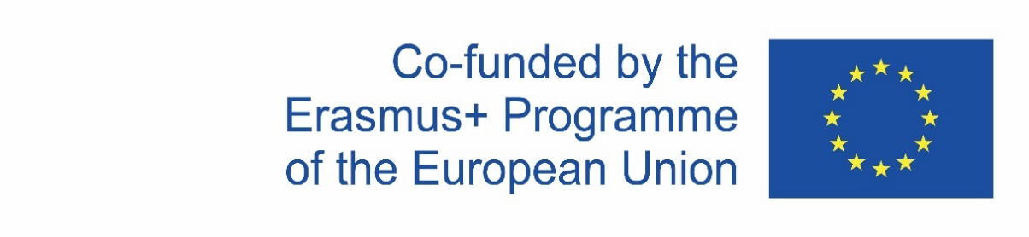
LTT meeting Erasmus+
“Different but together” 2019-1-RO01-KA229-063163
Messina December 9 – 13 2021
Czech participation
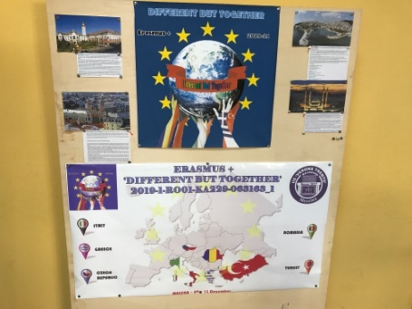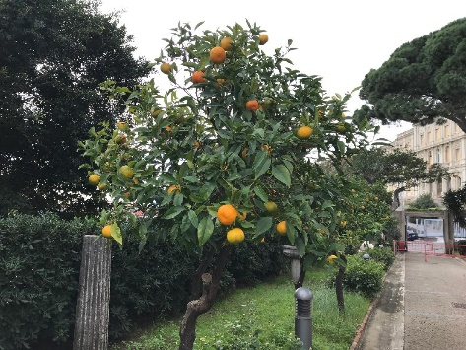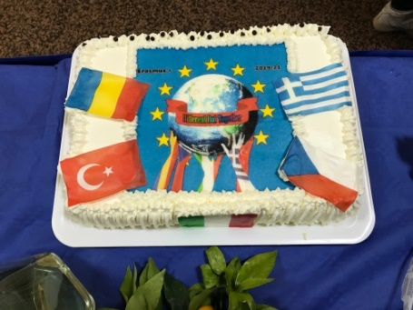
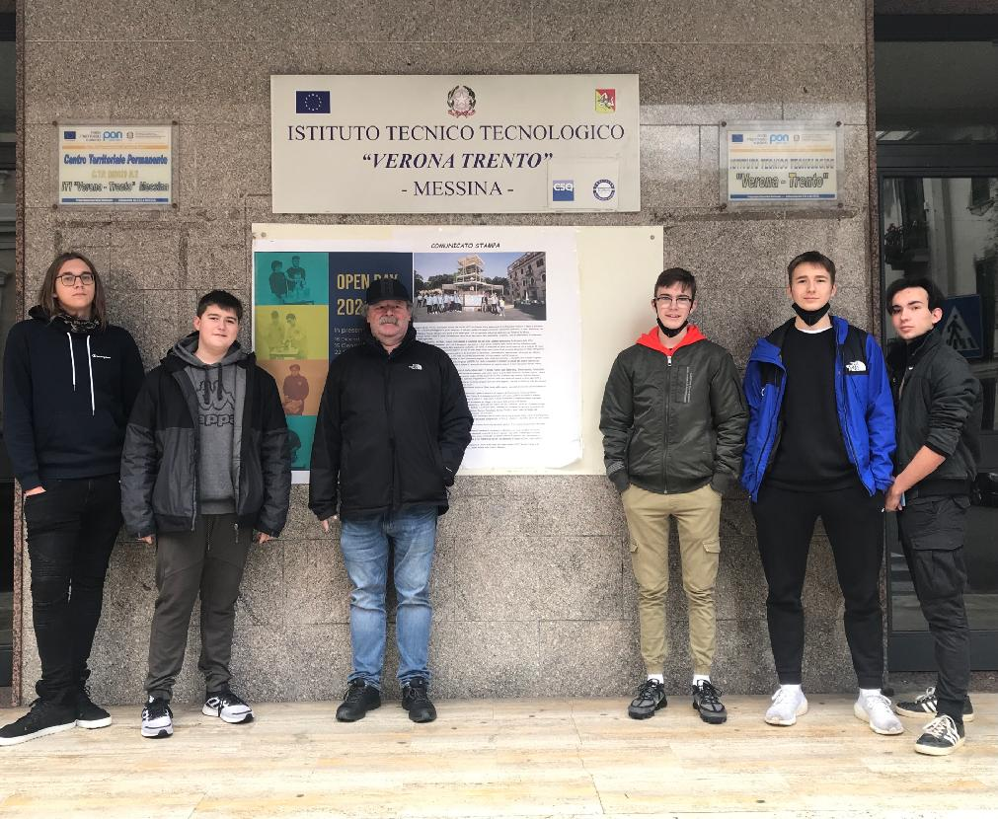

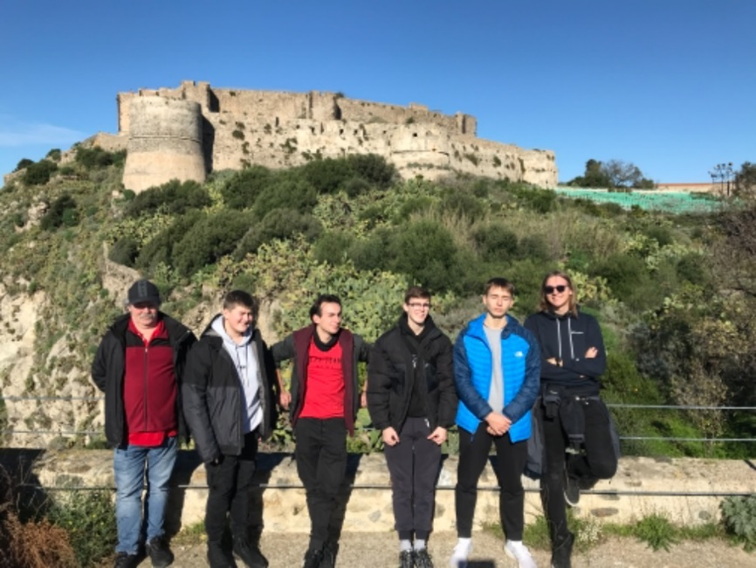

Due to the circumstances surrounding COVID 19, the first partnership meeting of the project “Different but together” took place in December 2021 in Italy at the Verona-Trento school, Messina (Sicily). The school has a technical focus like ours and has a similar number of students, i.e., around 1000. The meeting was attended by all delegations from Romania, Greece, Turkey, Italy and the Czech Republic represented by a delegation of 2 teachers and 5 students.

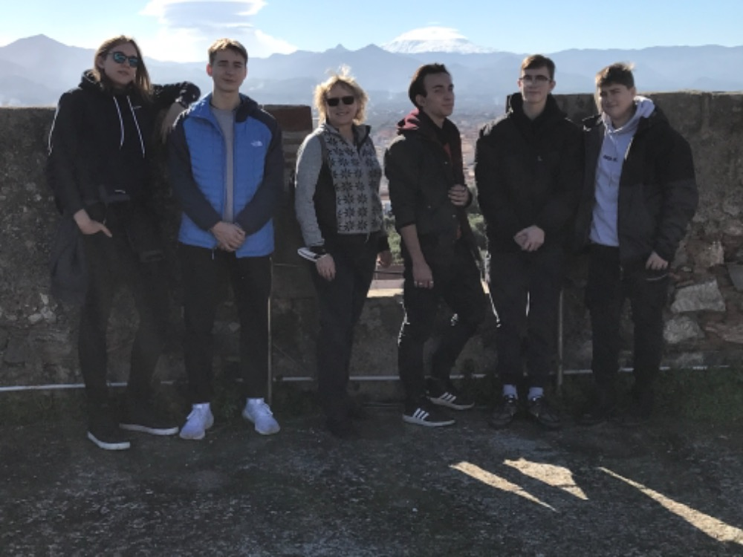

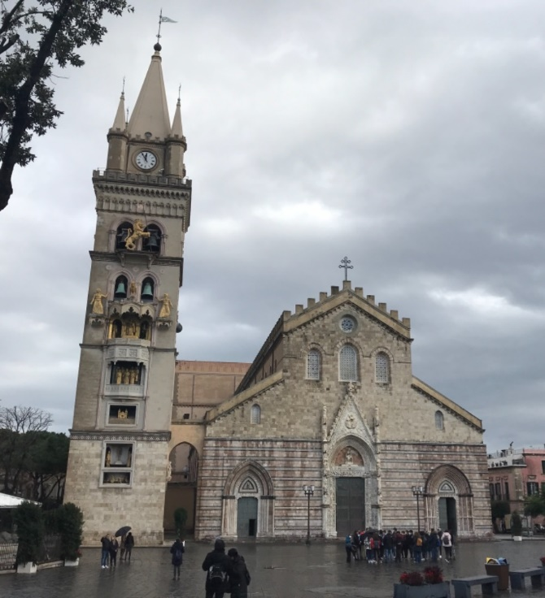

The first day of the meeting was devoted to introductory activities - an official welcome and introduction of individual delegations, ice-breaking activities and presentations of individual countries and schools. Students learned to work in the KAHOOT application. The introductory activities were followed by a tour of the city of Messina, prepared by teachers and students from the Italian school. The tour was focused mainly on the historical, cultural, and religious monuments of the city.

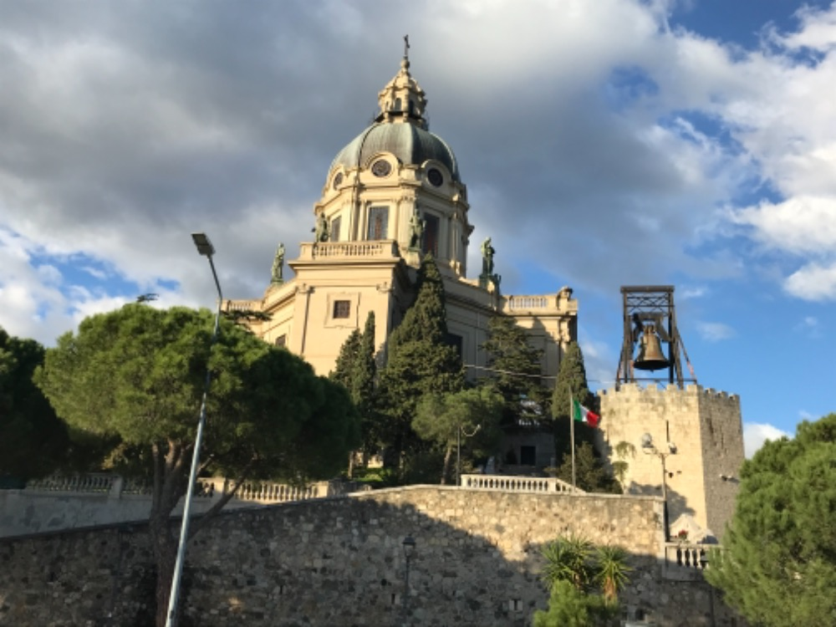
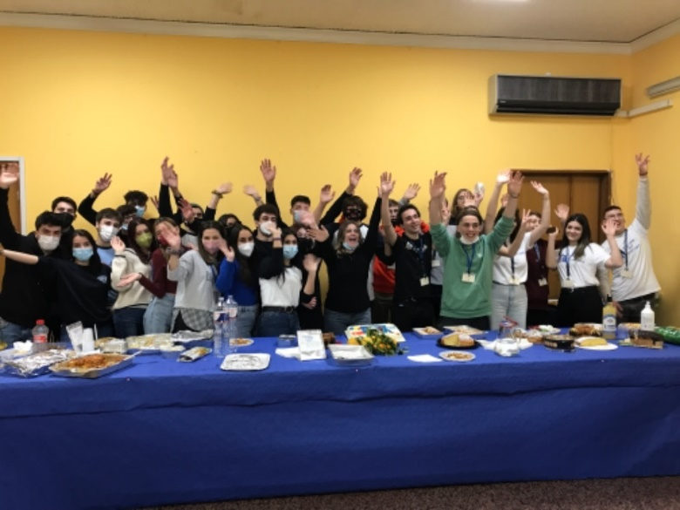

The next day was again a program at the visiting school. In the morning, we enjoyed a tour of the school, including special labs, accompanied by Italian teachers and students. In the afternoon, the students were preparing the small performance, which should emphasize the main theme of the project different, but together - the connection of cultures, interests, languages.

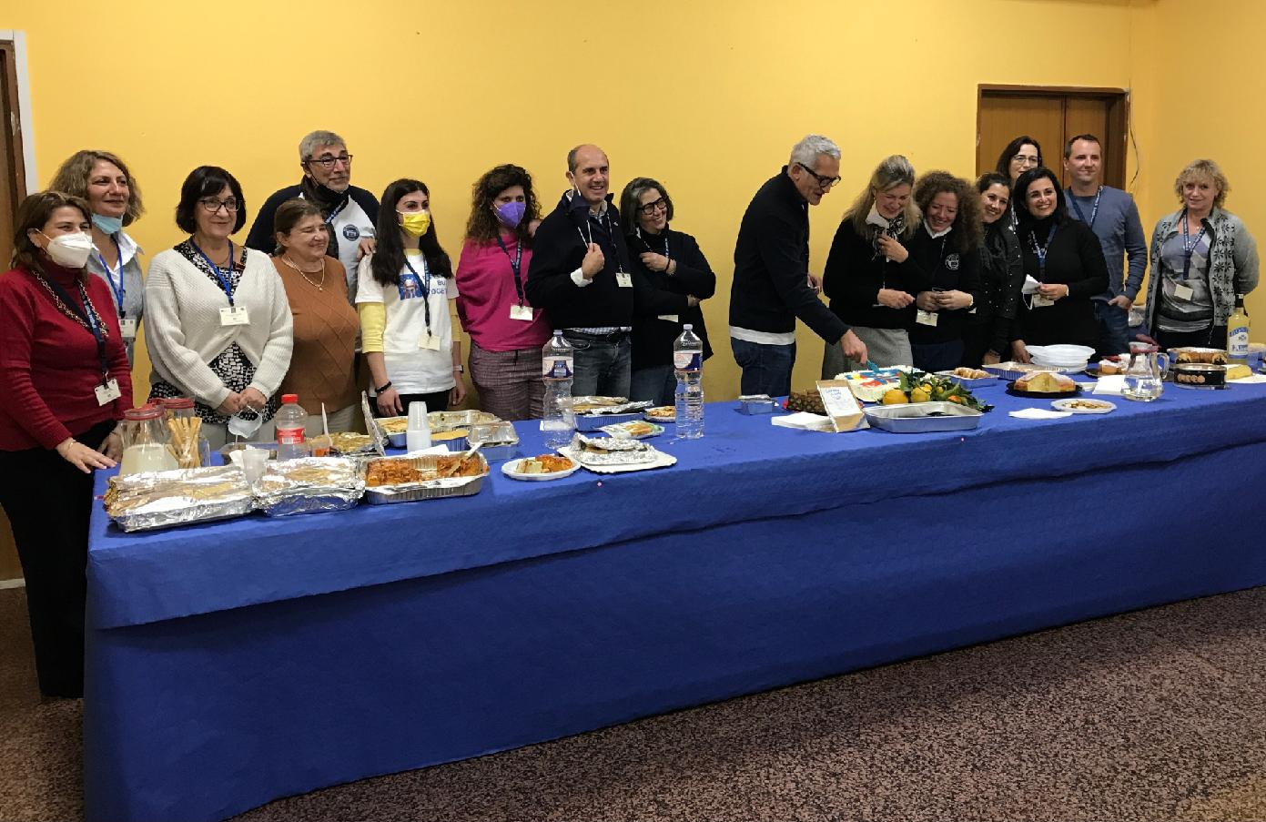

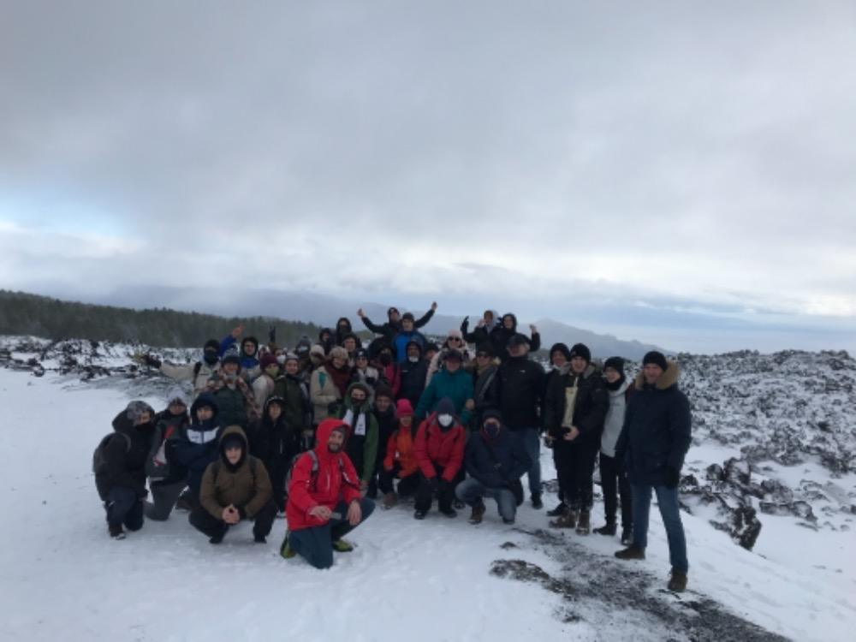

The third day was the culmination of this study activity. Accompanied by professional guides, all delegations went on a lighter hike around the volcano Etna. Along the way, we not only learned interesting information, but we could see with our own eyes the struggle of nature with nature. On the one hand, the volcano devastates to some extent the surrounding nature, but on the other hand, new life emerges on the lava, the soil gradually becomes more fertile, and we have been able to observe new vegetation growing on the lava that helps the economic development of the area.

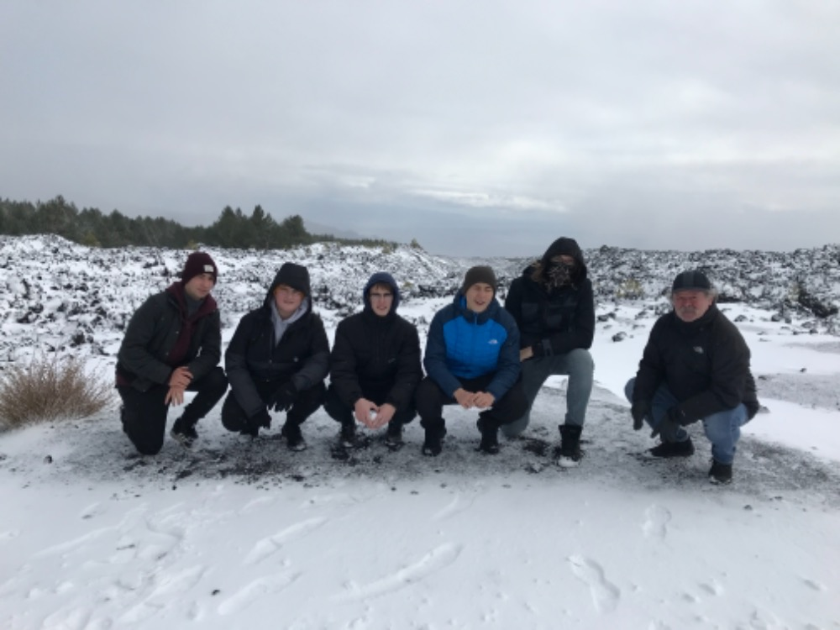

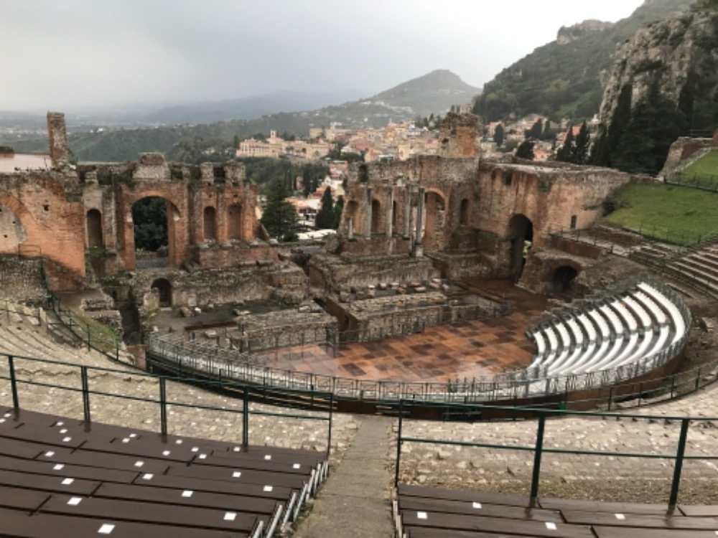

In the second part of the day, we visited the picturesque town of Taormina, where we most admired the Greek theatre and the art of our ancestors. During the day we experienced the alternation of different seasons…..

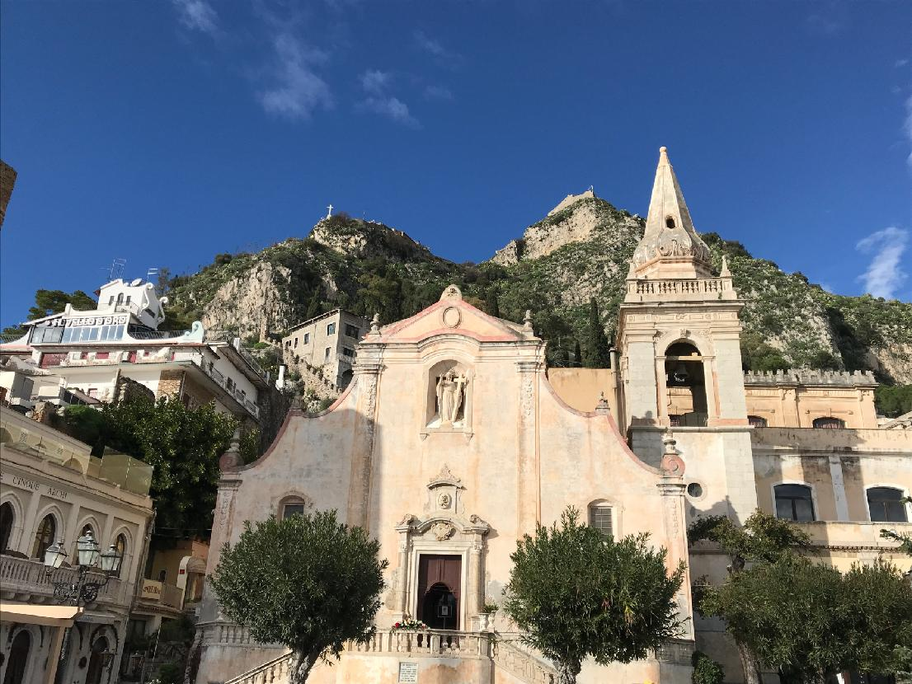

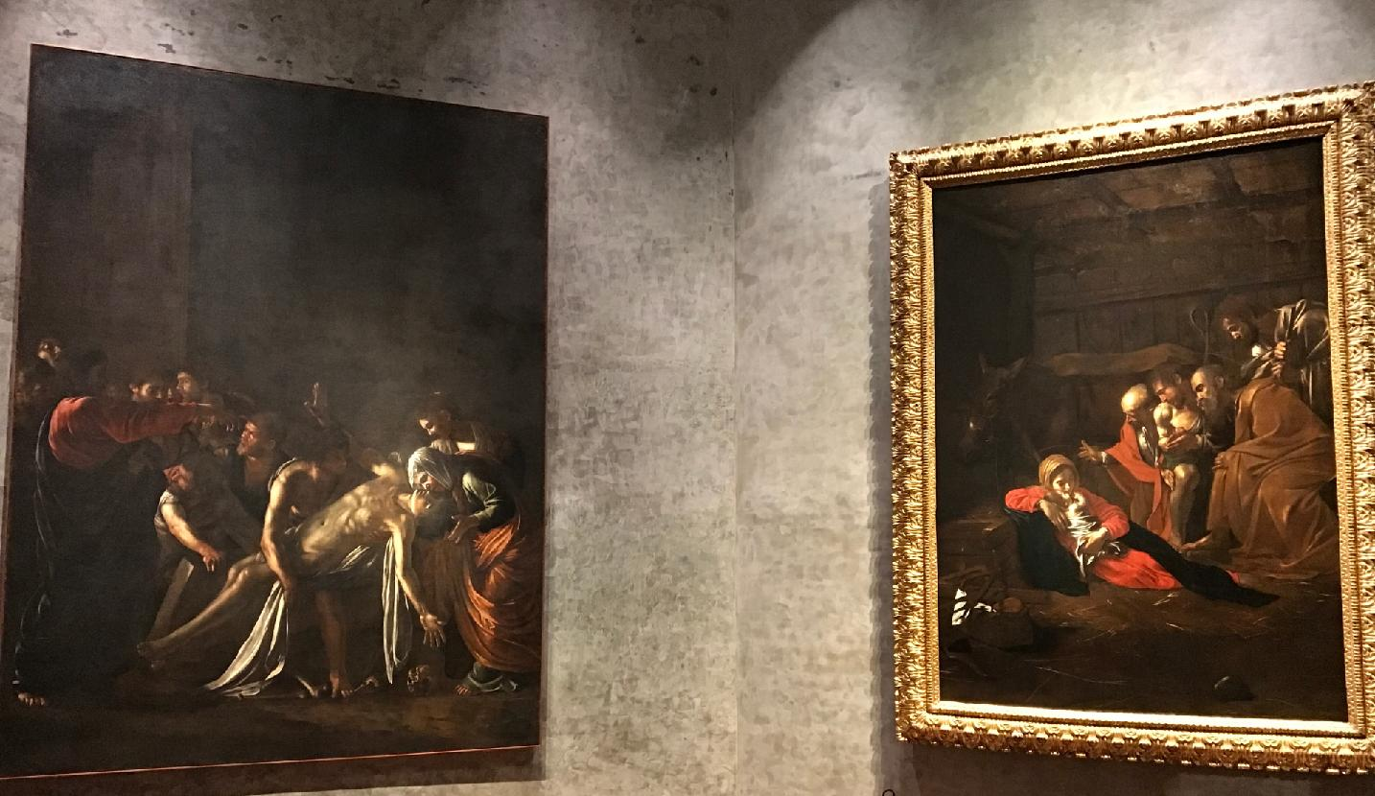
The program of the fourth day was a visit to the museum in Messina, where the project participants not only got acquainted with the history of the city and the area, but also attended a workshop. In international teams, they prepared a digital recording of the tour with their own photos and videos. There was always one student from each school in the team - everyone had their task such as directing, script, camera, editing. The students combined history with modern technologies, language training and teamwork.
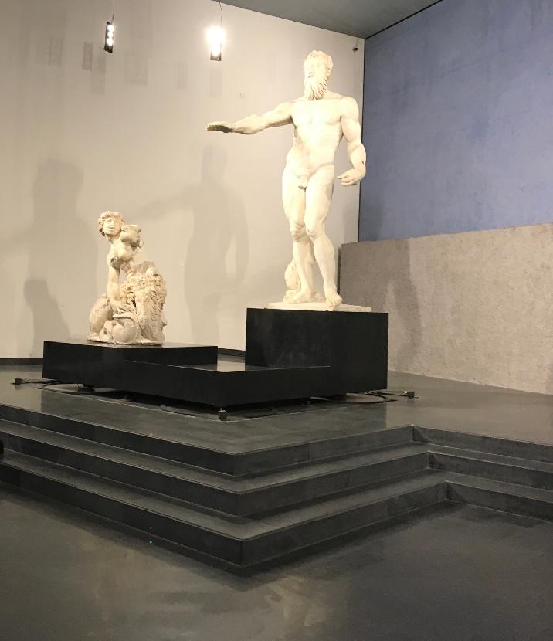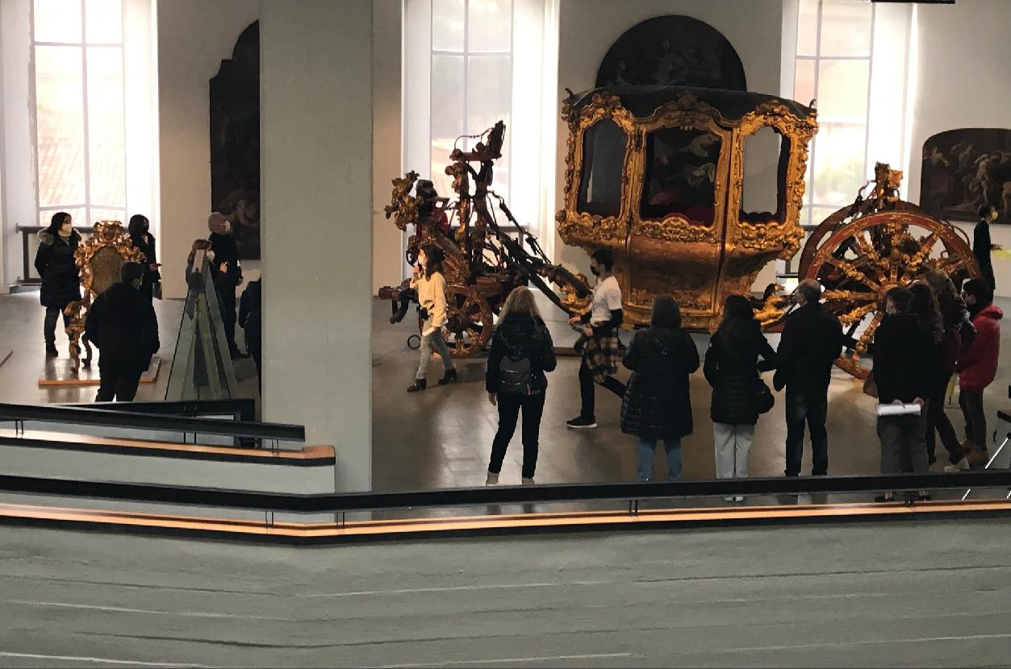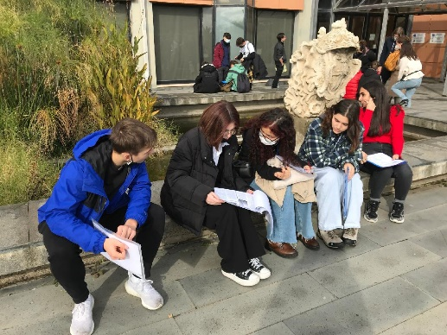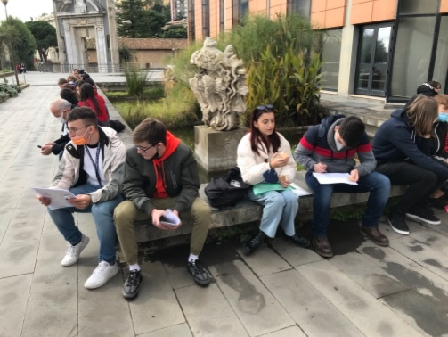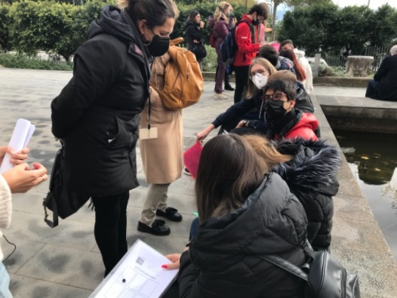
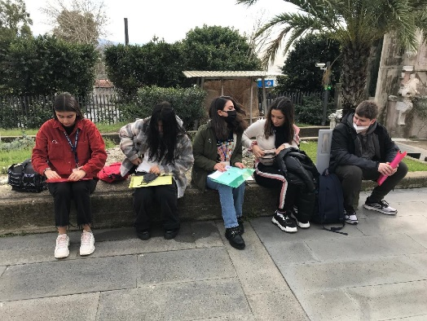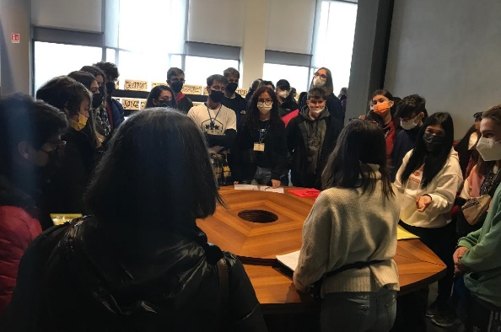
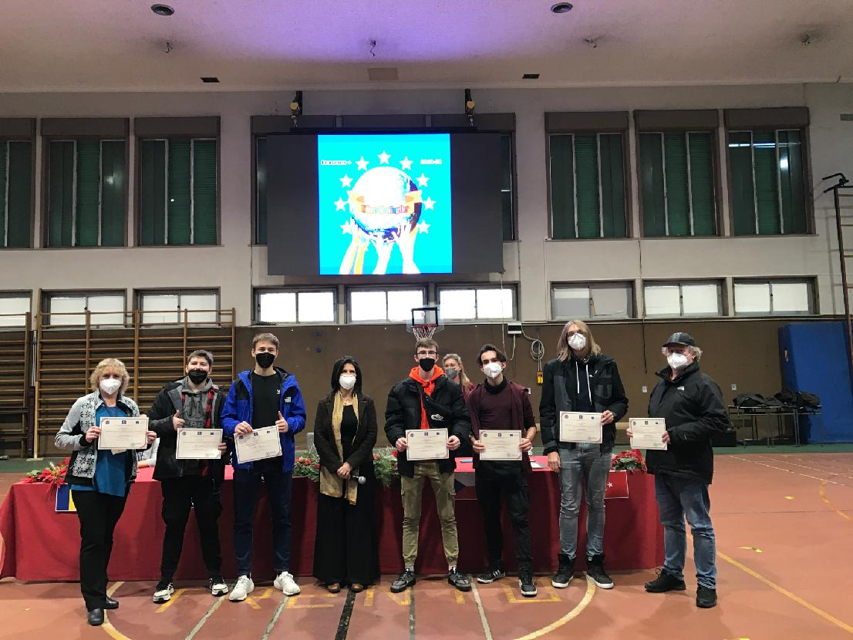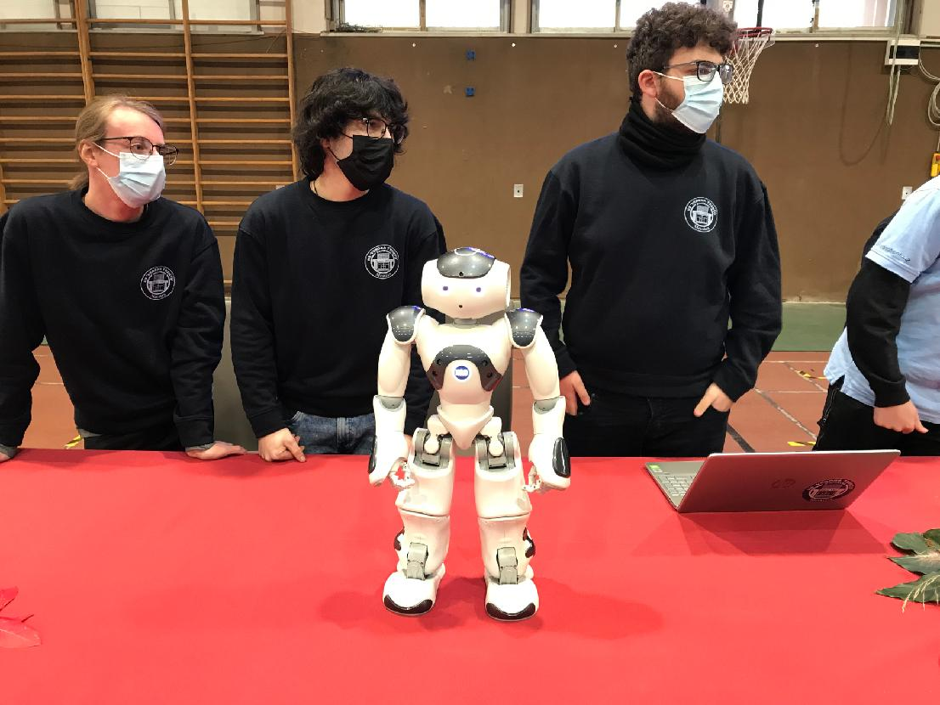
During the last day of the project, the participants received a confirmation of participation from the principal of the Italian school. Participants had the opportunity to get acquainted with the team of students at the school, which introduced the robot and work with it. The final ceremony was a rehearsed performance by students who together demonstrated a 10-minute movement creation, which expressed the main theme of the project "Different, but together".
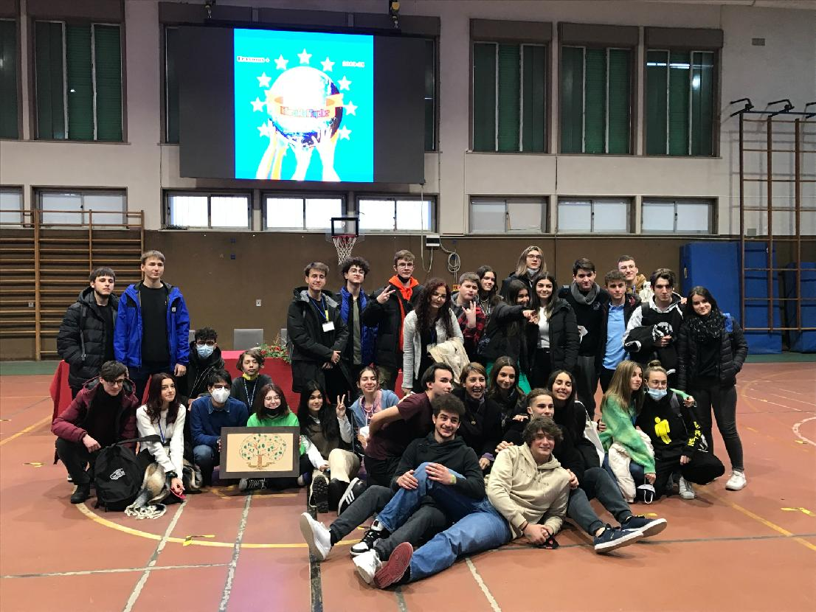
The activity was very successful, and all participants liked it very much. During the week, new relationships developed between both student and teacher participants. They all practiced English, got acquainted with the history, traditions, culture, and food of Sicily, learned to work in an international team, gained new experiences and knowledge.
