VIRTUAL MOBILITY

Primary School no 7
Ostrow Wielkopolski, POLAND

17.5-21.5.2021
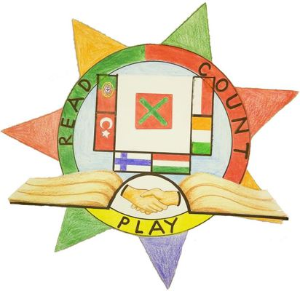

WELCOME TO POLAND!

1. GET-TOGETHER WITH PARTICIPANTS FROM ALL SIX COUNTRIES

Monday 17.5 at 12.30 Polish time

- Short introduction
- Every participating group will get to introduce themselves briefly
- Watch the short film about our town:
https://www.youtube.com/watch?v=YHTCzlyV2BE&t=1s
- Watch the presentation video from our school:
https://www.youtube.com/watch?v=cSnbpZq9trU
- See some basic facts about Poland:
https://www.youtube.com/watch?v=352SS0VnGCA
- Play the Quizziz about Poland
https://quizizz.com/admin/quiz/609cf817022d83001b02ae9b

2. ONLINE ACTIVITIES - GETTING TO KNOW POLAND

Participants may take part of the following activities whenever they want during the week:
*****************************************************************************

- A course in Polish, made by our students
https://www.thinglink.com/scene/1449715538086330371

- Watch a video about our town! Made by Polish TV
https://www.youtube.com/watch?v=YvcGLfvven4

- and one more from birds’ point of view
https://www.youtube.com/watch?v=QmhfmT51pFY

3. Folk Dance Presentations + ONE TO ONE MEETINGS
- During the week, the participating schools will meet two and two, so that each school will meet up with all the other schools. This will provide the students with a chance to interact more actively with each other.
- We will watch each other’s folk dance presentations, learn some nursery rhymes and try to learn some basic words and phrases in our languages.
- The participating coordinators have agreed on suitable days and times.

Meeting schedule (will be revised) -

IRELAND meeting times

Tuesday 9.35 Hungary, 11.30 Turkey
Thursday Finland 11.30
Friday

MADEIRA meeting times

Hungary - Monday - 8:40
General Meeting Monday - 11:30
Turkey - Wednesday 14:00
Finland - Tuesday 10:30
Ireland - Friday 12:00

FINLAND meeting times

Finland- Madeira Monday 11.05 Finnish time
Mia sent Today at 18:58
Finland-Turkey Tuesday 8.45 Finnish time
Mia sent Today at 18:58
Finland-Hungary Thursday 14.35 Finnish time
Finland-Poland (hopefully!) Friday 13.30 Finnish time.
Finland-Ireland Tuesday 25.5 12.15 Finnish time.

TURKEY meeting times

Monday, after general meeting - Poland
Tuesday 13.30 - Ireland
Wednesday 16.00 - Madeira
Thursday 14.45 - Finland
Friday 14.00 - Hungary

HUNGARY meeting times

Monday 9.40 - Madeira
Tuesday 10.30 - Ireland
Friday 9.25 - Finland
Friday 13.00 - Turkey

POLAND meeting times (Polish time)

Monday 12.30 General meeting
Monday 13.15 Turkey
Tuesday 11.30 Hungary
Friday 12.30 Finland

NB: Be careful about the time - double check with your partner if you are not sure about the time!

4. FLIPGRID

Record a 60 second video with information about your thoughts about “Read, count and play” project and add the video to the Flipgrid ( What did you like about the project ? What did you like about online meetings?) Other partners’ students can respond to the videos on Twinspace. We will add our videos during the week and also encourage our students to go on to Flipgrid to watch and comment on other students’ videos.

https://flipgrid.com/38d63d91

The guest passcode is: Readcount&play1

5. Collective story
Students can check their understanding of the story by plying Kahoot game.

https://create.kahoot.it/details/b70c6fb2-8afe-475d-97a2-c756e63a1cdd

They can also illustrate the story using traditional or digital tools. Each country illustrates one chapter.
Portugal - chapter 6
Poland - chapter 5
Ireland - chapter 4
Turkey - chapter 3
Hungary - chapter 2
Finland - chapter 1

7. We have learnt a lot
Play Quizizz game to check how much do you remember about partner countries.
https://quizizz.com/admin/quiz/609905a6b3bd7f001b5e4951

