ITINERARY FINLAND 14/15.3-19.3

ARRIVALS & DEPARTURES
Country | Arrival day | Time | Where | Departure Thurs.
Hungary (7) | Saturday | 17.35 | Vaasa Airport | 14.45
Ireland (5) | Saturday | 20.40 | Vaasa Airport | 6.45
Turkey (6) | Saturday | 21.54 | Pännäinen Train station | 9.22
Portugal (5) | Sunday | 12:08 | Pännäinen Train station | 5:45
Poland (6) | Sunday | ca 19.30 | Kokkola-Pietars. Airport | ca 11.00
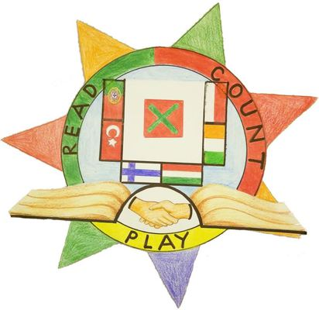

Saturday 14.3
17.35 | Hungary arrives in Vaasa
20.40 | Ireland arrives in Vaasa, shared taxi w. Hungary to Nykarleby. Arrival ca. 22.00
21.54 | Turkey arrives in Bennäs

Sunday 15.3
8.30 | Breakfast at Kredu
9.30 | Morning walk to Stjärnhallen sports centre: Floorball & other games
12.10 | Madeiran group arrives in Bennäs
12.30 | Lunch
13.30 | Outdoor activities
15.00 | Candy-making workshop
18.00 | Pizza night at school
~20.30 | Poland arrives

Budget: Ca. 15 euros for lunch, ca. 10 euros for dinner
Activities are free and no transport is needed (except for Portugal and Poland).
Monday 16.3

7.30 | Breakfast at Kredu
8.30-10.00 | Welcome ceremony, ice-breaker games and a guided tour of our school
10-11.15 | Students:  1. Cooking, part one at Stjärnhallen  2. Ice-skating at the Komarov Arena  3. Crafts project
Teachers:
Coordinators’ meeting + jobshadowing
11.15 | Lunch
11.50-13.15 | Students:  2. Cooking, part two  3. Ice-skating at the Komarov Arena  1. Crafts project
Teachers:
Coordinators’ meeting + jobshadowing
13.15-14.30 | Outdoor activities: Sledding and skiing  (Plan B if terrible weather: Indoor activities)
14.30 | Snack time, coffee/tea at Stjärnhallen sports centre
 | Time to walk back to Kredu to rest, hang out in Stjärnhallen or go buy sweets in town. ;)
16.00-18.00 | Students and teachers:  3. Cooking, part three  1. Ice-skating at the Komarov Arena + set the tables  2. Crafts project + set the tables
 | Teachers: Coordinators’ meeting
18.00 | International dinner!
- watch cooking videos
- games
Exact times may be changed!
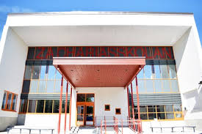
Budget: 0 euros (lunch, afternoon snack and dinner is on us)
Tuesday 17.3

7.30 | Breakfast at Kredu
8.30-11.05 | Morning walk to Kuddnäs Museum  The group will be split in half and take turns:  Guided tour of the museum + parallel activity (games)
Teachers: Coordinators’ meeting during the second half
Possibly time for job-shadowing
11.05 | Lunch at school
11:50-13.00 | School activities
 | Teachers: Coordinators’ meeting and job-shadowing.
13.15 | Bus leaves for Fäboda
13.45 | Fäboda beach:  Walk on the ice (or, if no ice, in the forest)  Making campfire bread on a stick  Snowball fight or other games
 | (+ Not confirmed activity, will be updated later.)
16-18 | Ice-bathing and sauna  (16-17 for women only, 17-18 for men and women)
18.00 | Dinner at Strandis
 | Back to Nykarleby by bus

Budget:
Kuddnäs Museum - free of charge
Lunch at school - free of charge
Bus transport 50 euro/team
Ice-bathing, sauna + dinner 20/25 euro/person
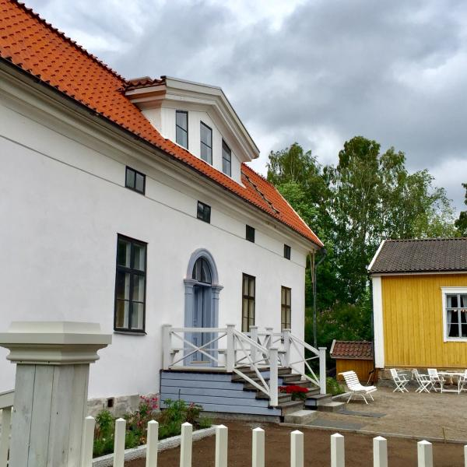
Wednesday 18.3

7.30 | Breakfast at Kredu
8.30 | By bus to Juthas Farm for a farm visit  (The farm is a visitors’ farm owned by the parents of one of our Erasmus students. They have llamas, sheep, mangalitsa pigs, ordinary pigs, poultry, two donkeys, a horse, rabbits…)
10.15 | The bus leaves for Seinäjoki
11.30-16 | Duudsonit Activity park, Seinäjoki  Lunch at the activity park is included in the offer we got.  Time for shopping and cafés at Ideapark shopping mall.  Duudsonit Activity Park is attached to the shopping mall so it is possible to decide with your students when you want to leave the activity park and go shopping instead. It is also possible to go back to the Activity Park if you keep your ticket.
16.15 | Bus leaves for Nykarleby
18.00 | Dinner at Kredu
 | - karaoke, games and fun

Budget
Bus - 42 euro/team
Farm visit - free of charge
Duudsonit Activity park - 24,50 or 27,50 for students. Teachers pay only for lunch.
(lunch included)
Dinner - 20 euro

Thursday 19.3

Time to say goodbye…

*********************************************************************************************************
While waiting for March to be here: Have a look at our crash course in Swedish!

https://www.thinglink.com/scene/1282707946559504385

