“The Future Begins Today”
Project KA229 2018-1-PL01-KA229-050749

The first debate in a nearby school in Croatia

On 24 September 2020 a teacher from Popovac Primary School Samanta Velemirović shared our project's aims and held a debate on the first part of the movie “Dreams come true” in Dr Franjo Tuđman Primary School in Beli Manastir.
After the debate they pantomimed their future occupation, and the other pupils guessed what it is. They found out that there are pupils in their class who want to become doctors, car mechanics, teachers, physiotherapists, musicians, soldiers...

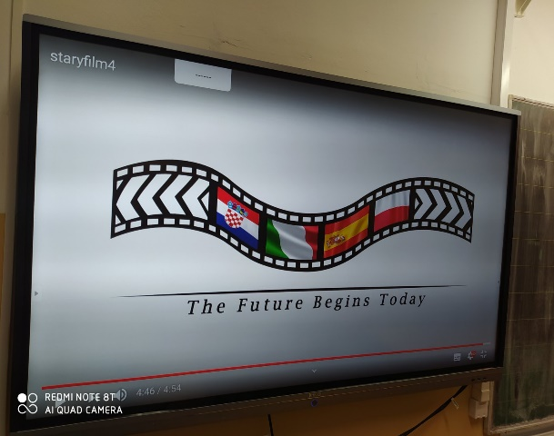
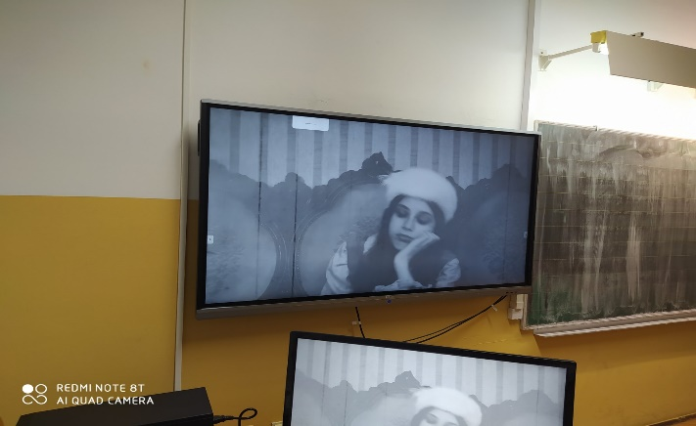
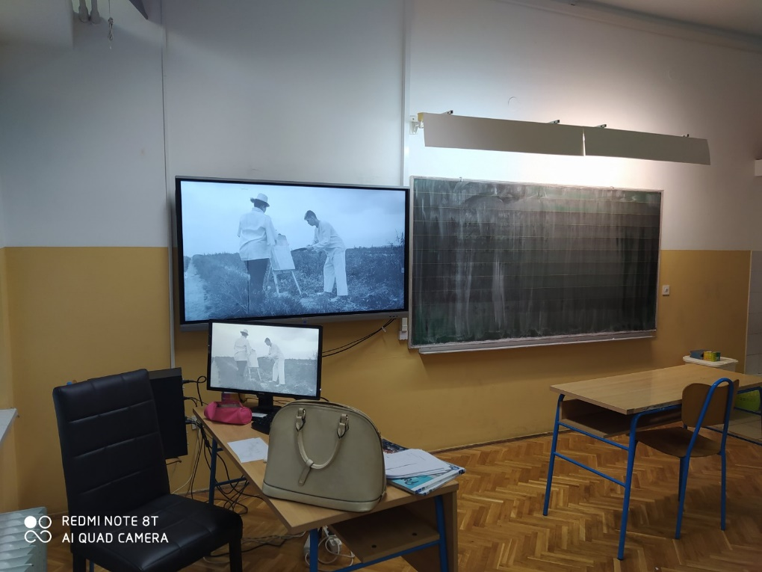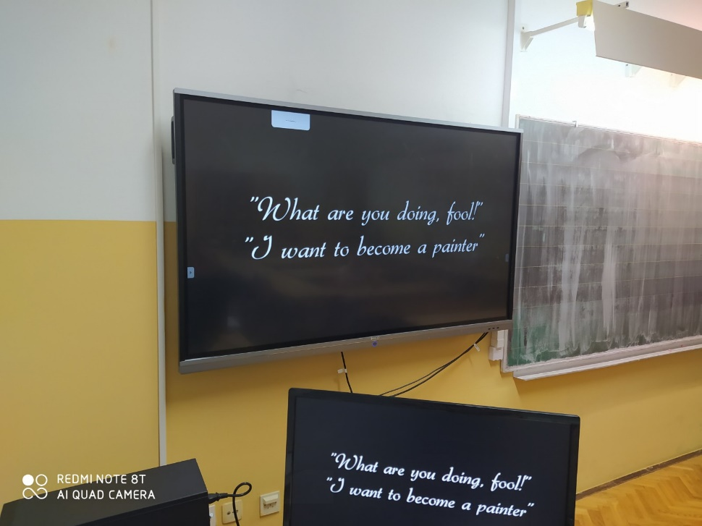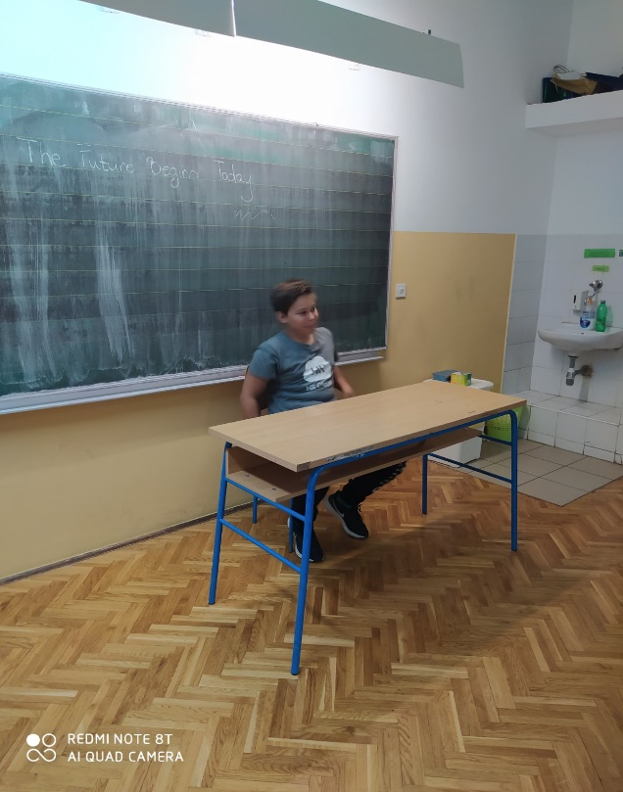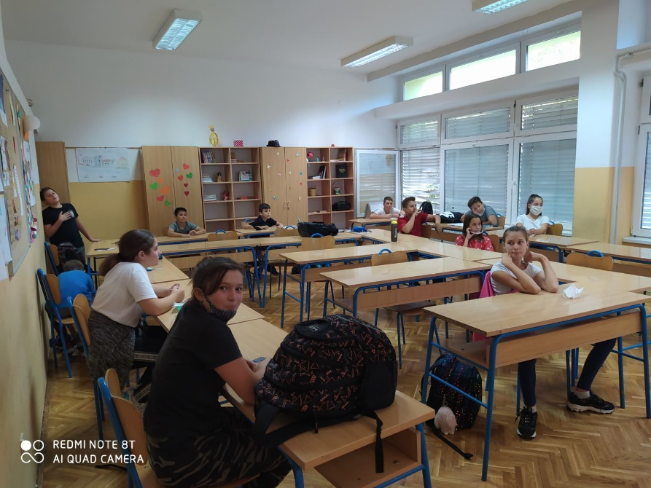
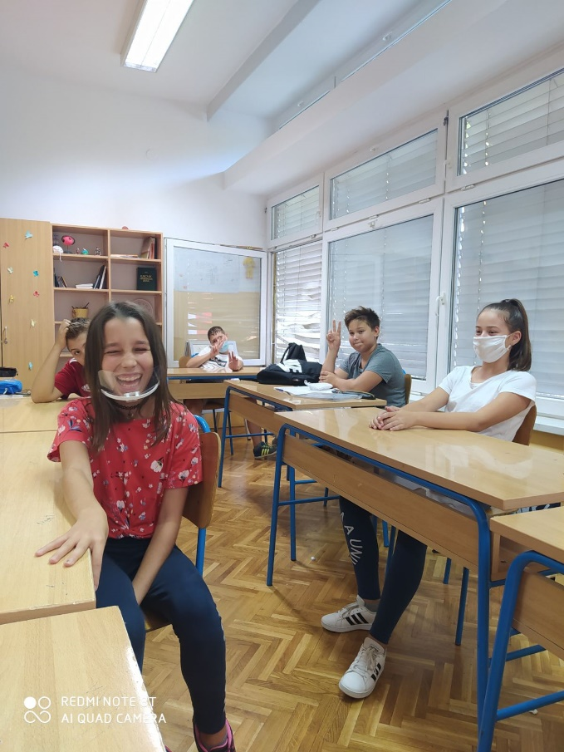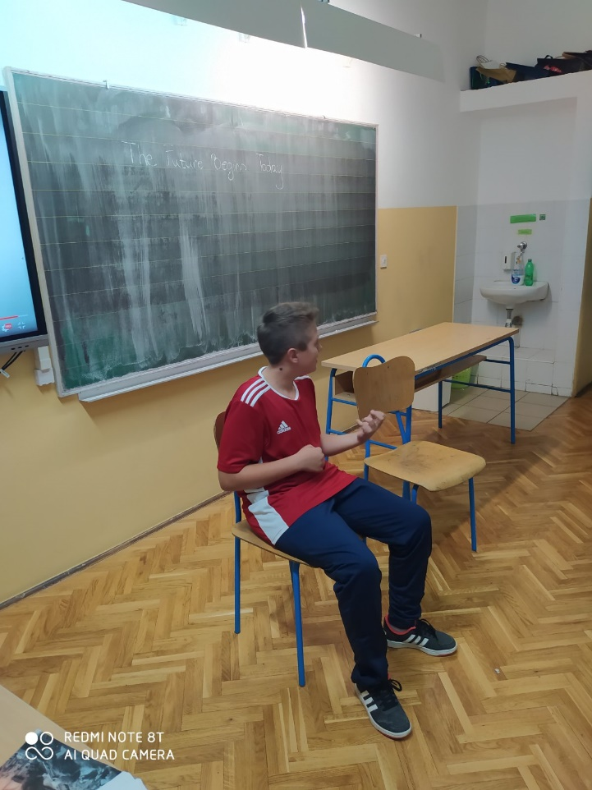

The second debate in a nearby school in Croatia

The students of the 3rd grade of the Second High School in Beli Manastir were shown the film "Dreams come true", shot as part of the Erasmus + project The Future Begins Today, in which Popovac Primary School is also a participant. In the introductory part of the lesson, teacher Ena Sabolek Šipoš
stated the main goals of this project, and after the screening of the film, a debate was held on the topic of choosing occupations and problems that young people encounter during this important step in life. As the biggest problem, the students stated the opposition of the wishes of young people on the one hand and the expectations of parents on the other. The students gave their examples and presented possible solutions to this problem. At the end of the debate, it was concluded that it is important to follow your dreams, never give them up, because the best job is the one that is done with the heart!