DAY 1 (Sunday, 20th October 2019)
Today Elementary School Popovac welcomed the students and teachers from Poland, Spain, and Italy who are participating in the Erasmus+ project “The Future Begins Today”. Our guests have arrived in the afternoon or during the night. They have been welcomed by the school principal Jadranka Sabljak, our teachers and the parents of our students who will host the students. After the introductions and first impressions, our guests had a welcome dinner at school. After that, the guests left for the host families homes to get enough sleep for the exciting week ahead of them, full of interesting activities and lots of socializing. We are happy all our guests have arrived and we can’t wait for tomorrow and all the activities ahead of us.

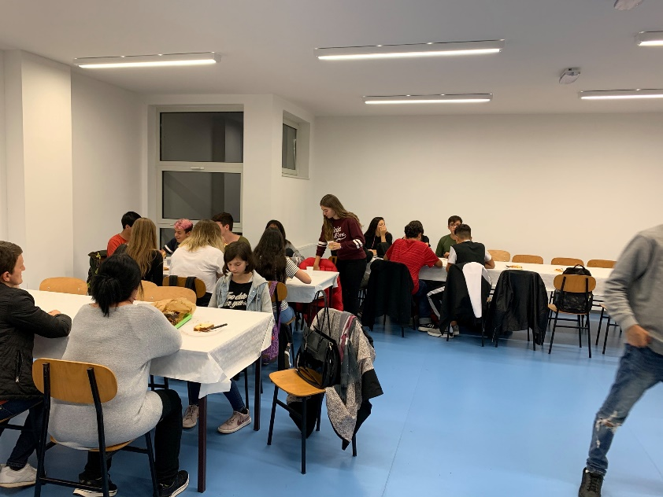

DAY 2 (Monday, 21stOctober 2019)
Our well-rested guests from Poland, Spain, and Italy have arrived at school at 10 a.m. and we handed out accreditations. After that, the students from Popovac had a welcome show combined with the Bread Day celebration. Our municipality mayor Zoran Kontak came to wish a warm welcome to our guests. The local women association “Maska” made homemade štrukli (strudels) so our guests could enjoy the local cuisine. After the show, the students participated in introductory games. After the games and lunch, our guests went on a tour around Popovac. They have seen all the sights of our small, but beautiful village. After the tour, we rested before the first workshop. Teacher Lidija Štimac introduced our guests to traditional Slavonian and Baranja dances in her workshop “Plesom po Slavoniji I Baranji / Dancing through Slavonija and Baranja”. They learnt the steps and even danced. The day ended by going back to the host families. We need a lot of sleep to recharge our batteries because tomorrow we are having a day filled with activities and interesting contents.
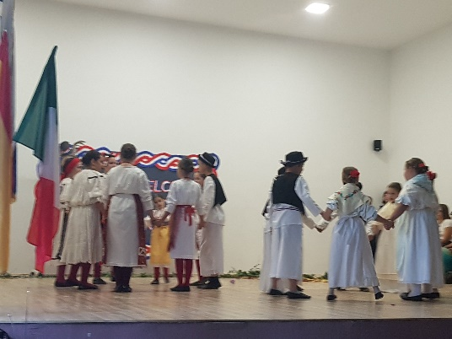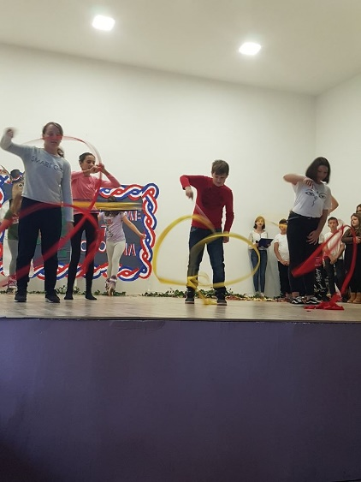

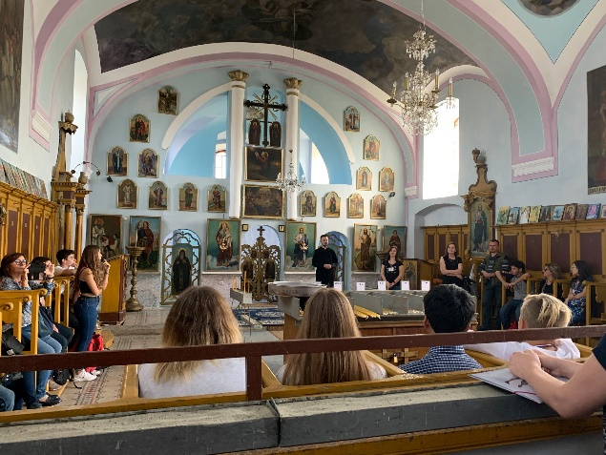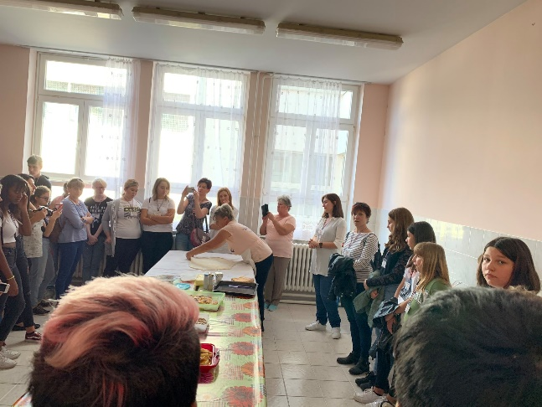
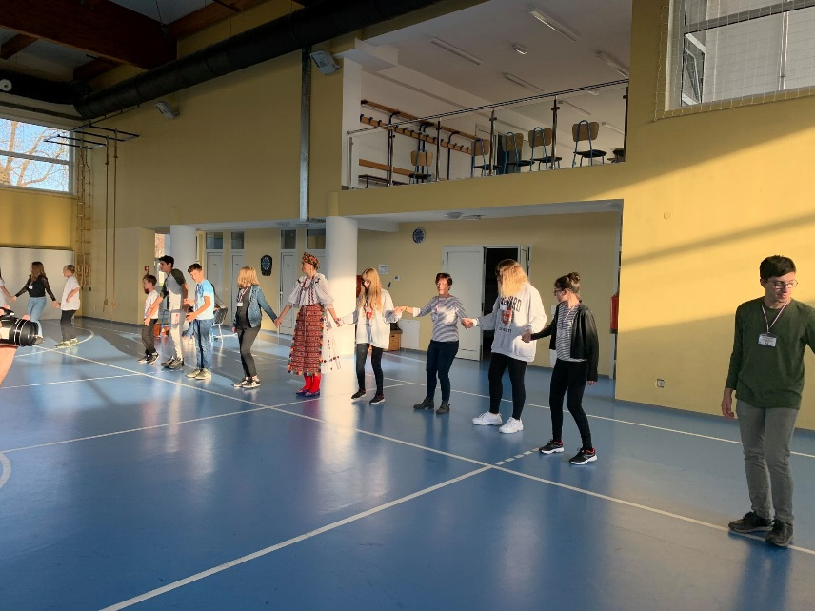

DAY 3 (Tuesday, 22nd October 2019)
Our guests have adapted well, so we decided that Tuesday was perfect for a trip! In the morning our students went to Osijek, the center of the Osijek-Baranja county, the beautiful city on the river Drava. While exploring the city, we introduced our guests to Osijek’s history and sights.After taking photos at Ante Starcevic Square, we visited the St. Peter and Paul Cathedral, the
Old Town-Tvrđa and the Museum of Slavonia Our guests were taken away by the beauty of the city and rich cultural and historical heritage. After Osijek, we went to the ethno- village Karanac, where time has stopped. While walking through the village, we took our guests back in time to the “time of our ancestors”, showing them a traditional kitchen, barbershop, forge, etc. We also visited the indigenous rural household “Baranjska kuća” where we had a tasty lunch. After Karanac, we went to Beli Manastir where we visited the “History of Ethnology Center of Baranja’s Heritage”. Together we admired all the treasures of Baranja’s heritage. In the evening, we returned to Popovac where we had dinner and a party for our guests, with karaoke to complete this amazing day. Satisfied and a little bit tired, our guests went to the host families to get some rest.

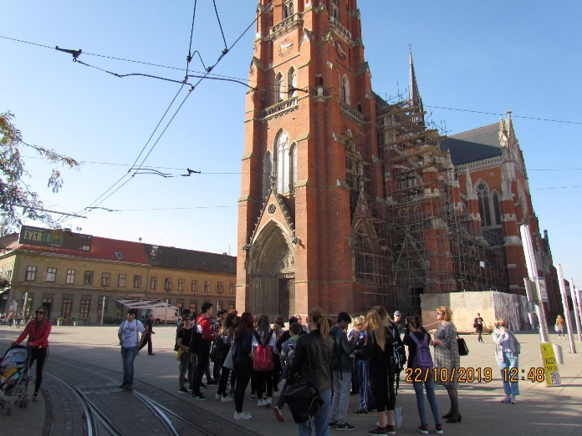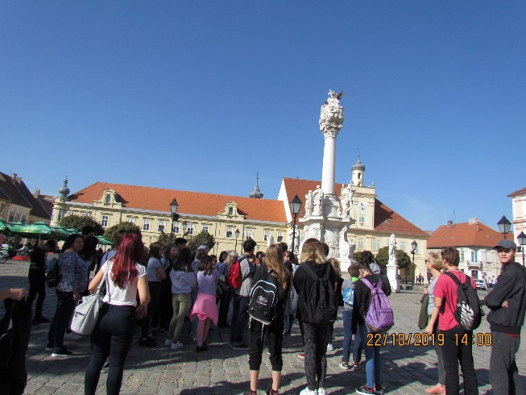
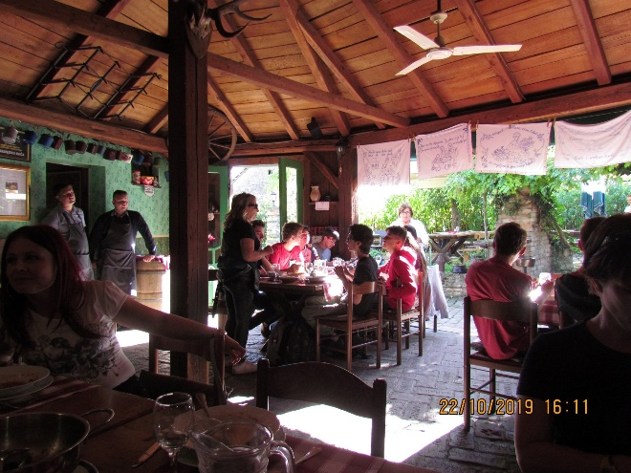

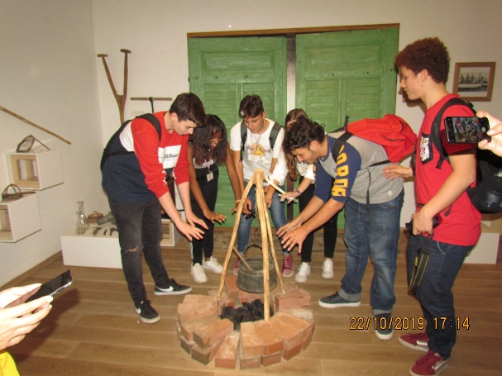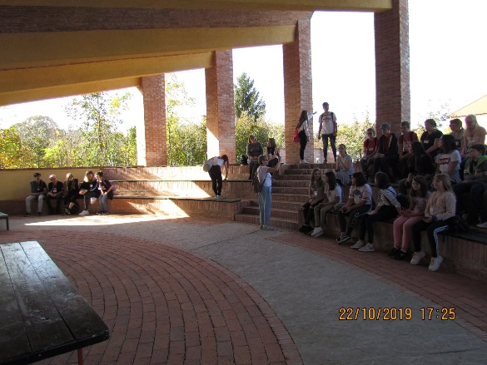

DAY 4 (Wednesday, 23rd October 2019)
The fourth day was dedicated to creative workshops. Before that, we planted a friendship tree which will be a beautiful reminder of this project and our new friendships. The students exchanged their impressions, by retelling the best moments and activities which will be the memories we will cherish. Our guests started with the workshop from teacher Martina Vidak called “Musical Creators” where they used different materials to make musical instruments. The workshop in the school gym got us some exercise to prepare us for our new adventures. After the lunch break, we continued with the workshops from teachers Suzana Vencl and Dina Lukić. The students learnt how to play a musical instrument and make an animated film. We can proudly say that with the activities and workshops we had a lot of fun and also learnt a few things. By hanging out, we exchanged our experiences and ideas. After a break, we started the preparations for the filming of our film “Dreams come true” with our Polish guests, which will be filmed tomorrow. The day ended with the guests going to the host families.

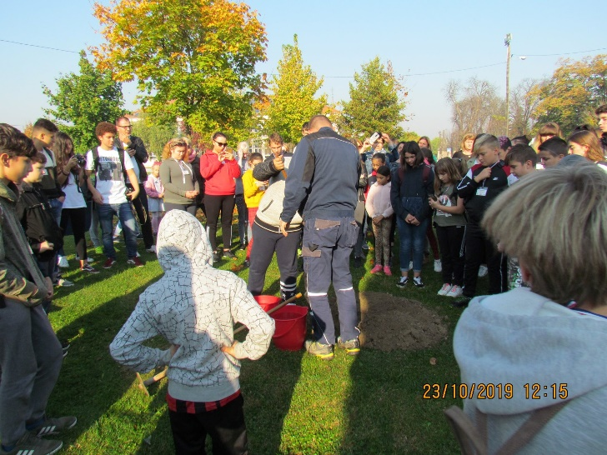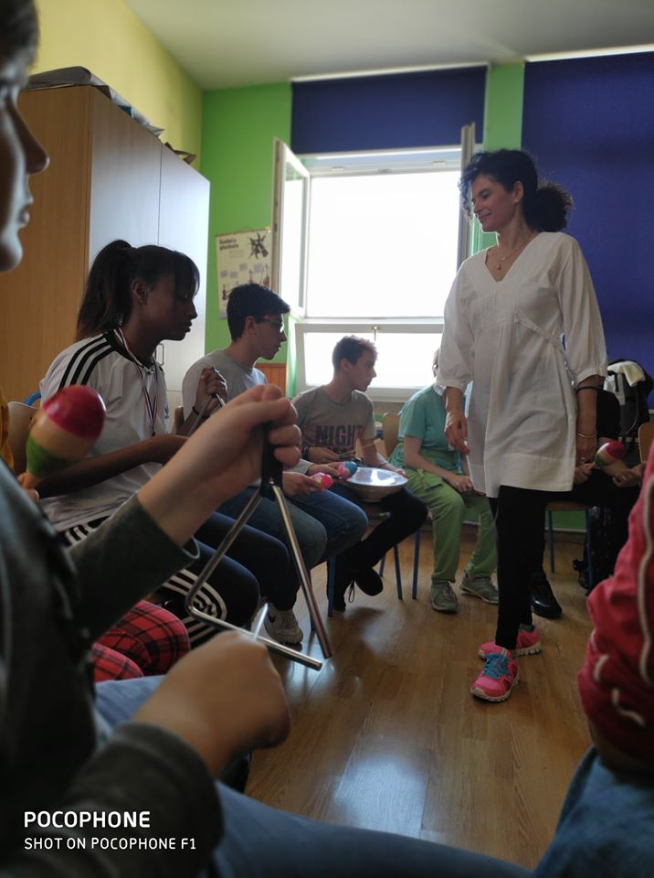
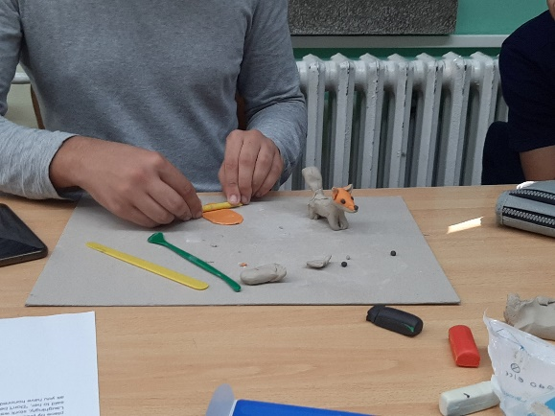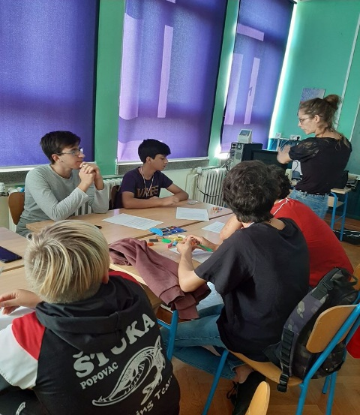

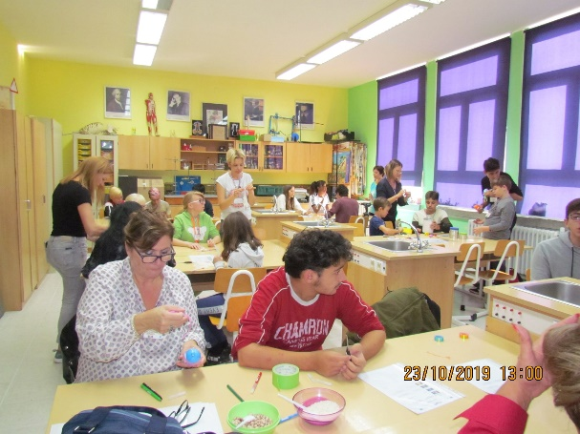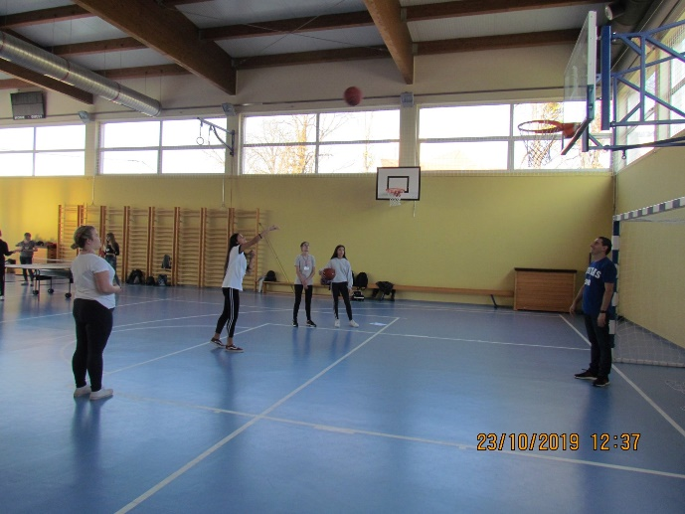

DAY 5 (Thursday, 24thOctober 2019)
After the initial morning activities, we started filming our film “Dreams come true” with our guests from Poland. They made us glad by showing us that our homeland is their dream journey. Our students have shown Mexico as the country that they want to visit in the future. Students from Spain wanted to travel to the USA and students from Italy to Japan. This was an excellent experience for both our students and our guests where they have proven that they are great actors. Who knows, maybe we will get some new actors. Our guests had a lunch break and continued to the creative workshop from teacher Anita Raguž called “Hobby clubs”. Since we are going on a trip tomorrow the participants got their certificates today. After the workshop, the students went home to spend some more time with the host families and prepare for the trip to Zagreb. The project coordinators had a meeting about the upcoming mobilities because planning and organizing ahead is the main key to success.

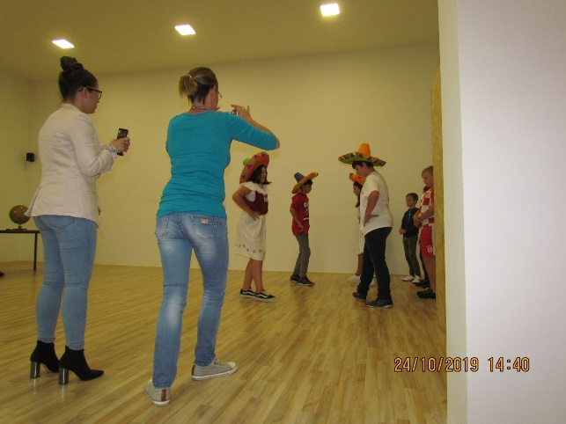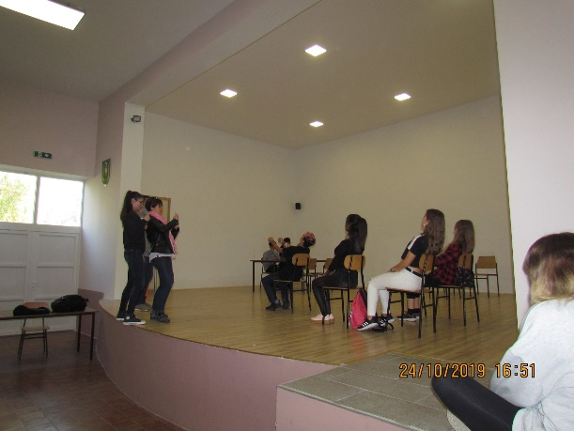

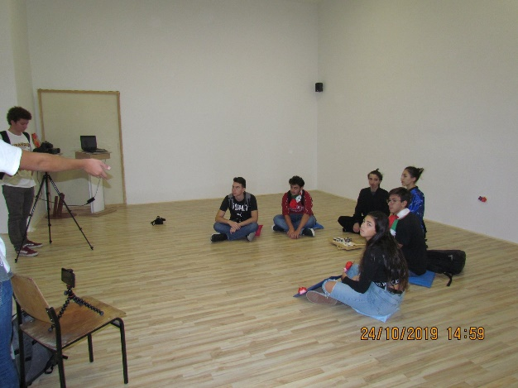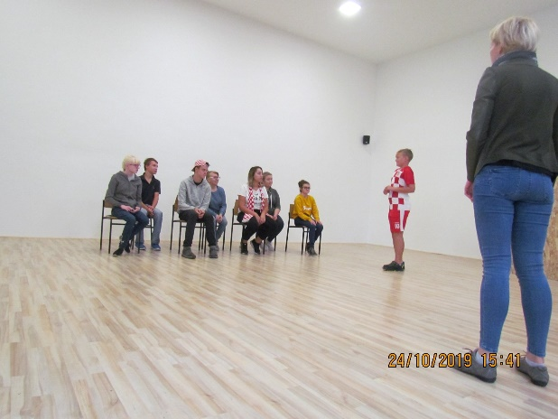
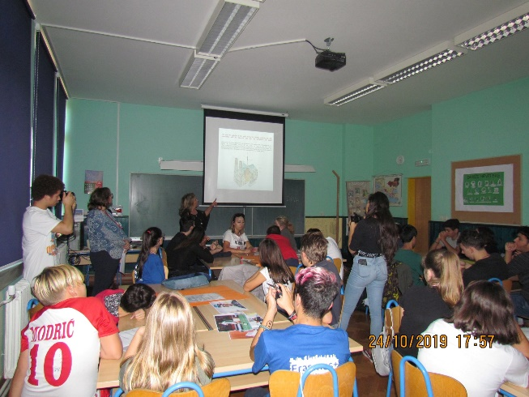

DAY 6 (Friday, 25th October 2019)
In the early morning, we headed towards Zagreb- the capital of Croatia. We all were excited to visit the capital of Croatia with over 1 million inhabitants. The trip did not last long because we used the time to talk about the previous days and activities. Our guests couldn’t wait to see Zagreb because they know it is the most beautiful Advent destination in Europe. When we arrived we visited the Ethnographic museum which houses the biggest collection of traditional Croatian costumes and fabrics. After lunch, we went sightseeing to see the most famous sights of Zagreb. Of course, we set aside some free time so we could explore the city on our own, get refreshments and buy souvenirs. We handed out the certificates to all the people who participated in the project because we had to say goodbye to our friends from Spain who went home. We went back to Popovac in a smaller number than before. We came late in the evening, a little bit tired but still impressed by Zagreb and its beauties.
We were very sad because we had to say Goodbye to our friends from Catalonia,Spain.

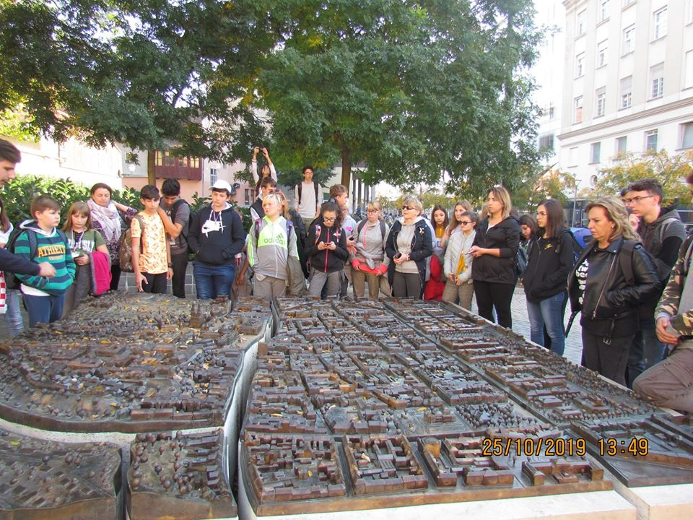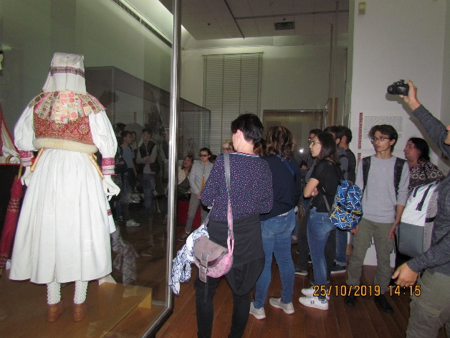
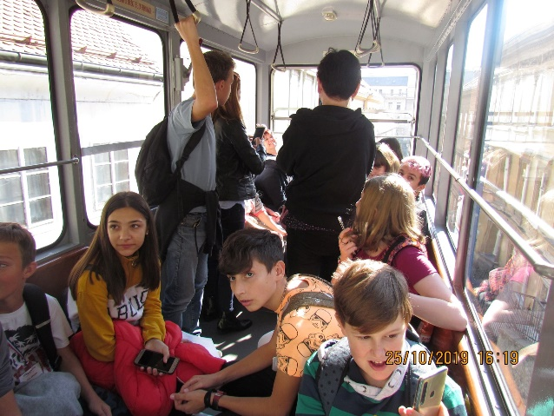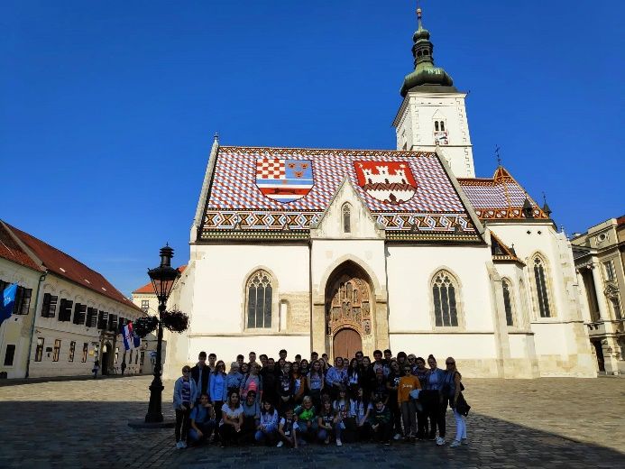

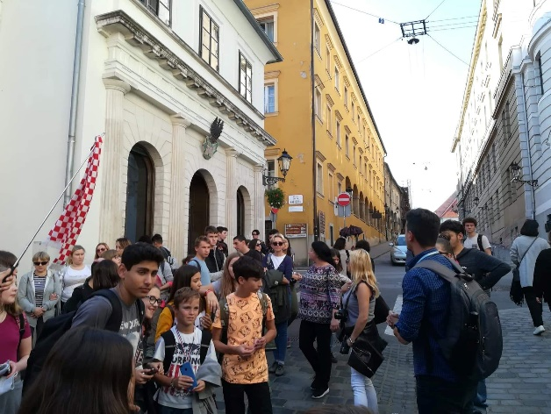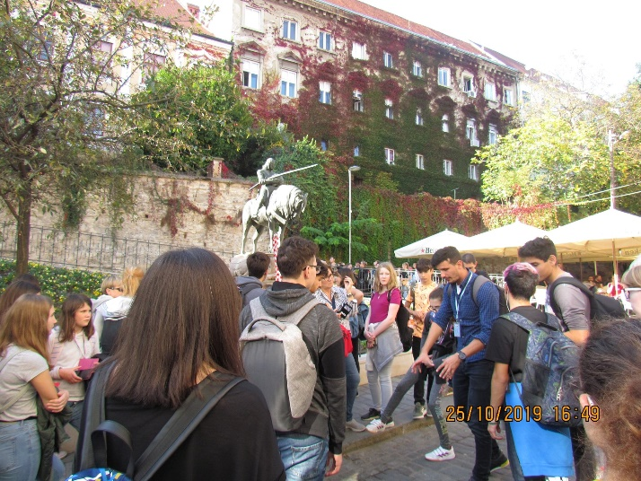

DAY 7 (Saturday, 26th October 2019)
All the good things must come to an end. The moment came and we had to say goodbye with the rest from our guests from Poland and Italy. We are ending this beautiful week with all the best praise for our guests. The teamwork and communication was on a high level. We learnt a lot and prepared for all the future activities in the project. We are overjoyed that our school was able to be the host to the Erasmus+ project “The Future Begins Today”. We thank all the participants and we hope that our guest had a nice week in our country. We can’t wait for the new activities, travels and our time together.

