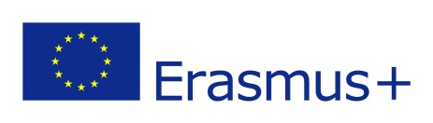
Project: «The Future Begins Today!»
EVALUATION for pupils from Poland
Virtual mobility 24.05.2021-28.05.2021.
The final results
1. White Hat (data and information)

Introductions, presentations of invited schools from Poland and Croatia about themselves, their schools, watching a film about the host school in Italy, discussion on the effects of Covid19 on the future, presentations of various volunteer activities, presentation of the results: a student's guide, the film "Dreams come true" , reportage from all mobility

2. Red Hat (feelings and emotions)
As for feelings and emotions during the meeting were the following:

- fear at the beginning (we were supposed to translate our statements using the translator ourselves), I didn't know if I could handle it, - curiosity - many students from other schools, not only from partner countries, participated in the meetings; - pride - I managed to translate using translators; - joy - I saw myself perform in the film;

3. Yellow Hat (benefits and positive view)
Benefits and positive view:

I found out where to find information and advice on getting a job. I saw colleagues from other countries. I was able to tell you about my role in the movie "Dreams Come True".

4. Black Hat (critical judgment)
As for critics there were some things:

I couldn't always hear everything well.

5. Green Hat (creative thinking and new ideas)

I think we have heard many interesting stories about how our peers in other countries deal with isolation due to Covid 19. The student's tutorial can be translated into many languages, it will be useful for others.

6. Blue Hat (process control and thinking)

I think it was successful mobility. I wish I could actually go to Soverato.

Thank you!

