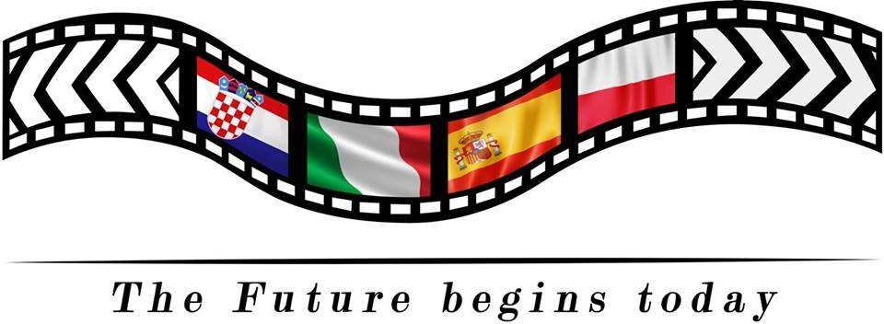

Project: «The Future Begins Today!» EVALUATION for teachers from Italy Spain/10/02/20 – 14/02/20
The final results

1. White Hat (data and information)
As for data and information about training in Spain, our partners mentioned the following events:
- Students attending an English lesson to learn about job expectations
- Welcome Cerimony with folklore, music and dance
- Students' presentations about interpersonal relations
- Visit at vocational school
- Tour around Manresa with mobile game
- Visit to AMPANS SEN school
- Guided visit to Barcelona
- Students reporting on visits to workspaces
- Workshop "get to know yourself”
- Training on Europass creation
- Role play on job interviews
- Recording the last scene of the film

2. Red Hat (feelings and emotions)
Sensations:

- Pure emotion: the visit at Sen school
- Strenght: We felt we realized a strong partnership
- Friendship: the realization of an effective feeling of empathy

3. Yellow Hat (benefits and positive view) Benefits and positive view:

- Sharing cultural traditions in dance, music, food
- Improving entrpreneurship spirit

4. Black Hat (critical judgment) As for critics there were some things we did not like:

1. some rehiteration in disseminating activities

5. Green Hat (creative thinking and new ideas)
- Realization of the possibility of creating new partnerships together

6. Blue Hat (process control and thinking)
The project has been resulting with a growing impact in the teaching methodology

Thank you!

