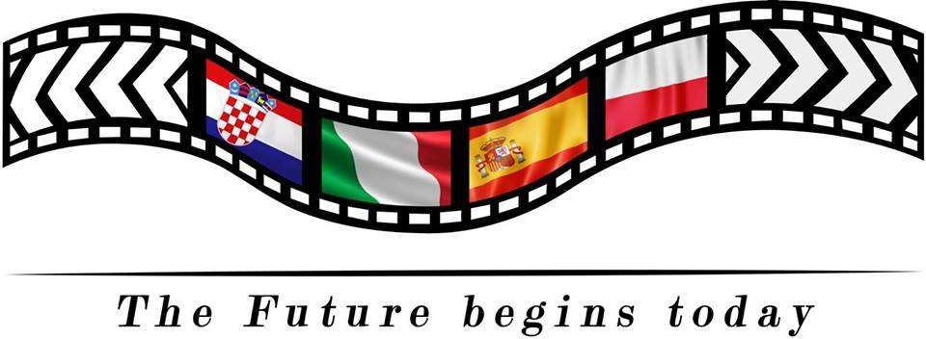

Project: «The Future Begins Today!» EVALUATION for students from Italy Spain/10/02/20 – 14/02/20
The final results

1. White Hat (data and information)
As for data and information about training in Poland, our partners mentioned the following events:
- Students attending an English lesson to learn about job expectations
- Welcome Cerimony with folklore, music and dance
- Students' presentations about interpersonal relations
- Visit at vocational school
- Tour around Manresa with mobile game
- Visit to AMPANS SEN school
- Guided visit to Barcelona
- Students reporting on visits to workspaces
- Workshop "get to know yourself”
- Training on Europass creation
- Role play on job interviews
- Recording the last scene of the film

2. Red Hat (feelings and emotions)
As for feelings and emotions during the meeting were the following:

- Tenderness: We visited Sen school
- Joy: we tasted Sangria
- Wonder: we visited Barcelona
- National Pride: we appreciated Catalan pride

3. Yellow Hat (benefits and positive view) Benefits and positive view:

- Feeling entrepreneurs
- Enhancing English and Spanish languages
- Improving our creative skills in the workshops

4. Black Hat (critical judgment) What we could have done better:
1. being more united with Polish students

5. Green Hat (creative thinking and new ideas)
- We could have taken part in vocational labs as well

6. Blue Hat (process control and thinking)

We are so grateful for joining Erasmus mobilities. We wouldn’t have had otherwise the possibility of visiting such wonderful places and to meet new friends

Thank you!

