Bonjour!
Me llamo Laura Pérez cervantes, tengo 16 años, soy alta, tengo el pelo castaño, los ojos marrones. Practico baile asturiano y me gusta montar a caballo.
I´ m a student at Emilio Alarcos high school, in the third year of compulsory secondary education. My high school is big; it has got three floors, one assembly hall, one Coffee Shop, one gym, one library, three computer rooms. My class is fun but sometimes a little bad; my colleagues often act out and are usually a little tiresome.
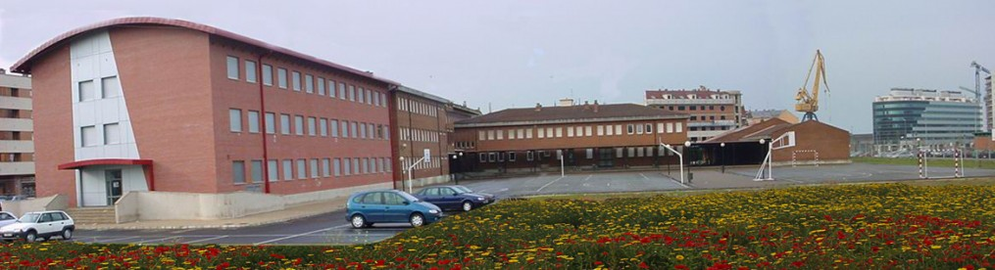

¡HASTA LUEGO !

