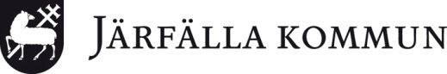

Course organizer: JÄRFÄLLA KOMMUN and CEE AUTO-LEARN
Christina Erenvidh
christinaeren@gmail.com
Text:+46704401701
SWEDEN

Training course, 2 days –
Erasmus PLUS project 2017-1-IT02-KA101-036200 -"Nuove Competenze Europee per Animatori Digitali" - USR Piemonte (Italy)
Place : Järfälla Municipality, SWEDEN and CEE Auto-Learn

Arrival date: 13th March 2018

Day 1 : March 14th, 2018

09:00- 11:00 at Komtek: Mr Roger Viklund, roger.viklund@jarfalla.se

Järfällavägen 102-104, about 10 min walk or one stop from Jakobsbergs station with a bus(541, 543, 178 ) to Frihetsvägen, a red brick building) , walk in through the entrance and walk to the 4th floor or take the lift.
Tinkering, ( building moving artefacts )
Lunch invitation in Barkarbyskolan, bus 178 Frihetsvägen at 11.20 to Veddesta centrum ACCESS cards at 11:51 you will be getting off and walk straight on to the school right in front of you.

12:20- Barkarbyskolan in Järfälla: School visit
Attend a class in the classroom of Charlotte Bergenwitt, where she shows examples of how she applies what the pupils have learnt at KOMTEK (charlotte.bergenwitt@jarfalla.se )
13:45- Coffee break and discussion
14:00- Tour of the school, Head teacher Rickard Ernfors (rickard.ernfors@jarfalla.se)

14:45 Christina Erenvidh comes to Barkarbyskolan to sign all Europass Documents!!!! Please bring them along.

March 2018 15thMarch

The Resource centre: Mr Anders Fridell : anders.fridell@jarfalla.se ( +46700025227 )

09:00- 11:00 at Mjölnarvägen 4, about 10 min walk från Jakobsberg station (or one stop to Frihetsvägen with bus 541, 178, 543 etc almost opposite KomTek.
The National curriculum on ICT, The Local curriculum;
How does Järfälla work with google- and the student portal.
The Digital echo system.
How to use tools/technical devices for facilitating learning.

11-12 Lunch on your own (in the upper secondary school nearby for 45 SEK per person)

12:00-15:00 Komtek: Mr Roger Viklund, roger.viklund@jarfalla.se (see above) (+46858028360)

Järfällavägen 102-104, about 10 min walk or one stop from Jakobsberg´s station with a bus (541, 543, 178 ) to Frihetsvägen, a red brick building) , walk in through the entrance and walk to the 4th floor or take the lift.
Coding in the national curriculum, possible ways to interpret guidelines.

Departure on the 16th March, 2018.

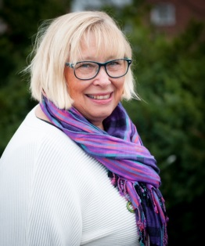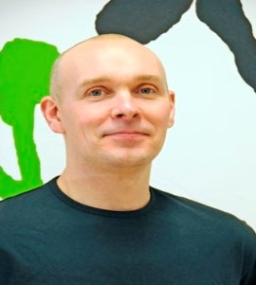
Christina Erenvidh Anders Fridell Roger Viklund

Barkarbyskolan:
Rickard Ernfors (rickard.ernfors@jarfalla.se ) head teacher
Merja Kallenbach, (merja.kallenbach@jarfalla.se) deputy head teacher
Magnus Åberg, (magnus.aberg@jarfalla.se) deputy head teacher
Charlotte Bergenwitt, (charlotte.bergenwitt@jarfalla.se

