Markets in Hranice
The first mentions of Hranice are from the 12th century. It had not been a town at that time yet, but the geographical location made it a very important place due to the many trade routes crossing through it.
Unfortunately, there don't seem to be any mentions of specific markets during the long history of the town, so we can only guess that markets there were very much like the others in the country and sold all sorts of goods - food, livestock, spices and handicraft products. But the markets did not only provide an opportunity to sell and buy goods, but they also served as a communication centre, where people could learn all the latest news. It was also the place where executions and different forms of torment took place.
Most markets were located in the town centre, mainly town squares and given that this is where markets are held even nowadays, it is certainly possible that it has been there since a very long time ago. The town centre of Hranice town is well preserved and is protected by law as an urban monument zone.
The main town square in Hranice is called "Masarykovo square". There is not an all-year market but seasonal markets are organised there mainly during Easter and Christmas but they are also held during other times as "farmer's markets". During Christmas, people can buy various handicraft products, traditional pastries and sweets but the most popular product during the Christmas market is mulled wine. There are alcoholic and non-alcoholic variants available so that both adults and children can enjoy it. Concerts and plays are often held when the market is on, too.
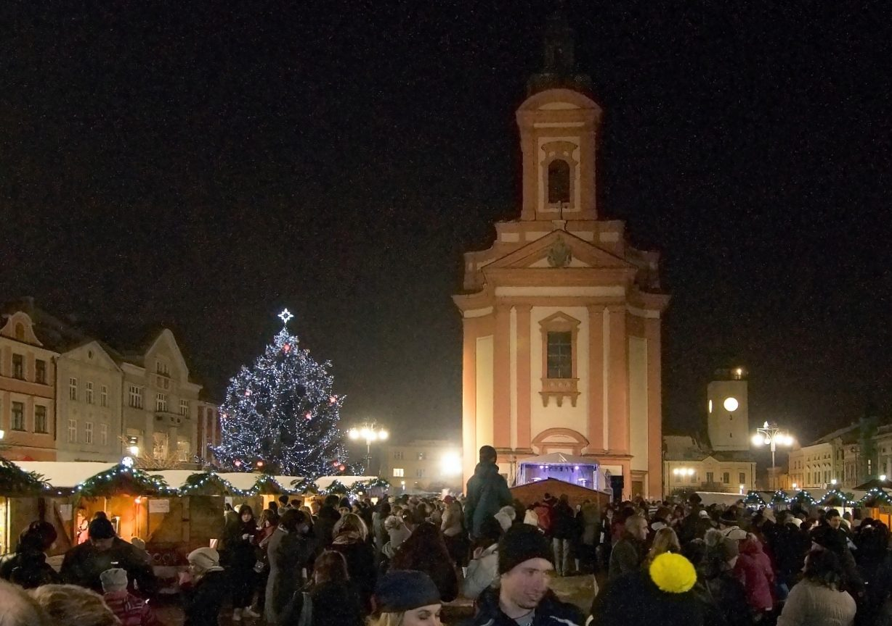
The selection of an Easter market is of course focused on products related to easter so people can buy eggs decorated with various techniques, decorative objects with Easter themes, pastries and sweets, flowers and handicraft products, but there is also a selection of not-Easter related products such as different articles of clothing and lots of food. The farmers' markets are focused mostly on local products, fruit, vegetables and flowers. In the 70s, the markets were much larger and were held under the arcades around the town square. People could buy seasonal flowers, handicraft products, fruit, vegetables, various sweets and many other products there .
There is also a small area dedicated to markets in the city centre at “náměstí 8.května”. People can buy seasonal flowers, fruit and vegetables there.
