Pedro and Inés
Love story from Portugal

Created by Slovak team


2019

Pedro and Inês lived what is still now considered as the most beautiful and tragic love story that ever existed on this Earth.
Let’s go back to the 14th century. Dom Pedro is the son of King D. Afonso IV and the heir to the throne. Dona Constança, belonging to the Castilian nobility, is chosen as his wife

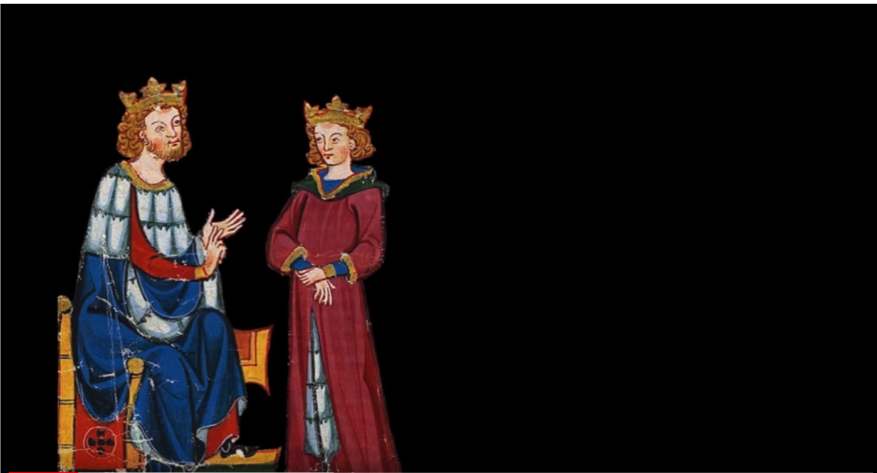
I know that it will be good for our country, I agree.
My dear son, you will marry Dona Constanza, it will be good for our Kingdom, I hope you understand.

Pedro married Constanza Manuel
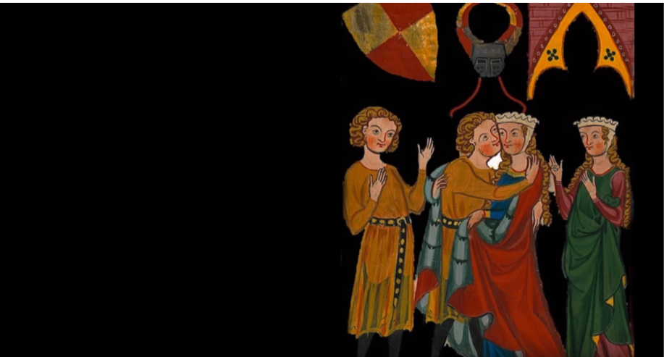
My beautiful lady Constanza, our wedding will bring peace to the country.
I hope to be a good wife for you, my dear Pedro!

Inés came to Portugal as a lady in waiting to Constanza
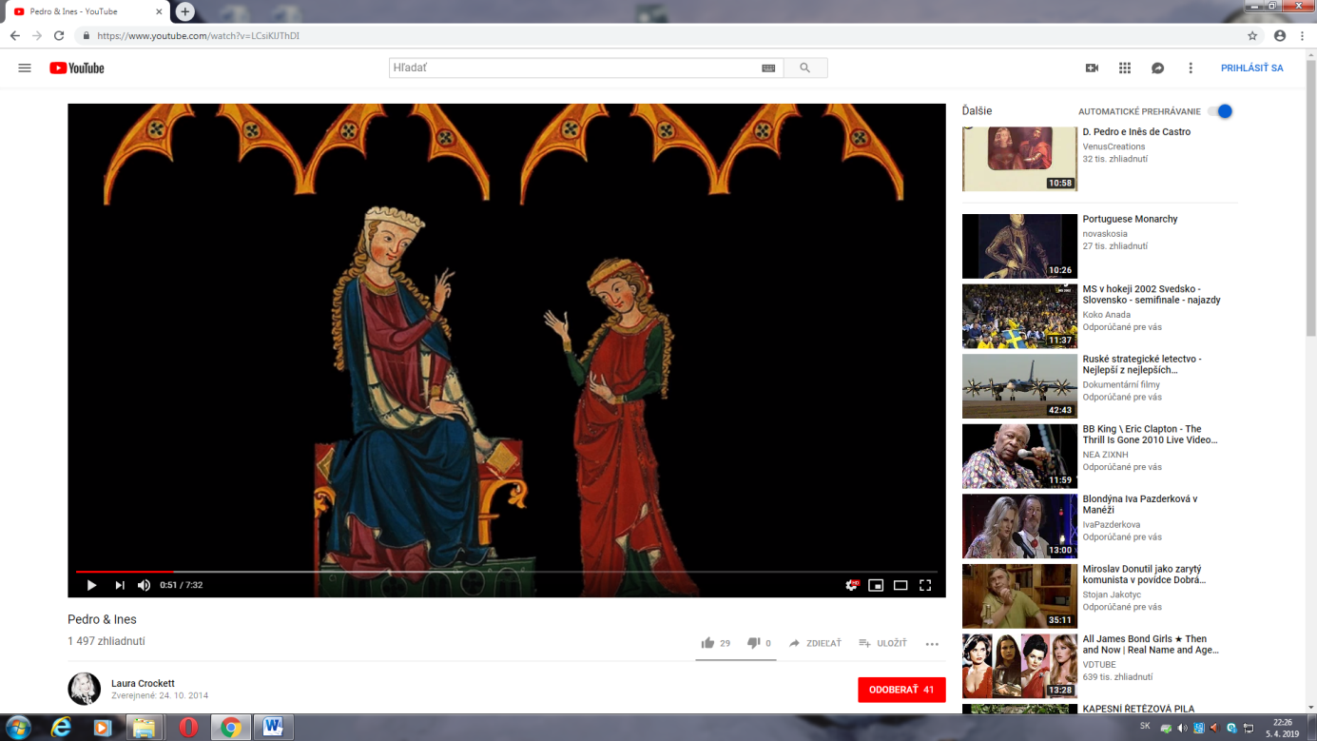
Yes, my lady, you can trust me.
My dear Inés, you are my close friend, I rely on you.
Pedro felled in love with Inés
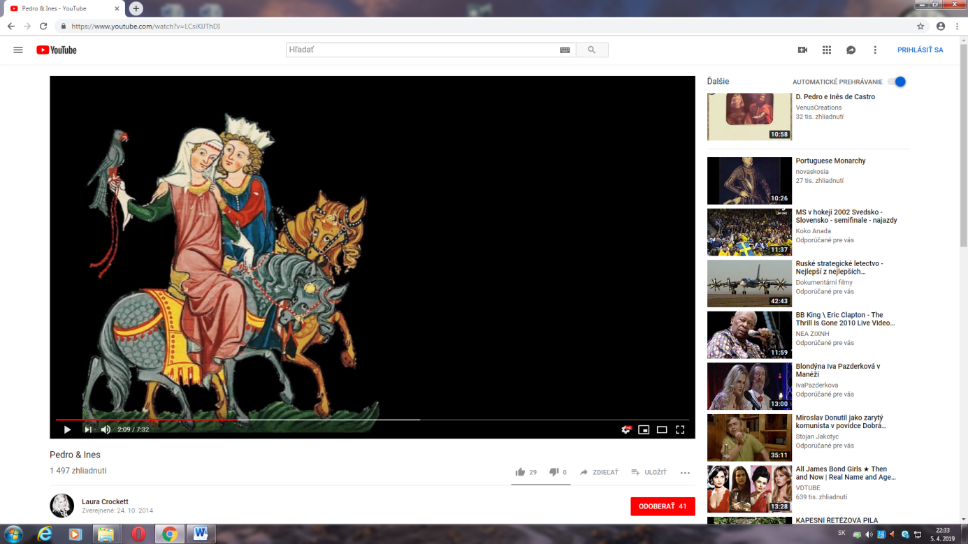
I think, you should not tell me such things, my king Pedro.
Inés, your beauty is amazing, your hair is like shining sun and your skin is as white as snow.

Pedro and Inés became lovers
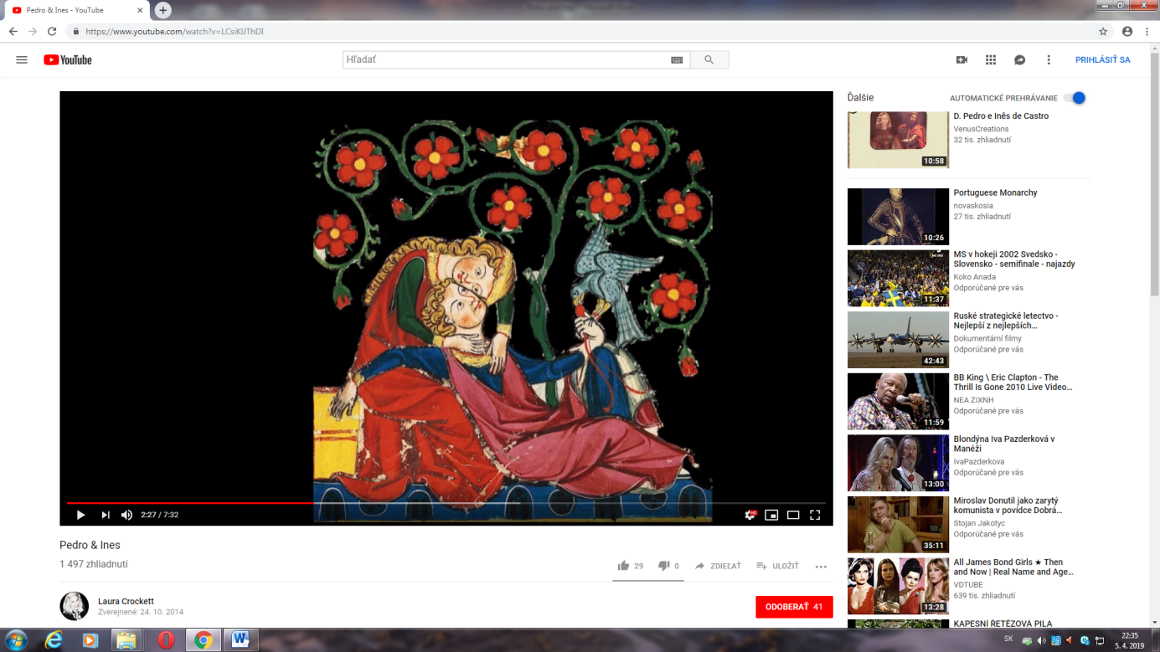
I can not live without you Inés, I fell in love.
I know my dear Pedro, I will always love you.
Constanza died ,Pedro and Inés lived secretly and had children
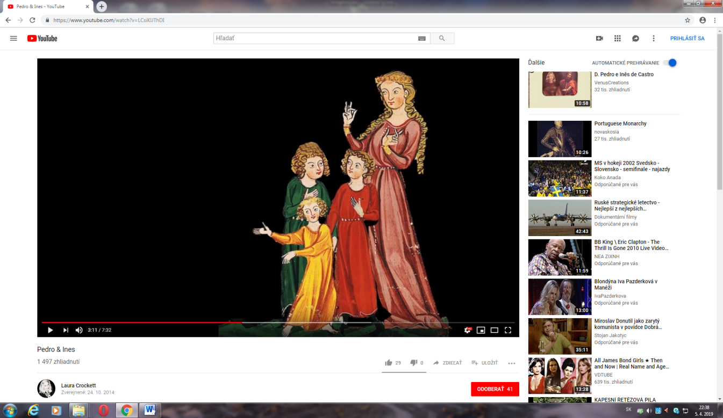
I hope, one day we will be together.
Mum, do you think we we will live with our father as a normal family?

They promised to be together to the end of the world
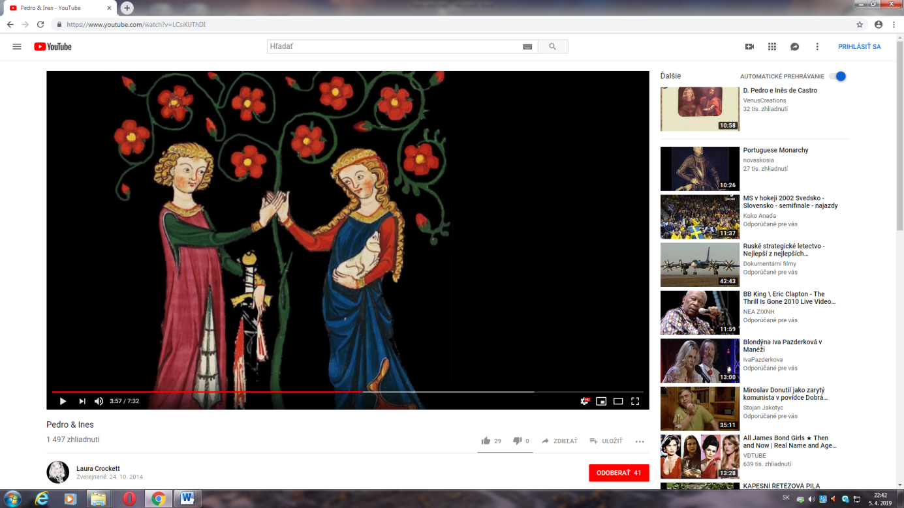
I love you Inés, my love is pure and nothing divides us.
My dear Pedro, our love will be eternal
The King Afonzo ordered to murder Inés
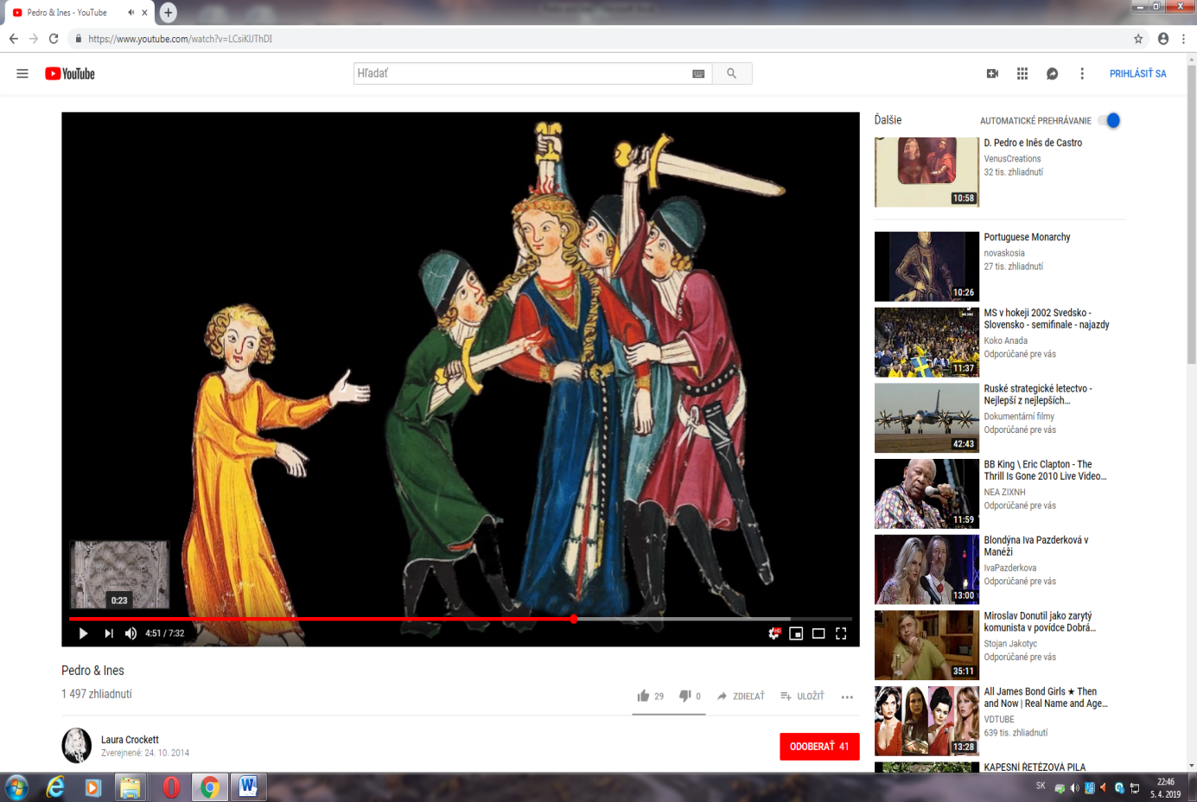
Do not kill me!!!
My children!!!
Pedro was in war with his father. When Afonzo died Pedro became the King and he was called „Cruel“
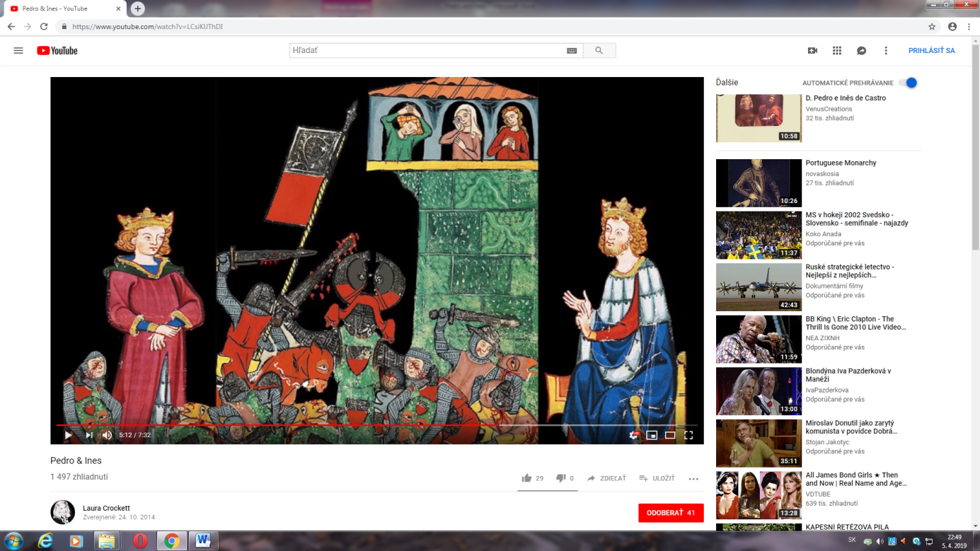
You are so cruel!
I hate you father!!!
Pedro made revenge and murdered the killers of Inés
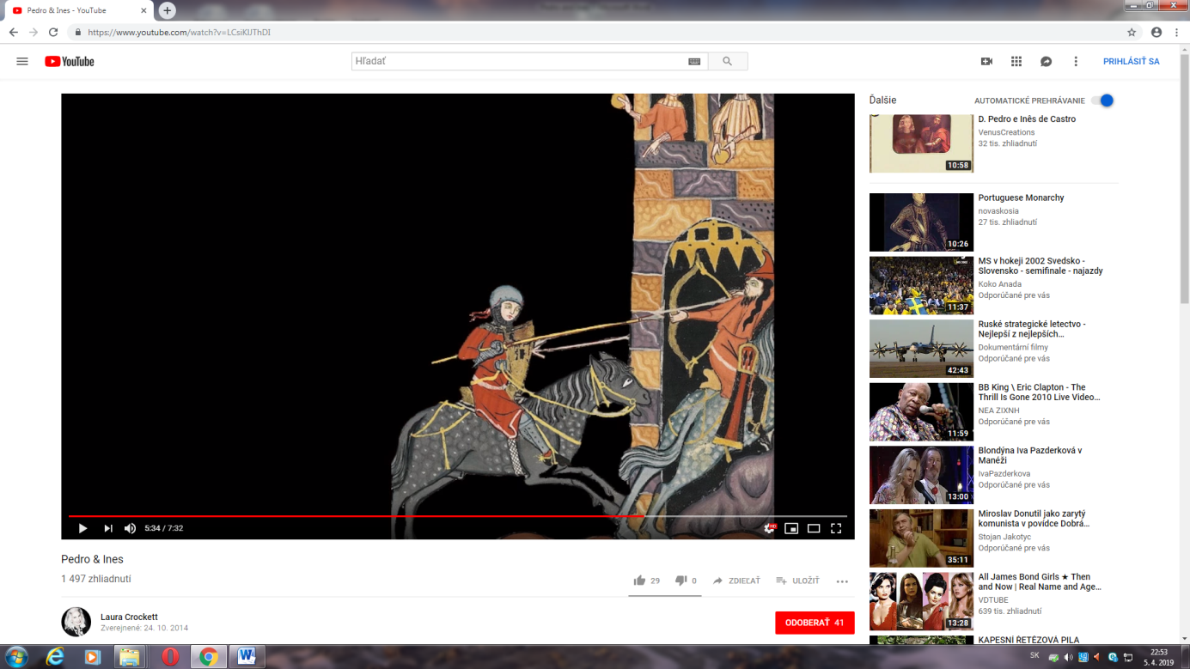
Oh no, please, do not kill us!!!
My grief is huge, I do not have heart, I will rip you your hearts from your chest!!!
Pedro exhumedhis dead Queen Inés
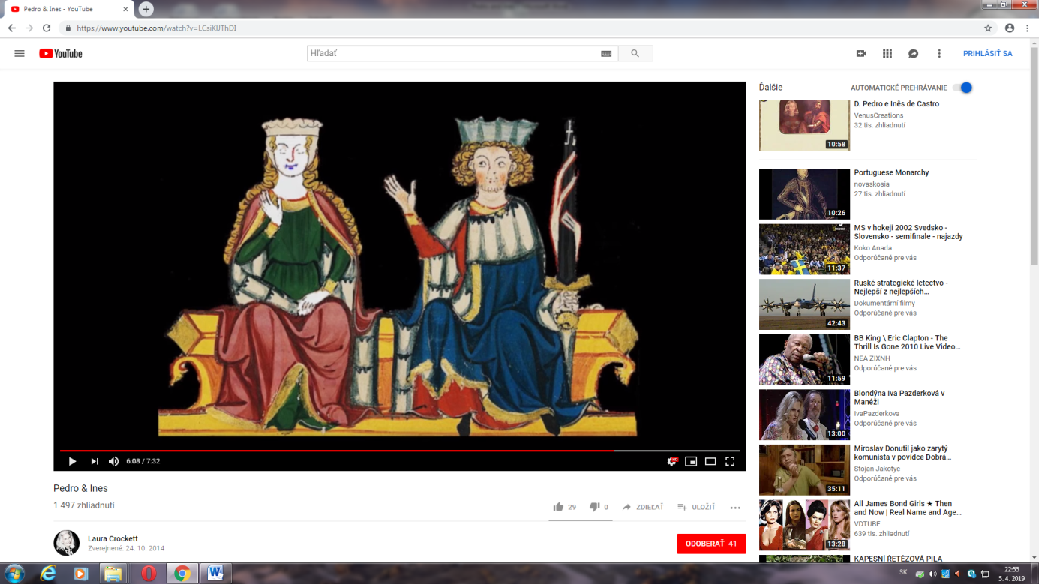
This is your dead Queen Inés and you must kiss her hand!!!
They are buried in Alcobaca monastery face to each other to the end of the world
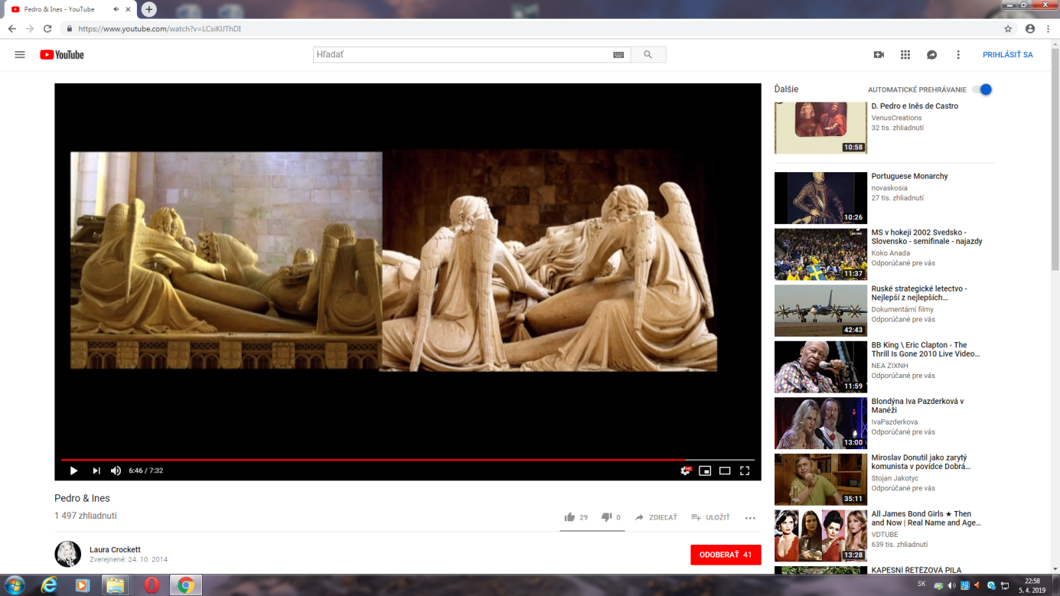

The legend has been embellished over the centuries and is deeply ingrained in Portuguese culture. As well as poems, there are books, films, television series, travel itineraries, sculptures, paintings and songs dedicated to Pedro and Inês.

