THE LOVERS OF TERUEL
In the year 1217 , in a city called Teruel in the north of Spain , two childhood sweethearts Diego and Isabel fell in love. They were both from wealthy families but Diego’s family had fallen on hard times. So, when they wanted to get married, Isabel’s father said no, as he was not rich enough.
Diego made an agreement with Isabel’s father, he would leave Teruel for five year to build his fortune and after that time, he would marry her.

But they had no news from Diego so on the day of the five years’ close, Isabel was forced to marry Don Pedro de Azagra. But at the gates of the city, watchmen informed the village that Diego had returned with great riches and with the intent of marrying Isabel.
That night, Diego sneaked into the bedroom of Isabel and her husband and gently awoke her. He pleaded to her” Kiss me for I am dying”and she refused, saying :,"God would not wish me to deceive my husband "He begged her one last time, saying that he was dying and wished for a final kiss. But still she refused. Upon hearing this Diego could not bear the separation between himself and his love, and with a sigh he died on the feet of his beloved Isabel. Isabel woke up her husband and told him all the story and they decided to bury him secretly the following day,. 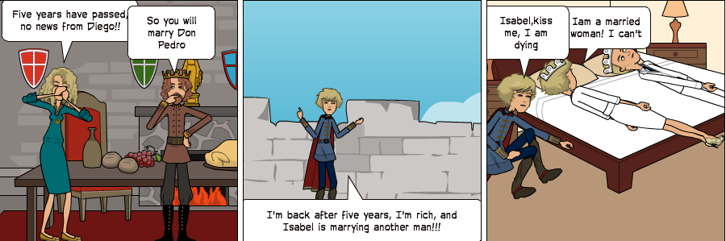

The next day, during the funeral for Diego Marcilla, Isabel showed up dressed in her wedding dress. She proceeded to walk to the front of the church and place a kiss on the man whom she had refused but in doing so Isabel died, falling prostrate on the body of the man whom she loved.
