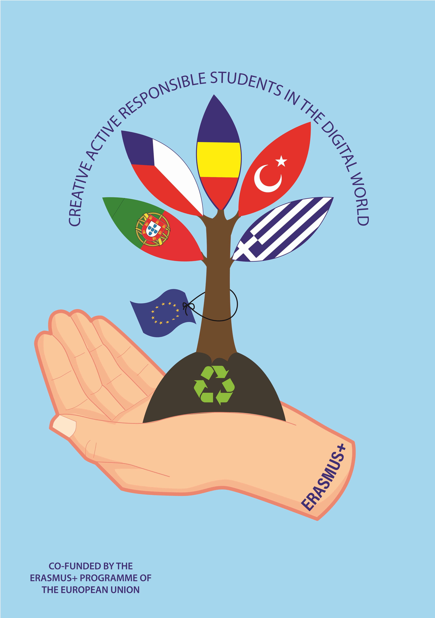
Základní škola Žamberk, 28. října 581

ŽAMBERK PSČ 564 01
tel. 465 613090, e-mail: zs28rijna@orlicko.cz
mobil 608308885, http://www.zamberk-city.cz/zs28rijna

Creative, Active, Responsible Students in the Digital World 2016-1-RO01-KA219-024478_5
Evaluation of the the first transnational teaching and learning aktivity
1st May 2017 – 5th 2017
Žamberk, Czech Republic
Answers from 37 participants
- Preparatory work

 | Yes | No | %
Was sufficient information supplied before the meeting? | 37 | 0 | 100%
Was the work load prior to the meeting acceptable? | 37 | 0 | 100%
Did you achieve the tasks you were supposed to deliver before the meeting? | 37 | 0 | 100%

- The meeting (activities) itself

 | Yes | No | %
Did the meeting give adequate time to introductions and finding out the background of the partners? | 26 | 11 | Yes - 70%  No – 30%
Are you satisfied that you were able to contribute to the discussion and decision making? | 36 | 1 | Yes – 97%  No – 3%
Did the meeting adhere to the agenda and were any changes discussed? | 35 | 2 | Yes – 95%  No – 5%
Were the goals of the meeting achieved? | 35 | 1 | Yes – 97%  No – 3% (1)
Are some goals not met? | 12 | 23 | Yes – 34 %  No – 66% (2)

Comments
- There was no free time discaussion.
- I wish we had more free time to know each other.
- I love it.
- The workshops were very interesting.
- I don´t know so good each other.
- The workshops were amazing.
- No agenda.
- The communication objective between Romania and the rest of the partners was not achieved.
- Wish we had more time.
- Wish to had more time to talk to the other pupils.
- The workshops were wonderful.
- I need more time.
- The workshops were great.
- New teachers didn´t have the chance to také part officialy, but at their free time.
- I need more free time.
- It was not dear. (The goals)
- Other factors

 | Yes | No | %
Was the working environment satisfactory? | 36 |  | 97% (1)
Were the accommodation, food and the social element satisfactory? | 36 |  | 97% (1)
We now know each other well (professionally) | 36 |  | 97% (1)

Comments

1. Friendly school environment.
2. The hostess did the best they could.
3. We know each other well only personally.
4. Different school environment.
5. We know only Portuguese.Chicken is too much.
6. Only Portugal.
7. Meet is too much.
8. The environment was different from Greece.
9. Only with Portuguese. They were the only who could be understood.
10. We do not know well how the Romanian partners are working because they did not want us to introduce us and to know us better.
11. The school was a little bit different but it was nice.
12. Only with Portugal.
13. Different school environment.
14. We now know each other well except for the coordinator of the project (Melinda).
15. The coordinator (Romania) could be more professional.
16. The coordinator (Romania) was unrelated.
4. Follow-up

 | Yes | No | %
There is a clear and reasonable timetable in place | 37 | 0 | 100%
I understand my role in the project | 35 |  | 96% (2)

Comments

- Everything has been planned and clear.
- It was interesting but also a bit tired.
- 3. I was tired but enjoyed it.
- I was sometimes tired but I enjoyed it.

