Project
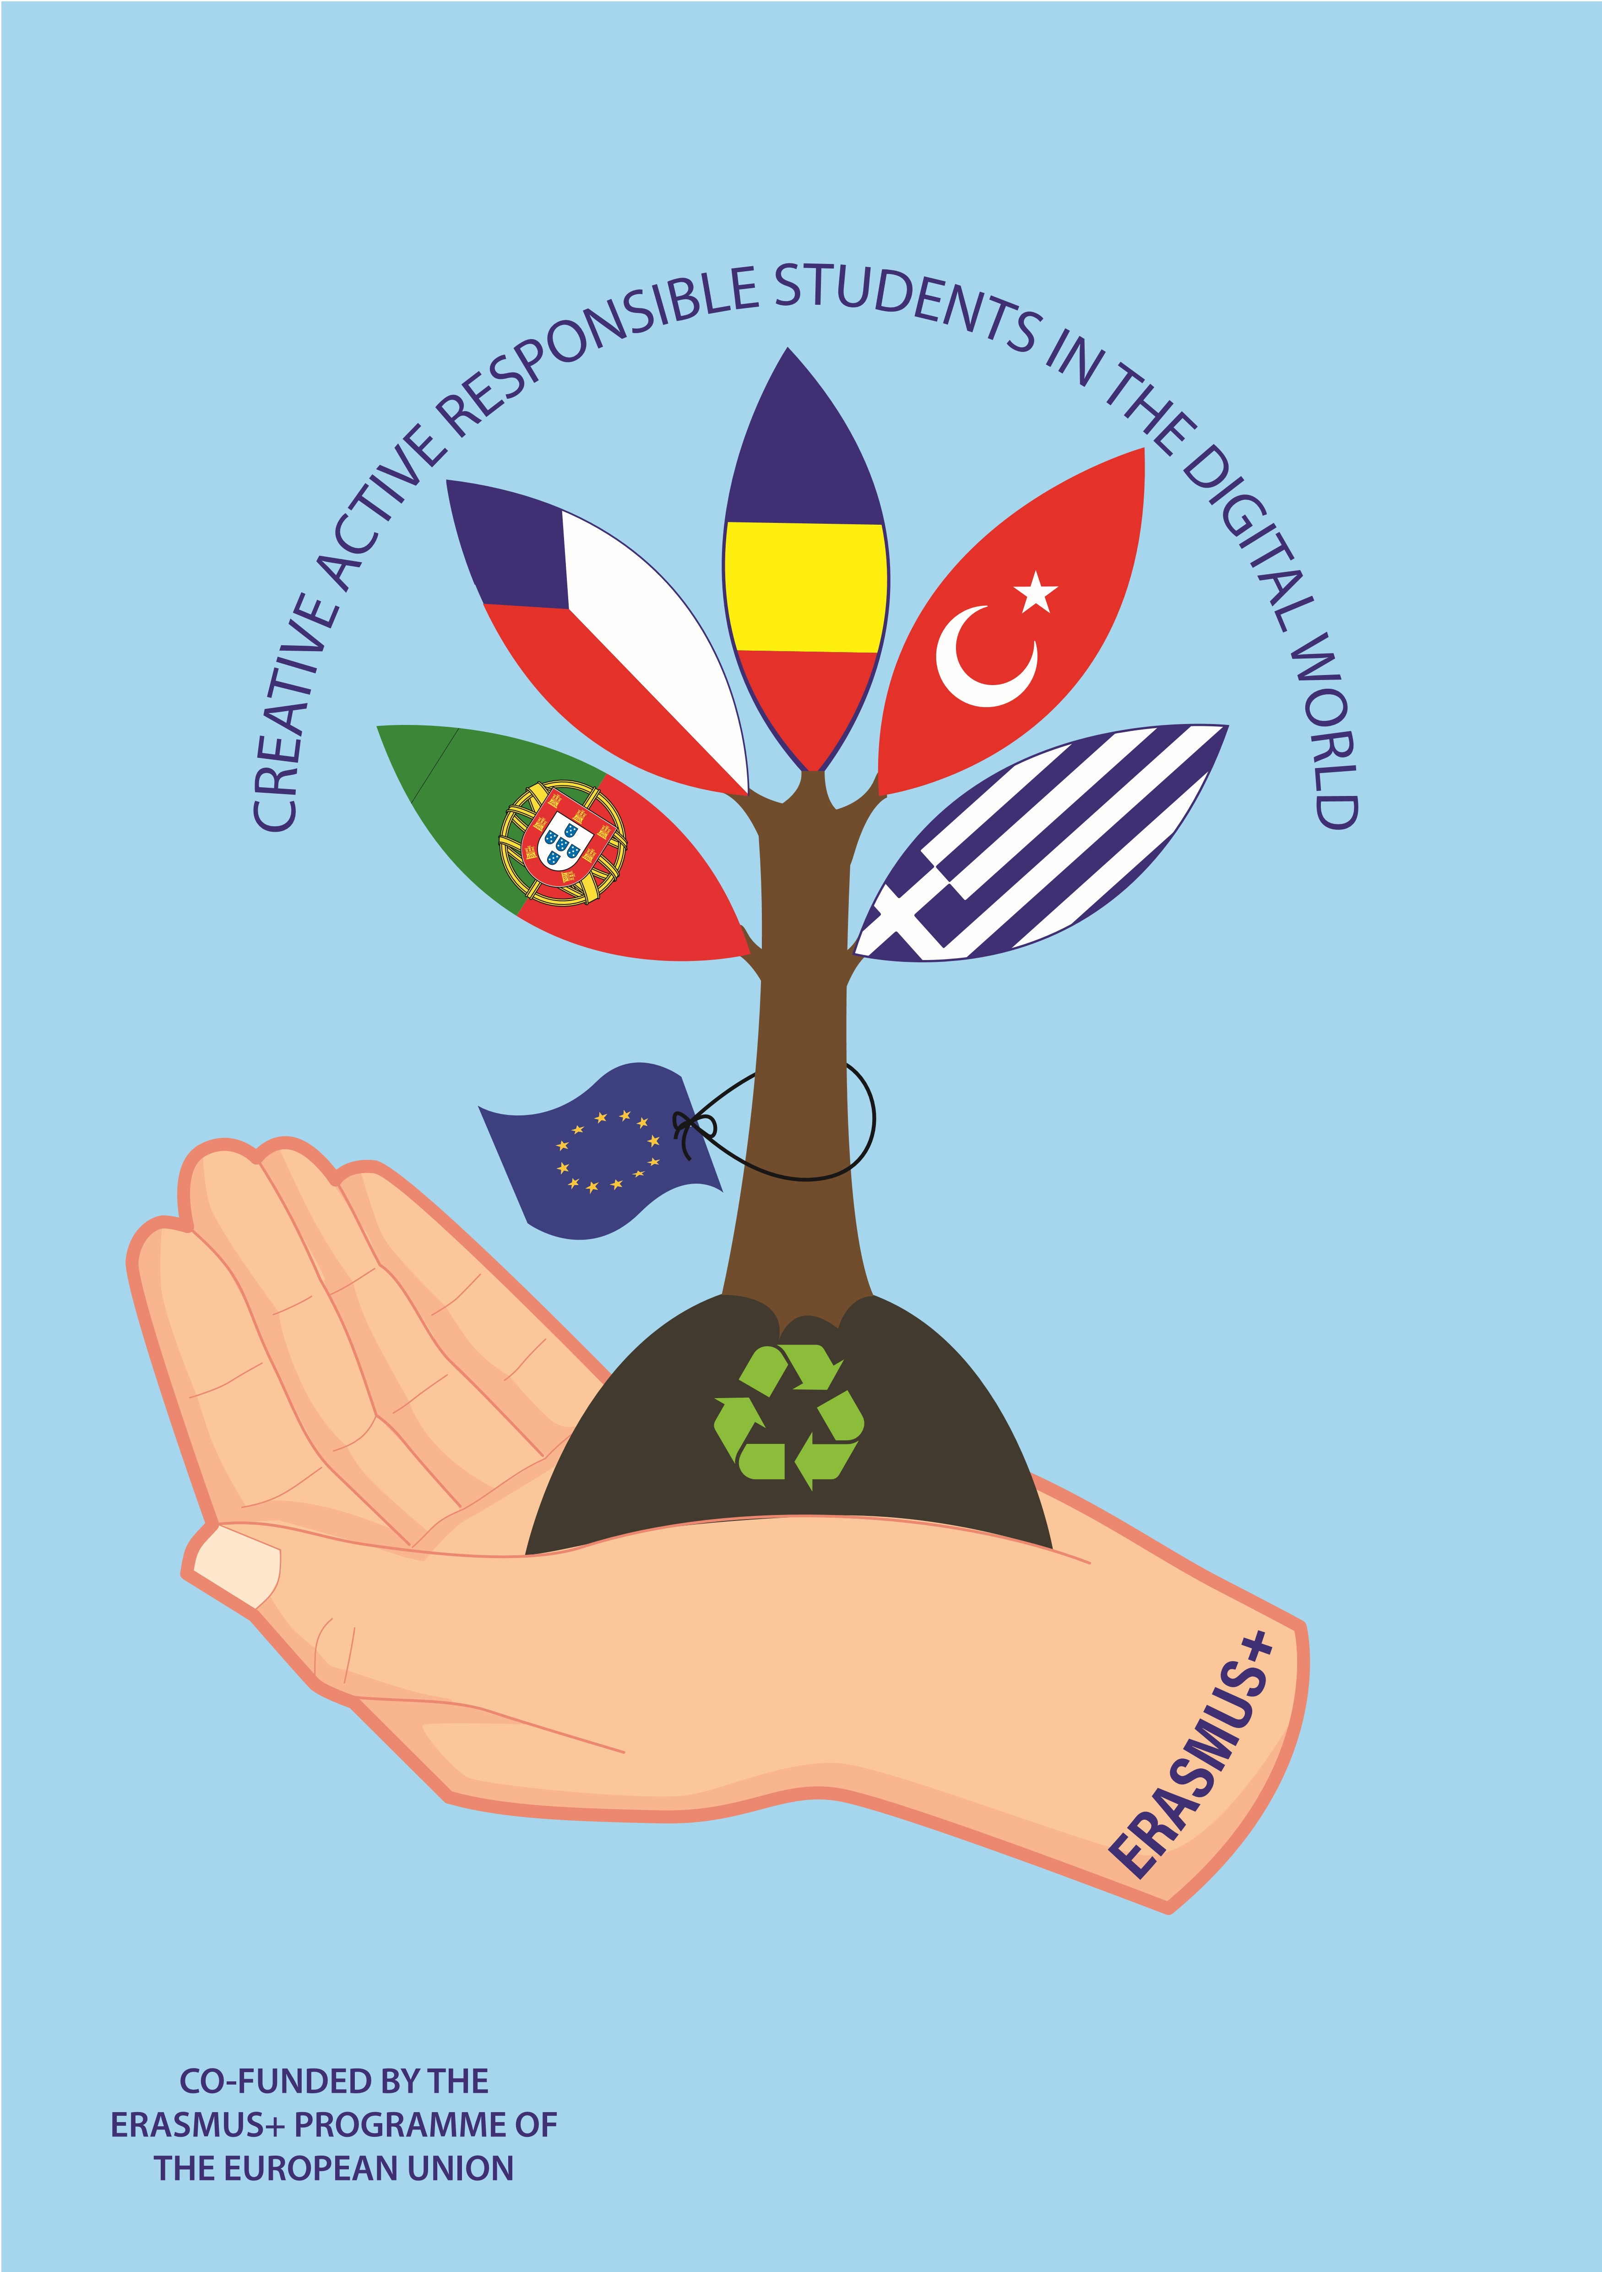
Creative, Active, Responsible Students in the Digital World

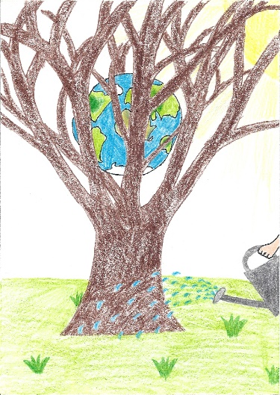
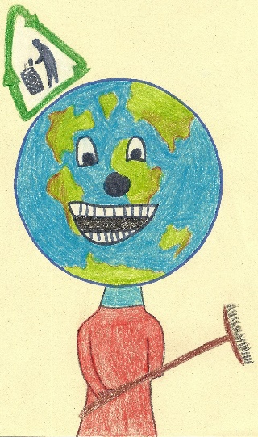
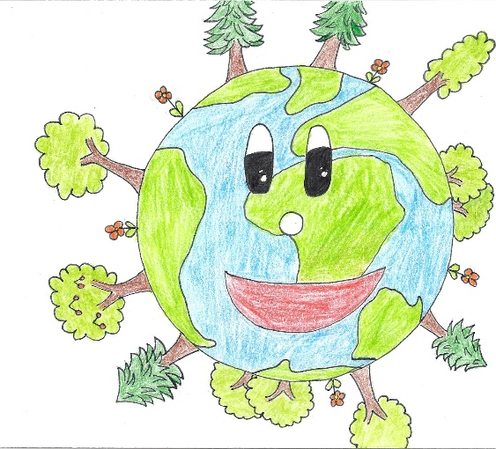
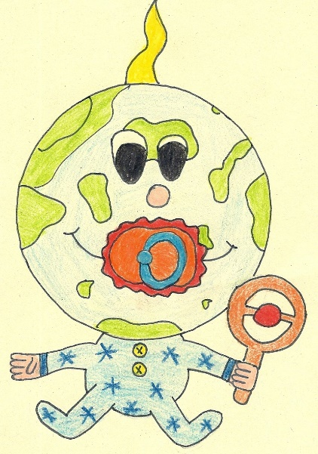
How to Save the Environment Story

By the students from ZŠ Žamberk, 28. října 581 Czech Republic
What are the ways to save the environment?
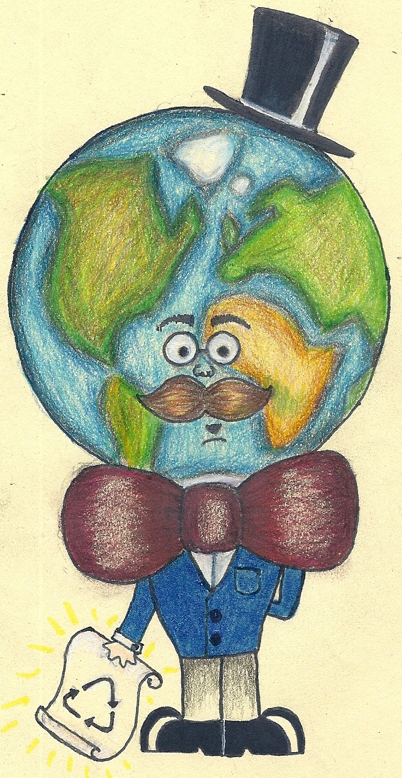

Hello! I´m a teacher. My name´s Earthy.

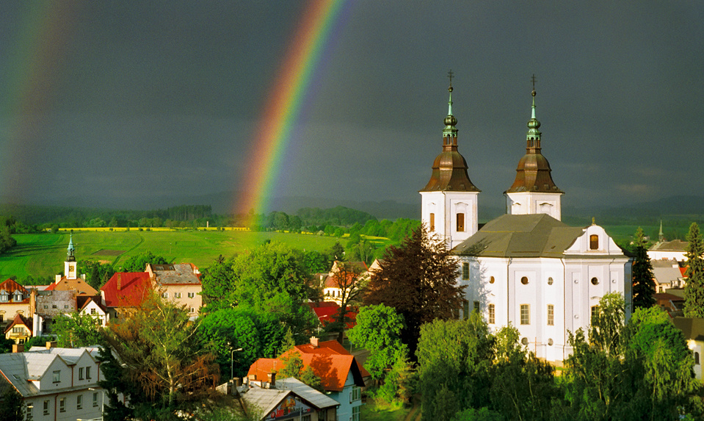

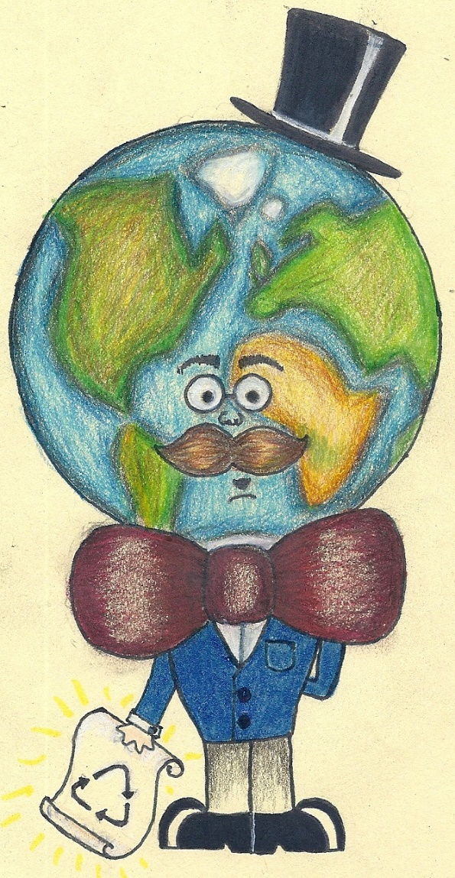
I´m going to teach you some ways how to save the environment.

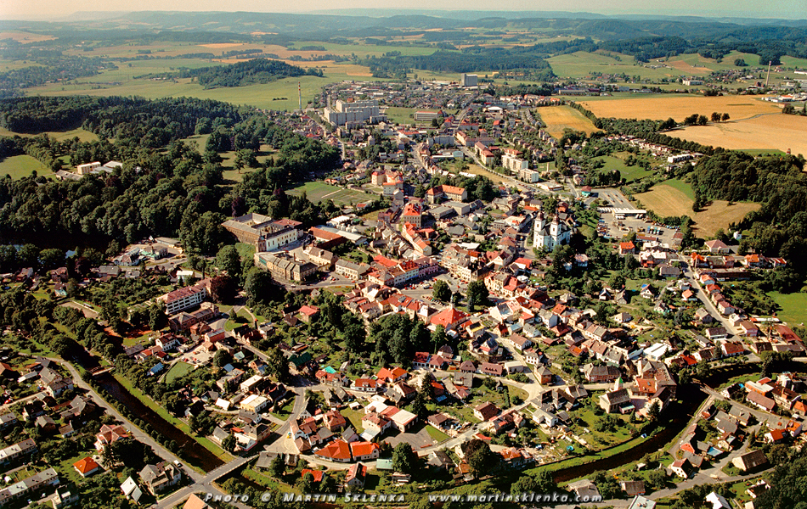

- To make the environment better
we should reduce levels of environmental pollution and avoid littering the environment

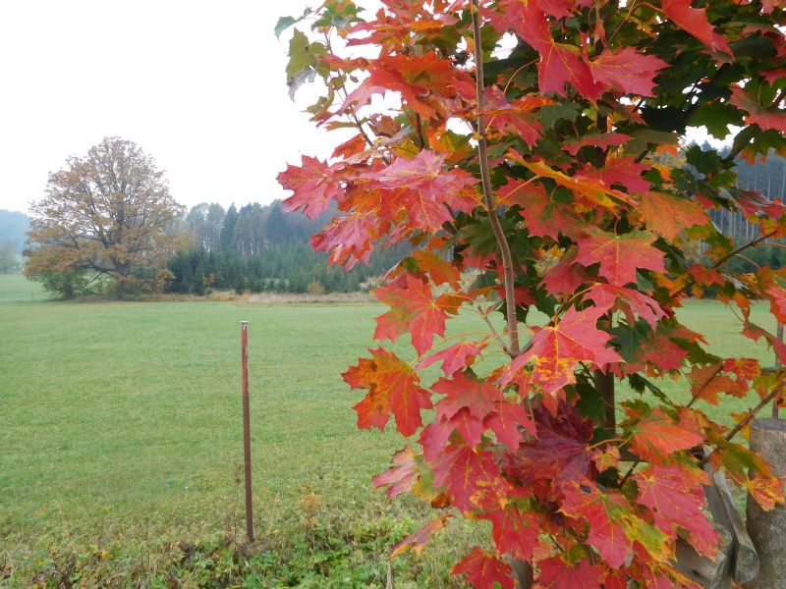
1. We should 1 ….
2. We shouldn’t 1

1. We should 1 ….
2. We shouldn’t 1

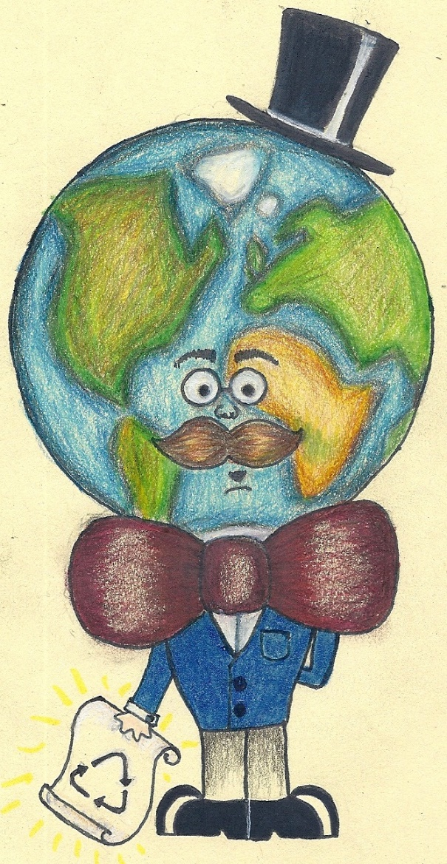

- 2. To make the environment better
we shouldn’t throw away things we can re-use and use strong chemicals for cleaning
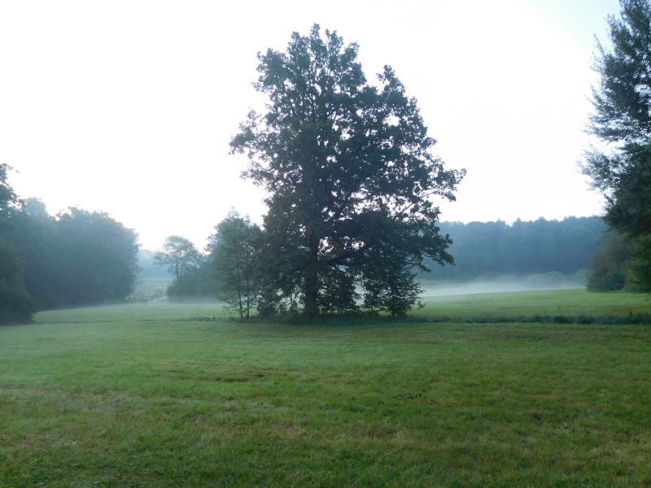

3. To make the environment better
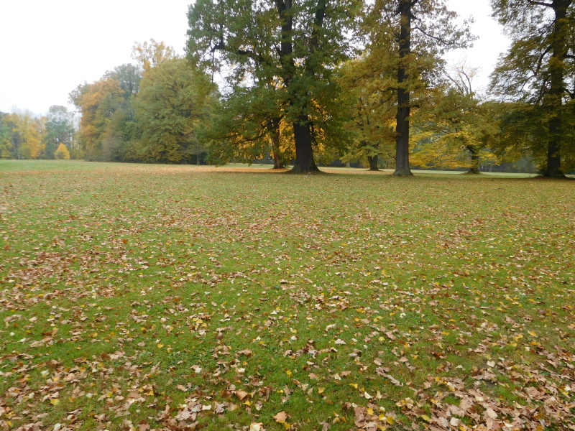
we should get used to recycling, reusing and reducing

4. To make the environment better
we should get used to using recycling containers more often and using recycling bins

5. To make the environment better
we should get used to using recycled paper and using eco-friendly products for cleaning
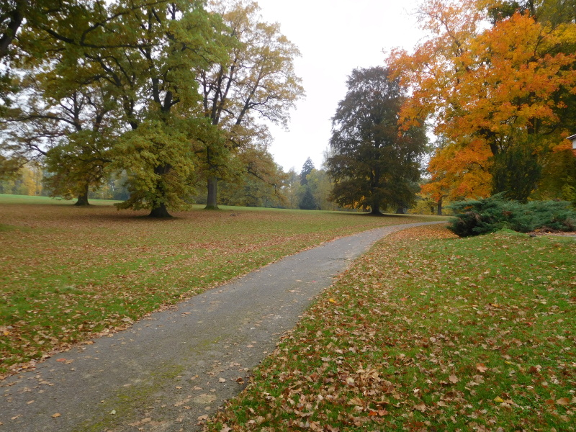

6. To make the environment better
we should get used to not using cars for short journeys and saving water and electrecity
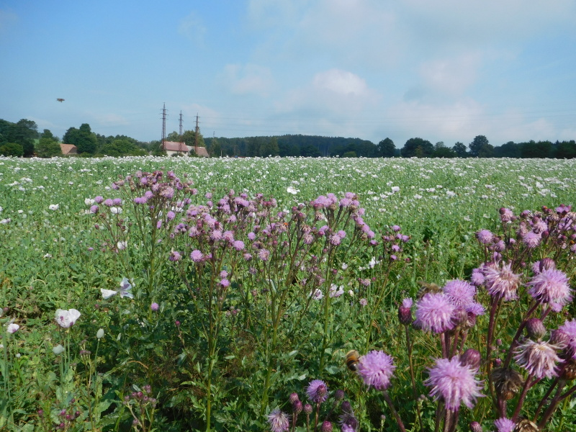

7. To make the environment better
we should stop air, soil and water pollution and use more wind and sun power

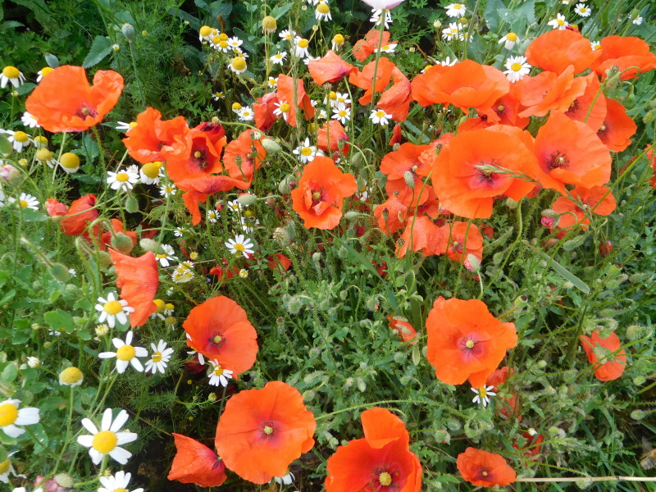

8.To make the environment better
we shouldn´t waste water and energy and use strong chemicals for cleaning

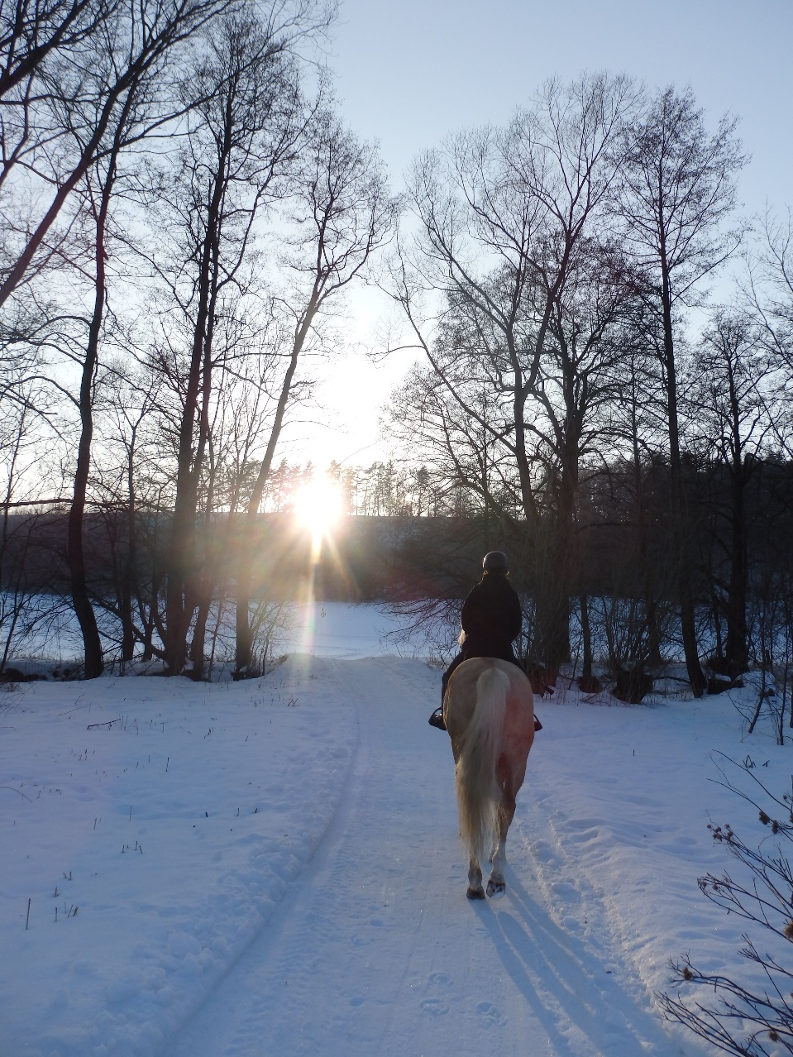

9.To make the environment better
we should get used to taking part in school recycling programmes and keeping the Earth clean

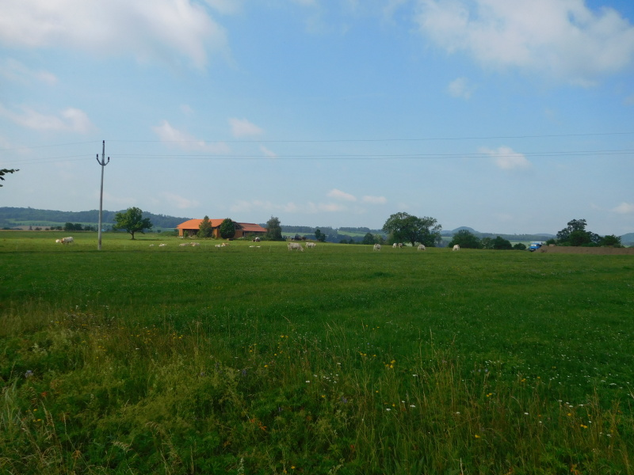

10. To make the environment better
it’s high time to invent things good to the invironment and minimize pesticide use

Dear students,
Now you know how to save the environment. If you fill in the worksheet, you´ll be really friends for me.
Love,
Earthy
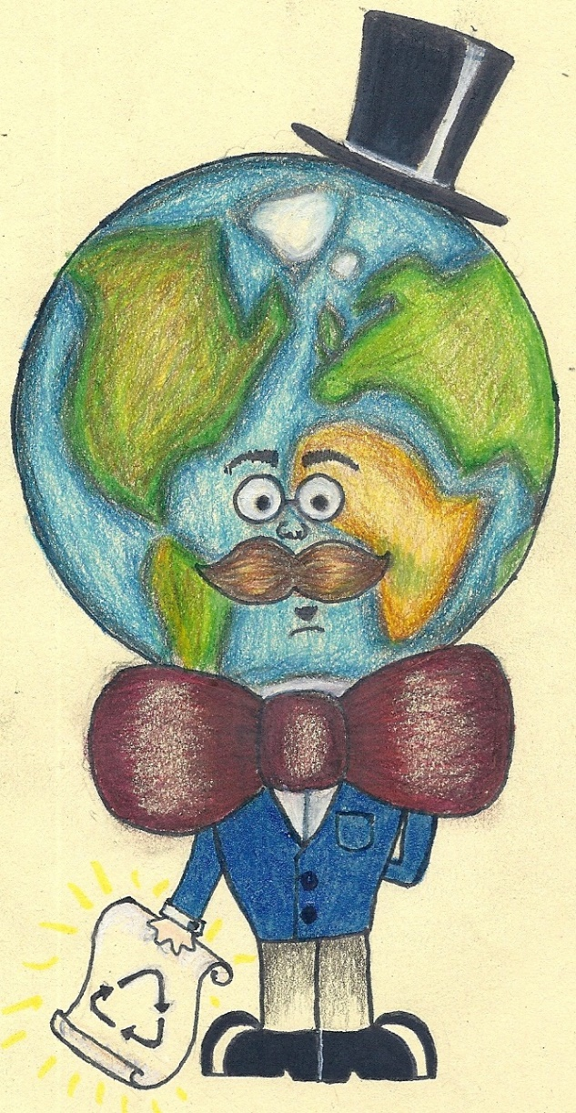

Worksheet: Some Ways to Save the Environment
1= infinitiv
- We should 1 | - We should get used 1+ing | - It’s high time to 1 | - Personally, I try to 1

We should

It’s high time to

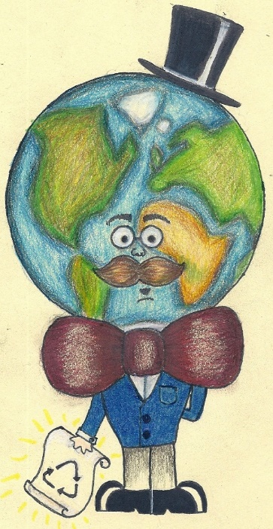

We should get used

Personally, I try to

Name …………………… Class ……
Some Ways to Save the Environment

11 | use lowflow showerhead
12 | pick up trash
13 | lend a hand to save trees
14 | bike or walk more
15 | turn off the lights when not in use
16 | save energy
17 | learn about the environment
18 | use energy-saving light bulbs
19 | unplug the phone charger when not in use
20 | recycle glass bottles and jars
1 | take shorter showers
2 | take part in trash pickup
3 | organize a litter clean trip
4 | use a reusable shopping bag
5 | turn the water off while you brush the teeth
6 | turn off electronics when not in use
7 | reduse energy use
8 | recycle carboard and paper
9 | say no to plastic bags
10 | shut off computers
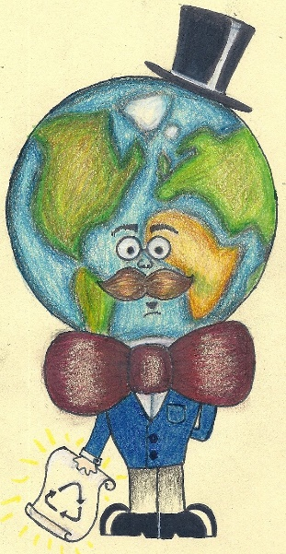
Vocabulary

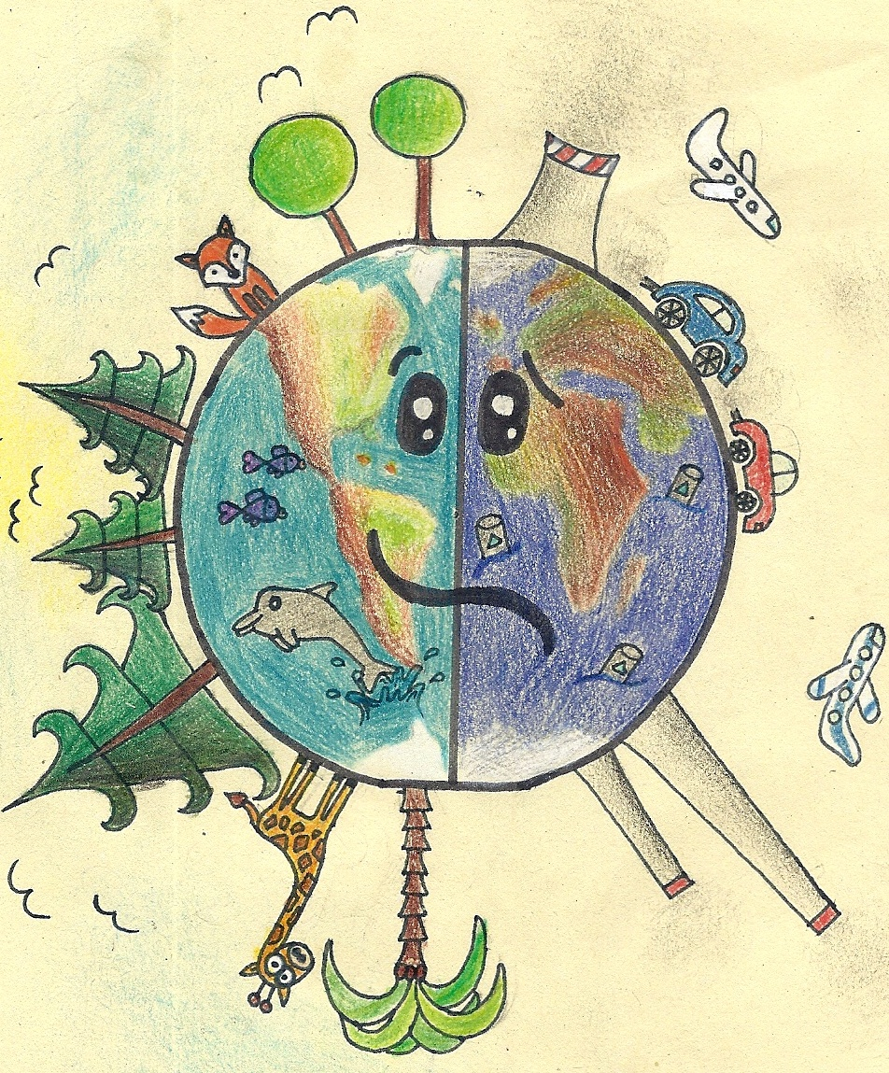
DO YOU LOVE ME?

USE LESS OF ME!

