*„PEOPLE“*

Author of piece „People“ is academic sculptor Branko Ružić. Sculpture better known as „Group of citizens“ with it's thematic is tied to human figure, primary preoccupation of it's author, Ružić. On a round low position there is a group of stand-alone sitting figures connected to a unique volume. Sculpture expresses feelings of spirit and life, temperament and expression, pervaded with a universal, almost archaic form, presently presented. Sculpture presents source of happiness for children of all generations since it has been set on Square of freedom in Osijek, back in 1977.

In 2004. sculpture was removed from Square of freedom, which today is named Ante Starčević's square, because of reconstruction of square itself. There was an argument: whether to put it back on the Ante Starčević's square or not? Some experts thought that the newly put sculpture of dr.Ante Starčević and ,,People'' cannot be on the same square.

With a great ceremony sculpture was brought back on square in 2011., which brought general pleasure to all citizens of Osijek.

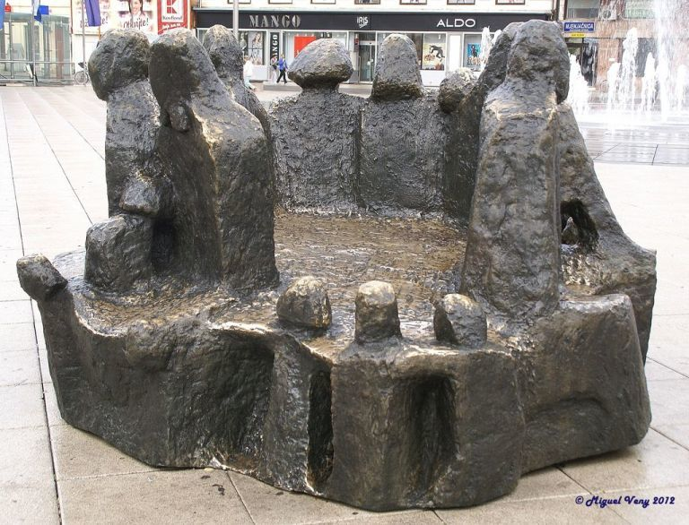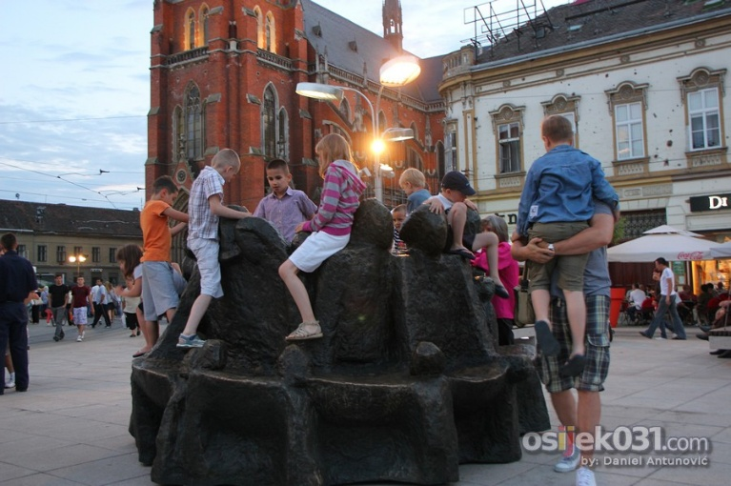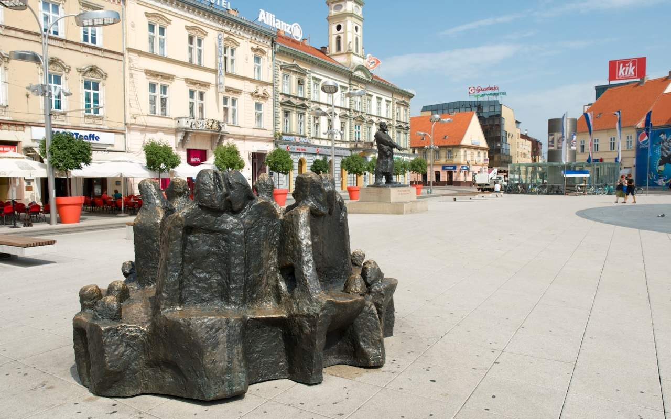

*Author: Branko Ružić*

*Material: Bronze*

*Jagoda Truhelka*

Jagoda Truhelka was Croatian writer and teacher born in Osijek,1864. Through life, she was a teacher in many schools(Osijek,Zagreb,Gospić); she was also principal in schools for girls in Banja Luka and Sarajevo. She thought that teachers should always reflect on themselves and try to improve. She also thought that you can't make someone do something, that decision must come from that person, so it's teacher's job to try to motivate each child on different way because they are all different.

She was writing for some journals of her time. She was using pseudonym to write about women and relations between sexes. Her female characters are intellectually strong. That was a new way to describe a woman, her representation of female characters was never seen before. Also, she wrote a lot of childrens books.

She died in Zagreb, 1957.

Today, there is a school in Osijek under her name.

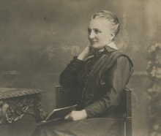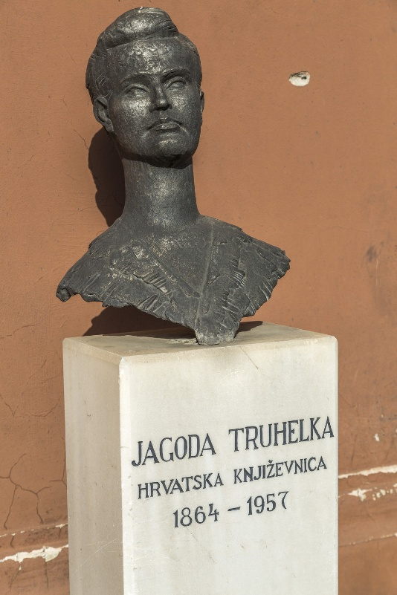A bust of her is placed next to the entrance to the City Library. The bust is very detailed and made of bronze. The sculptor was Vanja Radauš.