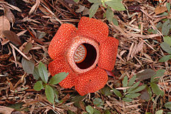
Borneo Flora

Borneo's flora includes 15 species of dicotyledons, 37 species of dicotyledons and 49 species of endemic monocotyledons for the rich forest of Brunei Darussalam. Borneo is also home to the world's largest flower, Rafflesia Arnoldii, it is the largest flower in the world and can reach up to 15 pounds in weight. This plant parasitizes on shrubs of the genus Cissus related to the vine, it does not produce roots, stems or leaves. It gives off the foul smell of rotting carrion that attracts flies pollinating it. It blooms for 5-7 days once every few years.

