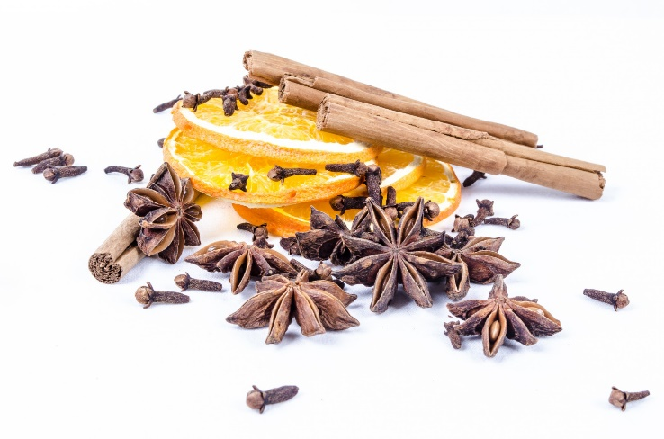
CINNAMON
Cinnamon is a popular seasoning, made from cinnamon tree.
We add it to cakes, or different food. Cinnamon smells, and tastes very well.
This seasoning, is also good for our health. We can find it in North America and Souteast Asia.
Remember, that cinnamon can be dangerous for us, but onle when we will eat it too much.

https://pl.wikipedia.org › wiki › Cynamon

Dendrelaphis Boulenger

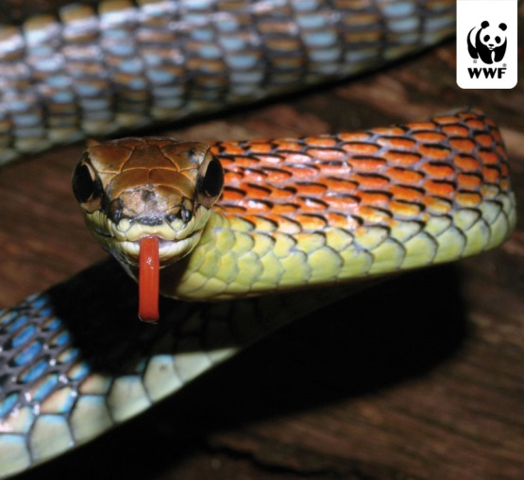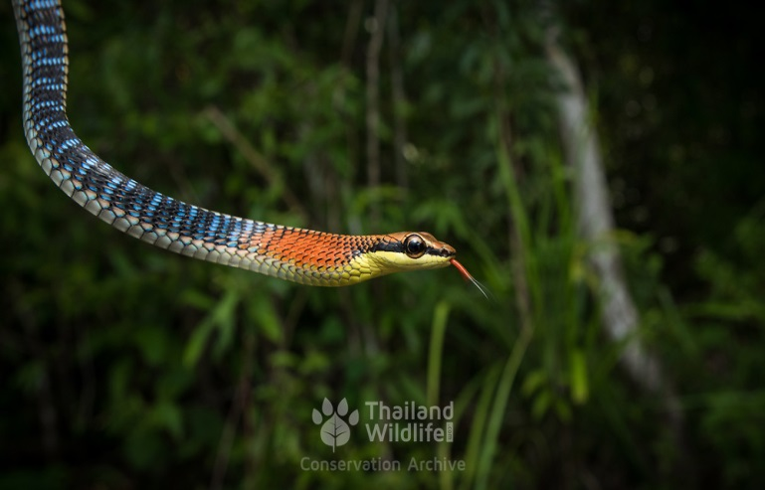

The colubrid snakes of the genus Dendrelaphis Boulenger 1890 are widely distributed, ranging from Pakistan in the West to the northern and eastern coast of Australia in the East and South and to southern China in the North). Members of the genus Dendrelaphis are slender, diurnal species that are pre-dominantly arboreal and feed on lizards and amphibians. The recent description of D. hollinrakei Lazell, 2002has brought the number of known species to 21. They live in Borneo.

NOSACZ SUNDAJSKI
The species was first described scientifically by F. von Wurmba in 1787 under the name Cercopithecus Larvatus. The male has a prominent, widened nose in the shape of a cucumber, in old males the nose extends to 10 cm and hangs over. The female's nose is smaller and torn upwards. The average build, adult male reaches body weight from 16-22 kg, female 7-12 kg. The male body is 72 cm long and the female body is 60 cm long. The length of the tail slightly exceeds the length of the body. Colouring of the back and shoulders from pink, red to brown. Extremities and tails are grey. Sunday glands lead a daily, mainly tree lifestyle. They are most active from late afternoon to dusk. They feed on leaves, fruits and seeds. They also eat small invertebrates. They live in small, permanent groups of males and females. Such groups form a loose herd of up to 32 individuals. They do not show any territorial features. They swim and dive well.

1180 × 787
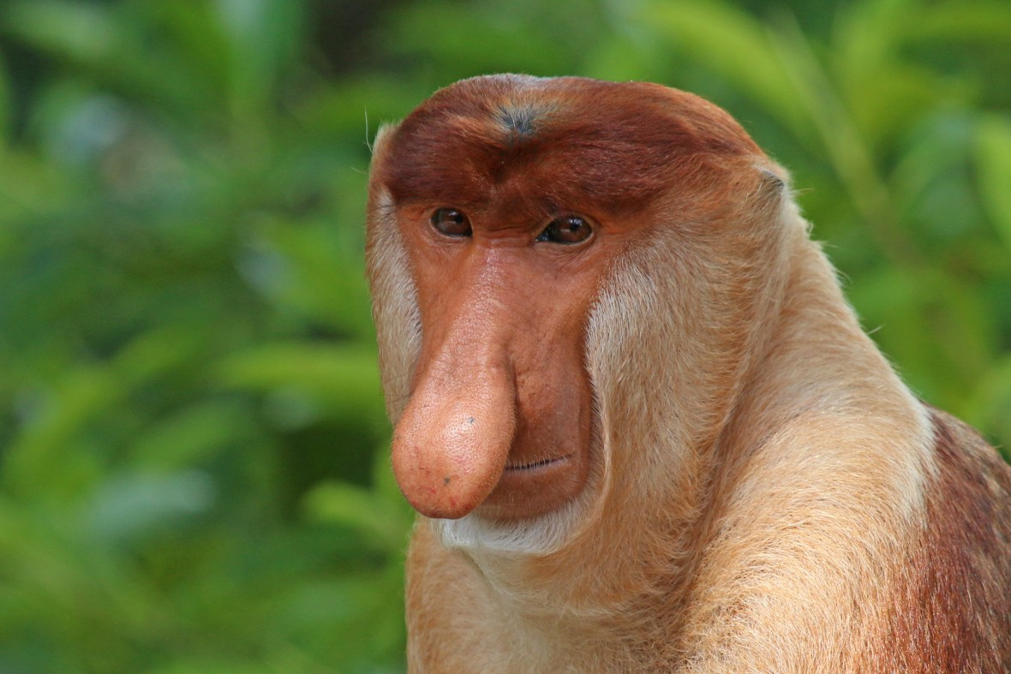

Origins: https://pl.wikipedia.org/wiki/Nosacz_sundajski

