Coffee
A wild variety from the Ivory Coast is already extinct. Ten others are on the edge of extinction.

Bananas
In 10 years' time, bananas can only be remembered. Although these fruits are phallic symbols, they have been living in man-made celibacy for thousands of years.
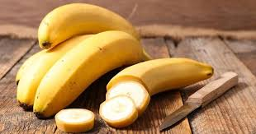

Spelt
once widely cultivated in the Roman Empire, today in the wild it is preserved only in Turkey and, perhaps, in Yemen.
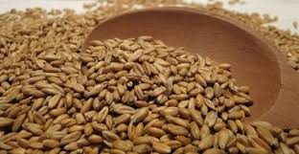

Tomatoes
their wild ancestors are now endangered throughout South America, including through environmental degradation by opencast copper mines
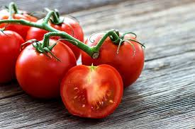

Soya
a wild variety grows today only in a few small enclaves of the Yellow River delta.

Jaguars
In the past, jaguars were found in almost all of South America. Because of its extremely valuable fur and environmental degradation, this unusual cat is now in danger of dying out.
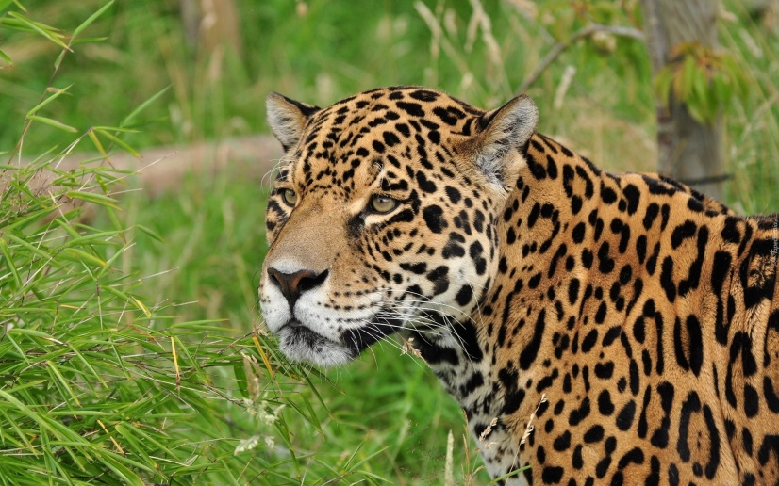

Capuchin Worship
These animals use different tools in order to get food, which proves the high intelligence of these little creatures. Danger from destructive human activity - constant cutting down of rainforests, hunting and dealing.
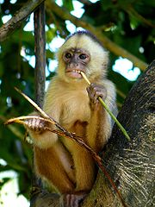

Black cap
Called a monkey kayak, this little acrobat lives in the tree crowns and doesn't often go down to the ground. The decline of these nice monkeys is caused by hunting and, above all, the destruction of their natural environment, which is the tropical forests.
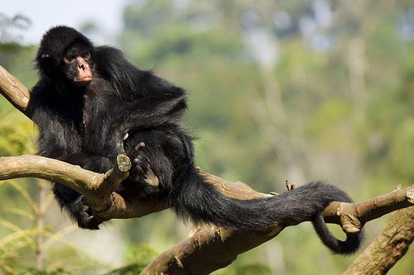
Red-blooded Amazon
There are more than 140 species of parrots in Central and South America, which is 40% of all species in the world. One of them is the red-blooded amazon. As a result of continuous rainforest cutting and international trade in parrots, which reached terrifying proportions in the middle of the 20th century, the bird is unfortunately at risk of becoming extinct.
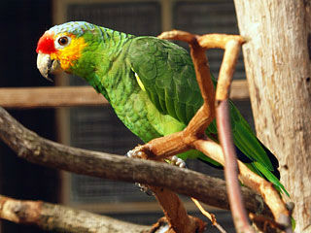

Saimiri squIt
Is also called "dead head" because of its mouth. This monkey lives in tropical forests of the South America, especially endangered to extinction because of the cutting down of tropical forests and hunting.
