SNOWMEN OF FRUITS

Ingredients:

2 Bananas

1 Apple

4 Chocolate sticks (mikados)

1 Chocolate bar

2 Cranberries

2 Skewer sticks

Elaboration:

1. Cut the bananas in 3 parts and the apple in 2 triangles.
2. Unit the bananas and the triangles apple with skewer sticks.
3. Put the cranberries on the top of the apple triangle.
4. Melt the chocolate bar in the microwaves.
5. Draw the eyes and the buttons of the snowmen.
6. READY TO EAT!

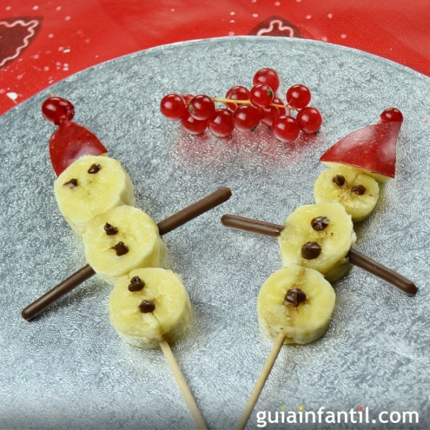

By Deva and Noa