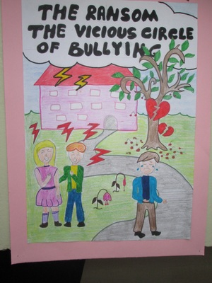

Some students are at Radice-Alighieri school in Catona,Italy.
It's 3.00 p.m. and Marco, Luca, Maria are at the music classroom for the music rehearsal. They are ready to start playing when a boy comes in and says : Good afternoon teacher. I'm Giuseppe Longo and I'm here to replace Luigi.
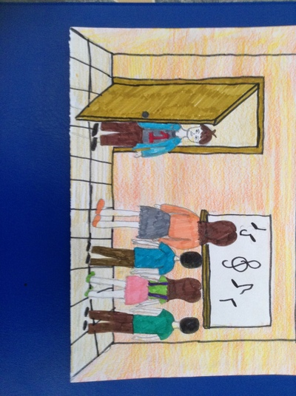

Mrs Rossi: Okay, hello Giuseppe. So you play the guitar,do you?
Giuseppe: Yes ,that's right and he starts playing.
Mrs Rossi: Okay, you know the songs we're rehearsing?
Giuseppe: yes I've got the list
Mrs Rossi: Ready? a one-two-three-four...
All the students are playing their instruments and Giuseppe too,but ...he is out of tune ; the teacher goes on making them to play twice,then she says: Stop! Are you sure you can play the guitar ,Giuseppe?
Giuseppe:Well you know! Mrs Rossi : I'm sorry ,you can't do it. You can go home and practise a lot!!
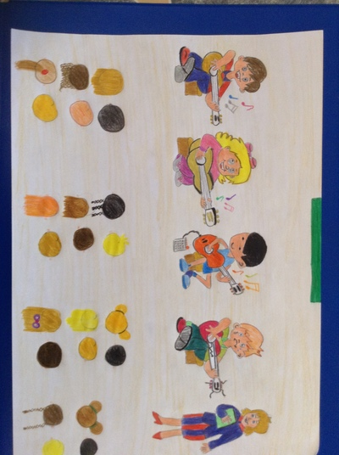

He goes out getting nervous and angry for having made a bad impression !
The next afternoon Marco and Luca are practising music, Luca tells Marco that his guitar is beautiful and Marco tells it is a Gibson SG ,worth a lot of money. Luca asks if he can try it and Marco gives it saying:
- Sure, but be careful!
While Luca is placing the guitar, Giuseppe arrives and taking it,starts to play. Marco, amazed, says: - Hey! What are you doing? Stop it !
Giuseppe says: - Why? Don't you like it?
-No, you can't play . Marco answers and Giuseppe smiling: Is it your guitar? Well, it's out of tune. I'll tune it.
So he tightens a guitar string until he breaks it and , tauntingly , he gives Marco his guitar saying : - Now it's tuned. You can play it and goes out.
Marco is dumbstruck ! Luca is speechless !
- What a bully !! says Marco
Luca, shyly says: Have you got a spare string?
Marco : Yes , I 've got one. I won't tell anything to my parents! I'll tell that I broke it accidentally. I hate that boy, I want only forget him!!
The following day Marco sees Giuseppe in the corridor who pretending to be distracted, thrusts Marco and goes on his way.
Two days after Marco,Luca and Maria go to the music classroom , Marco takes his guitar case ,opens it but it's empty, the guitar is missing! He turns pale. Maria looks at him and asks: Marco what's the matter?
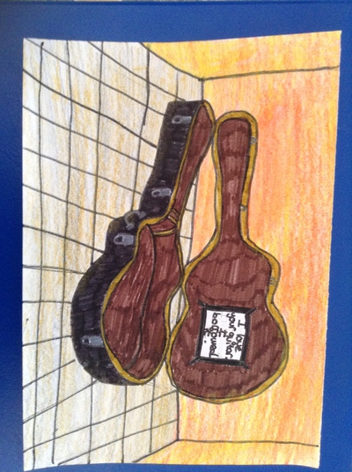

Marco: Someone took my guitar ! Look !
Maria has a look into the case and sees a paper note ; -What is this?
Marco opens it and reads: - "I love your guitar. I borrowed it. If you want it back leave 20 euros in your locker and put the key under the mat. Don't tell anyone or else...."
Maria: -Oh dear! Who wrote the message?
Luca: Who knows!
Marco: - But what can I do now? My beautiful guitar! My parents bought me to make me feel happy. Oh,no!!
Luca:- Let me think. Have you got the money,the 20 euros ?
Marco: - No, I only have 5 euro.I had my pocket money last day.
Luca: - I 've got 10 euro. My dad gave me to buy a phone charge .
Maria:- Don't worry, I've 5 euro ,my pocket money , Here take it Marco.
Marco : -Thanks a lot . If my parents knew.....But what's your plan ,Luca?
Luca:- Listen! And he starts telling what he has hatched out.....
When the school bell rings, all the students leave the school, but Luca,Marco and Maria don't. They go to the locker room and hide behind a row of chairs .They are waiting for the person to come and get the money . A boy comes in taking a guitar covered under a blanket .
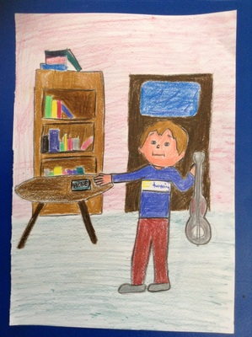

It’s Giuseppe! He puts the guitar down into the guitar case, gets Vic’s locker key under the rug, opens it and takes the money out, then he closes and locks the locker, replaces the key under the rug and goes out.
Luca and the other kids are amazed, Marco is embittered, they were suspicious of Giuseppe.... Marco picks up his guitar, they decide do not tell anything to the headmaster nor to the music teacher Mrs Rossi and go out of the room sadly and angrily.
In the afternoon they meet at Luca's and decide to play a trick on Giuseppe. That bully deserves a lesson !!!
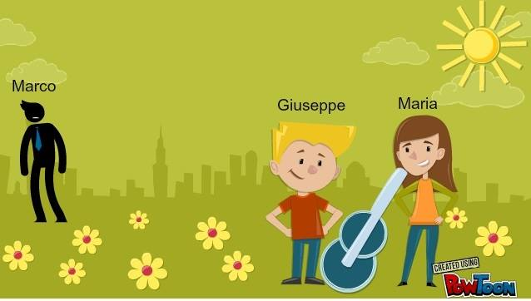
Two afternoons later....
Luca, Marco and Maria go to the school library because they know that Giuseppe must consult some books for a Science project .
Maria has finished to study and stands up, says goodbye to her mates,when she arrives near to Giuseppe she makes a note slide on his desk.
Giuseppe, a bit surprised, opens the note and reads: You're cute. I like you. Meet me tomorrow in the park, near the ice-cream kiosk at 5,30 p. m. Don't be late !
Maria and Giuseppe meet at the park and sit down on a bench.
Maria: You know Giuseppe, I have something to tell you.
Giuseppe: What is it? Is it about Marco?
Maria: No, it’s about you. I think you are very handsome.
Maria: The things you do to Marco are so cool! I love it!
Giuseppe: Oh, thank you, I think the same about you.
They started meeting and Maria said things to Giuseppe about Marco so Giuseppe could know the things Marco didn’t like.
Marco finally found out about the relationship between Giuseppe and Maria, and he was sad because he lost one of the only friends he had. Maria forgot about Marco and he was left alone and sad.
Eventually Maria started bullying Marco because Giuseppe told her to do so, and Marco could never get any friends at school. Marco got depressed and had to move to another town.

