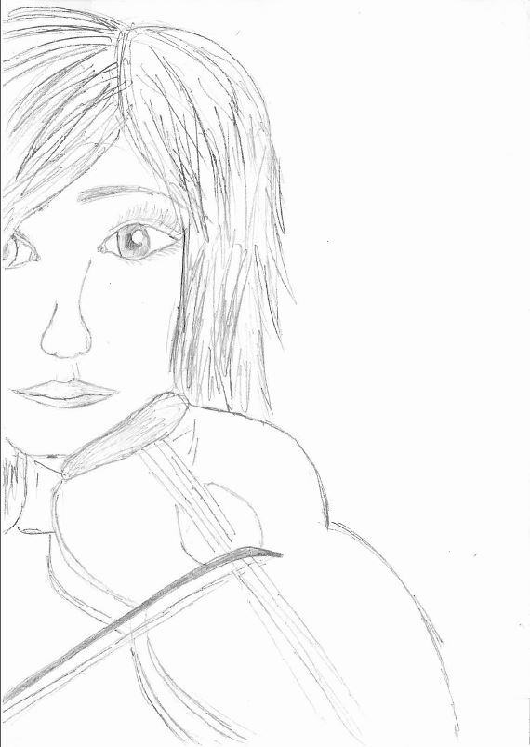

Grace Kind is a high school student and she studies music at conservatory. She is good at all her subjects . She is quite successful and very polite. She is 16 years old and she is tall,but feeble with hazel eyes and short fair hair.
It is 9 o’clock in the morning and she comes to the bus stop with some books and a violin case in her hands so as to go to school. The bus stop is too small and crowded.She starts waiting for the bus like the other people at the bus stop. She has got a very important practical exam and she wants to go to school as soon as possible on that day. The bus arrives at the bus stop after twenty minutes. When the bus arrives at the bus stop,people try to get on the bus by pushing each other. Grace waits patiently for her turn to come.Just as she tries to get on the bus,a rude man with a huge body pushes Grace,says “sorry I’m in a hurry”,jumps the queue and gets on the bus.
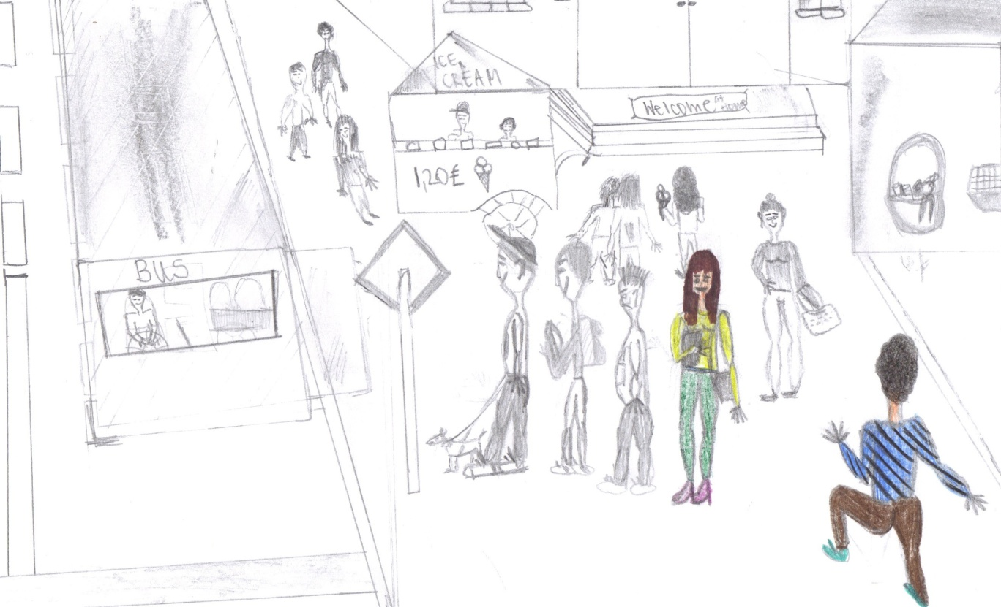

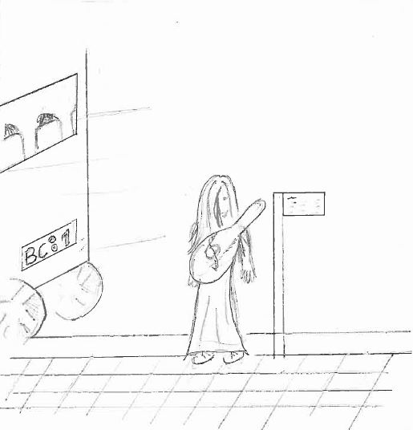
When the man pushes Grace ,she backs a few steps and falls down.Nobody helps her stand up. In the mean time the bus leaves the bus stop.
Grace is shocked and furious and she says nothing,but represses her anger.She thinks she hates men. She checks her watch .It is 8.20 a.m. She knows that the next bus will be at the bus stop in half an hour . She starts waiting impatiently,but she cannot help thinking her exam starting at 9 o’clock.She hasn’t got enough money to take a taxi either.
The second bus comes at 8.50 and she gets on it. She sees all the seats in the bus are full and most of the passengers are students. She stands near a seat and holds it. A septuagenary man gets on the bus at the next bus stop. He is too old to wait standing ,but no one gives him a seat. She can’t stand and she says ;
--why don’t you give your seat to that uncle ?
--What’s that to you? One of the students replies and adds
--- This old boy does not need to sit anywhere as he will die in a few years.We are more weary than him.If you like,you can get him to sit on your lap.
The other boys nod him and look at Grace angrily. Grace is speechless , says nothing and looks at the old man desperately.
---“Do not worry,dear and I will tell you a short Indian story.When you listen to it,you will understand what I have felt” says the old man and begins to tell the story.
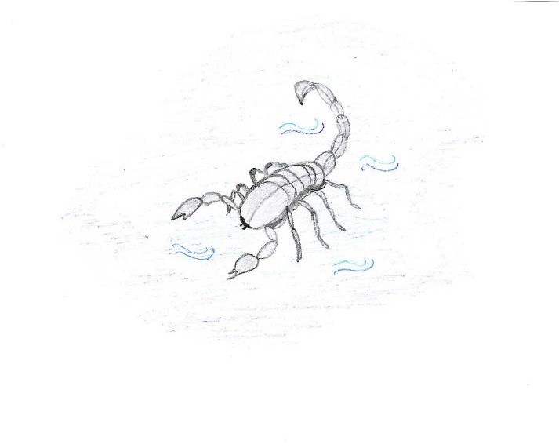

One day a sadhu goes to the river and there he notices a scorpion struggling in the water.The scorpion cannot swim and if the sadhu does not save it,it will drown.The monk rescues it,but the scorpion stings him.The sadhu flings his hand in pain and the scorpion goes flying back to the river.This drama goes on for several times….
Then a hunter watches the sadhu and the scorpion.He comes closer and says
---Forgive me for my frankness,but Why don’t you give up and let the scorpion drown as it is going to sting you again ?

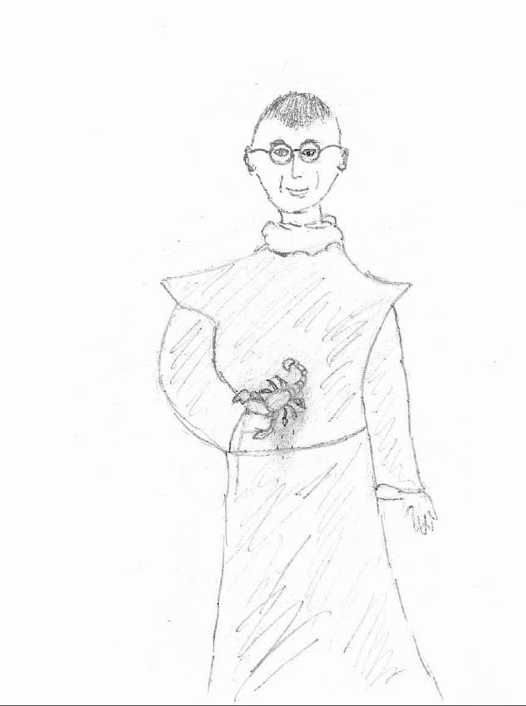
The sadhu replies ;
-----My dear child,it is the scorpion’s nature to sting.My dharma is to help any creature of any kind-human or animal. Just as he is not leaving his nature ,why should I leave my nature?????
That is the story,my dear.I love today’s youth.I am sure they will learn through experience one day.Why should I hate him? I feel I am young at heart.
While the old man is telling the story,the young boy and his friends eavesdrop on the story too.After a while……………..

After a while one boy ,smiling,says:
--- Ehi girl, have you listened? The old man agrees with us,it's not our duty to let him sit down!! Ah,Ah, know-all girl!!
Another boy says;
--- The old man is ....young at heart !! and they start laughing. --Very young! Younger than us ,do you see?
The old man pretends not to hear them,but Grace is getting furious.

At the next stop, a seat is freed up and Grace runs to take it to the old man but one boy
,discovering what she is going to do,trips her and Gace falls down.

She hurts her right knee and her right hand which is bleeding !
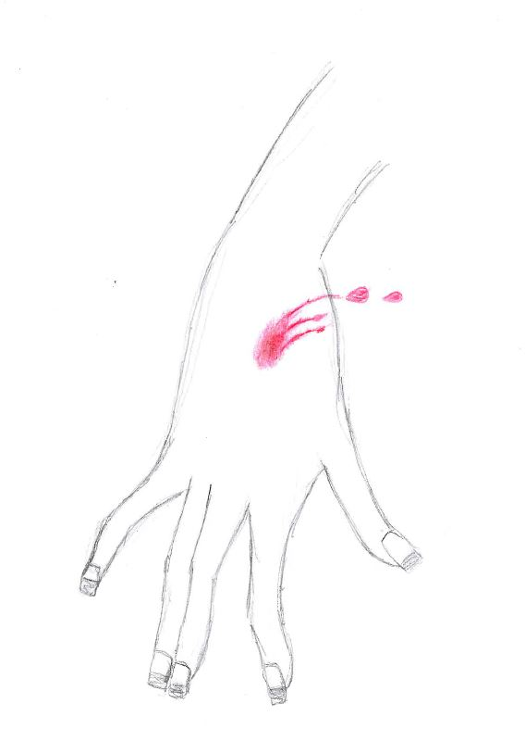

She cries for pain while the boys get off the bus acting as if nothing has happened.
The old man is very sorry about her .She is very sad and angry: she can't play the violin
because her hand hurts!
Those bullies have ruined her day and her exam.

