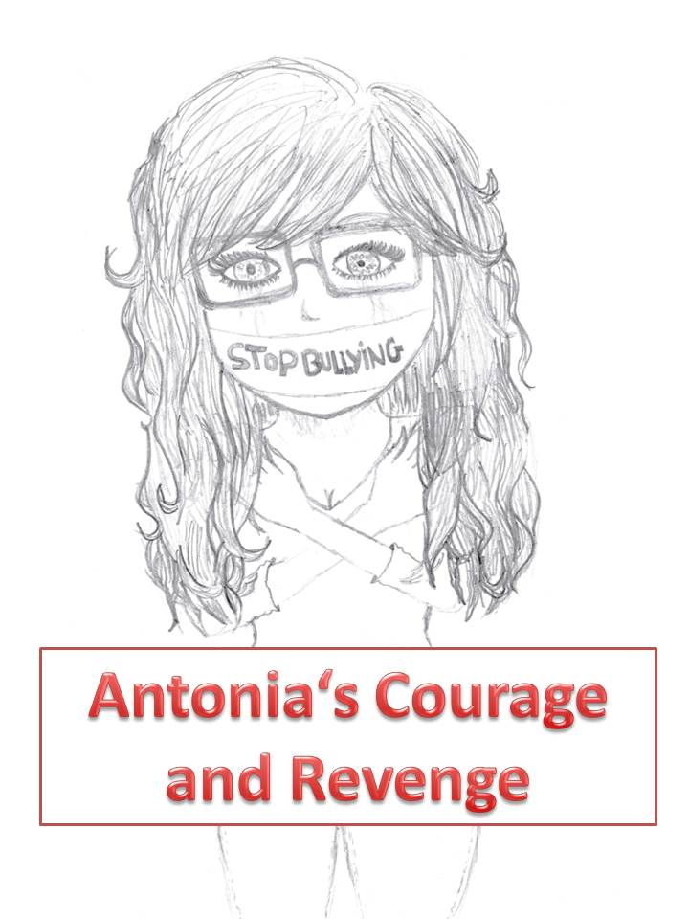
So, I’m going to tell you the story of Antonia, the girl who was bullied by a group of three boys.
Just to make some sense, the names of the boys were Yannick, Richard and Tristan.

It all started, Antonia was new at the school. She wasn’t skinny, like “normal” size. She was a bit bigger and wearing glasses. As the boys saw her, they immediately started to call her names. “God, why are there such fat pigs in this world?” said Yannick. “That’s a big glassed whale right there!” shouted Richard. Everybody else was laughing or just pretending not to see or hear anything. At this point Antonia already knew something: “This is already like all of the other schools. Bullying starts all over again. Hopefully I can handle it this time. I don’t want to change school again!”
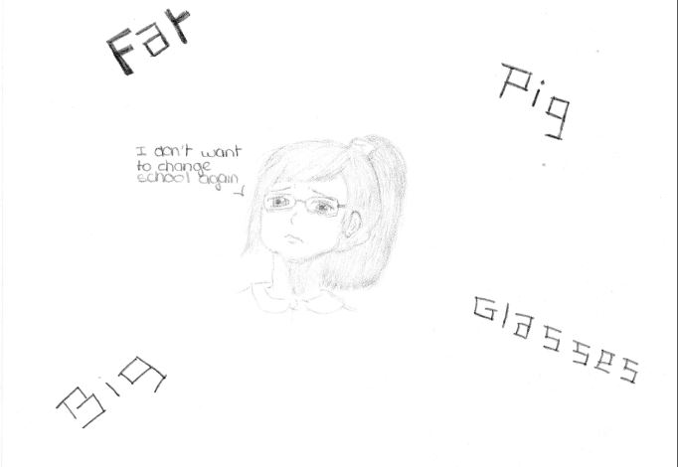

In her first lesson they threw paper at her with little insults on it. In the breaks between the lessons they pulled her hair and screamed, “Look! I caught a big glassed whale!” Every time she came home, with tears on her face, she immediately ran into her room threw herself on her bed and just cried. And every day at school it started all over again.
One evening she chatted online with one of her friends, Florentine, who she had met in a summer camp for talented musicians during the summer holidays. “They throw paper at me with insults on it. They call me names. They pull my hair. They draw ugly pictures of me on the board. And they gossip about me.

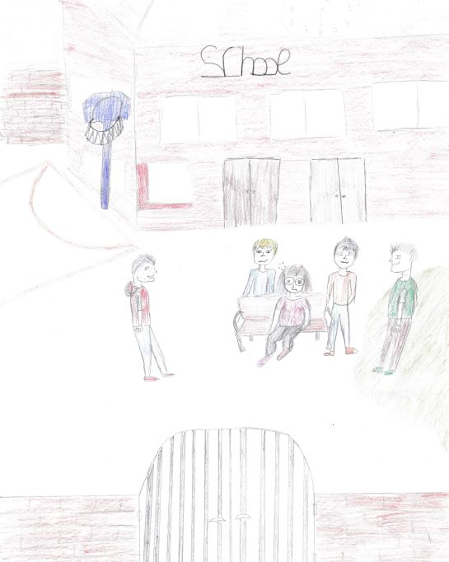
It’s not really nice, I can tell you.” Antonia was silently crying while telling her friend about her hard days at school.
Why didn’t anybody stop the bullies? Why didn’t anybody seem to notice anything? Why did the teachers seem to be blind?

Florentine tried to cheer up Antonia. She said, “Come on. You are such a nice and talented girl. You are a great guitar player. I am your friend and will always be there for you. Just ignore those bullies; they don’t know anything about you. They are so superficial.” “If I looked like you, they wouldn’t call me names,” Antonia replied with an upset voice, but somehow her friend had encouraged her. That night she didn’t sleep well – like all the other nights – but something was different. She did no longer want to be a victim: tomorrow she would stand up against those mean boys.

On her way to school the next morning the three boys were bullying Antonia again, so she tried to commit suicide, because she could not stand it any longer. But she could not kill herself because her mother was supporting her.

The following day she realized that the three boys were going away from school because their parents did not have money to pay for school. Antonia was going to live calmly because the boys were going to go away and might not bother her.

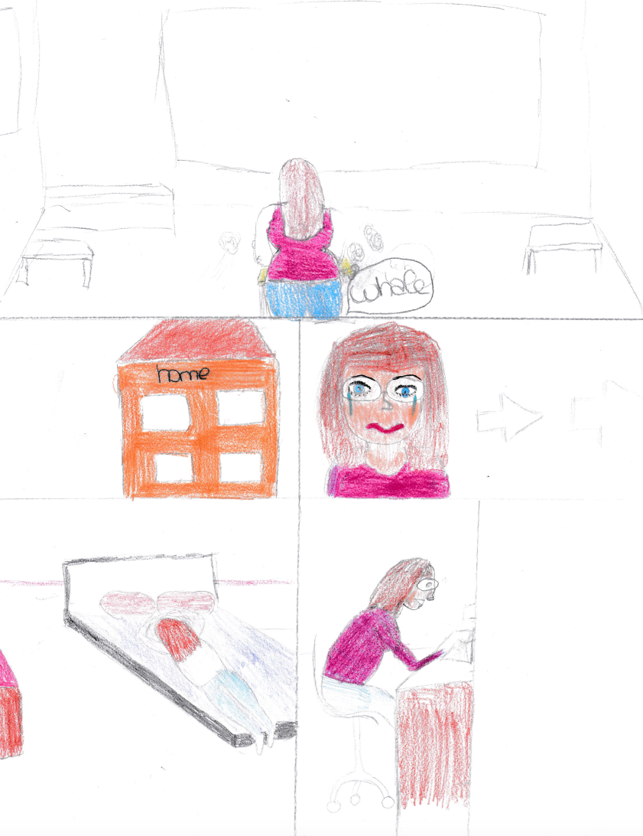

But eventually the guys didn’t go, so Antonia had a plan. The next morning when Antonia got to class she decided to do what she had thought about for so long to do to get rid of those jokes and people who only tried to damage her.
She sat at her desk, left her backpack and hoped to start the routine day: insults, after five minutes they were attacking her and laughed at her. Then she closed her fists, clenched her teeth strong and started saying, ”See I know you cannot please everyone, we are all different, but for that reason you cannot treat me like you do. Why do you like doing this?” Then she thought: I'm tired already of each of you because I have shown that there are good people for your actions and if you think I will go into your game, you’re mad. I would never do anything I do not like to be done.
