Vladimir Putin rides sharks for Fun

Everyone knows who Putin is, but few people have knowledge about this hobby he has.
Being one of the most feared men in the world, Putin said to the paparazzi who took pictures of him in the beach riding his pet shark that:
“For me, being myself is easy. About this hobby I started when I was younger and my father said that in order for me to become a full grown man I’d have to kill a Rhino with my anda and ride a shark as a cowboy. Killing the rhino was hard but I did it. When the time to ride my first shark came I fell in love with it because it made me feel like aquaman”
So even though this was supposed to be a secret Putin has a private beach and around 10 personal sharks.
More information will appear soon due the fact that Putin agreed to give an interview to the National Geographic Channel.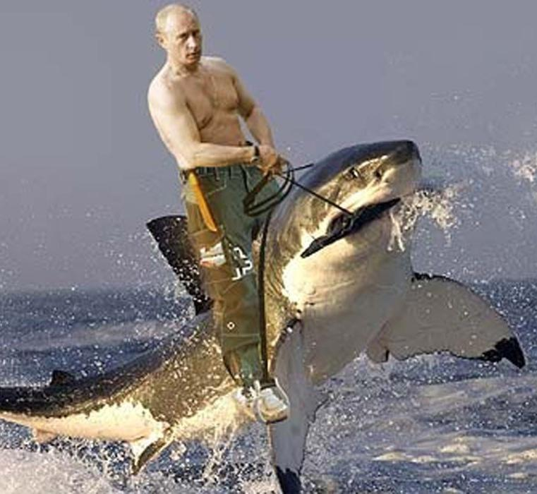
Murilo Nascimento 12J

