Racism present in Florida middle school

Last month, on the sixth day of December, Terrace Community Middle School, in Florida, was accused of separating classes according to the skin color of the students. Kelvin Jones, an 11-year-old student told his mother, Isabella Jones, what happened. She immediatly informed the school´s management of human rights violation, claiming it to be na act of racism.

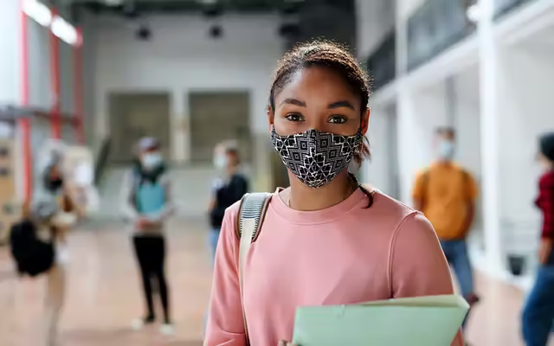
«Everyone is entitled to all the rights and freedoms set forth in this Declaration, without distinction of any kind, such as race, colour, sex, language, religion, political or other opinion, national or social origin, property, birth or other status. Furthermore, no distinction shall be made on the basis of the political, jurisdictional or international status of the country or territory to which a person belongs, whether it be independent, trust, non-self-governing or under any other limitation of sovereignty.» is the second article of Human Rights.
Henry Williams, the ex principal of Terrace Community Middle School, was fired after the mother's complaint. According to the students, Henry Williams would have already demonstrated some acts of racism towards students and teachers of color. «It is unacceptable for such a situation to happen in the 21st century.», said Isabella Jones. The students said that the teachers told them to separate according to their skin color and even asked to not talk about the new rule imposed by the principal or they would be expelled. Kelvin Jones rushed to tell his mother what had happened,not caring about the possible consequences.« Even though we didn't agre, we were forced to make this decision or our job would be at risk», said Sophia Davis, a geography teacher who works at the school. A week after the event, all the students at the school attended a conference and discussed various current issues, including racism, organized by the new school principal, John Brown.

