0 Test **PROCHÁZKA TÁBOREM S QR KÓDY**

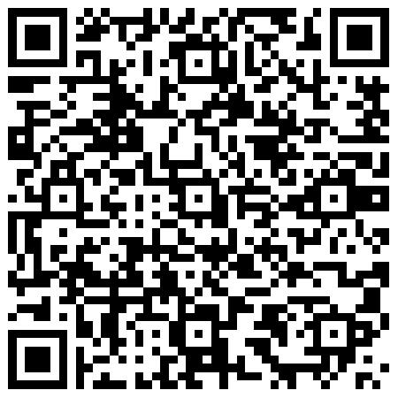

1

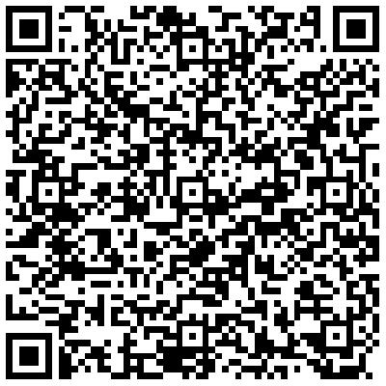

|  |  |
| --- | --- |
| Odpověď |  |

2

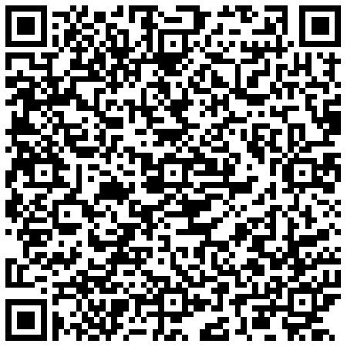

|  |  |
| --- | --- |
| 1 |  |
| 2 |  |
| 3 |  |

3

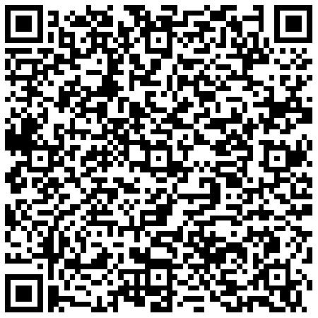

|  |  |
| --- | --- |
| 1 |  |
| 2 |  |
| 3 |  |

4

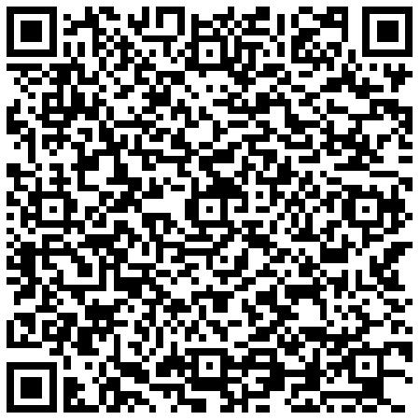

|  |  |
| --- | --- |
| 1 |  |
| 2 |  |
| 3 |  |
| 4 |  |

5

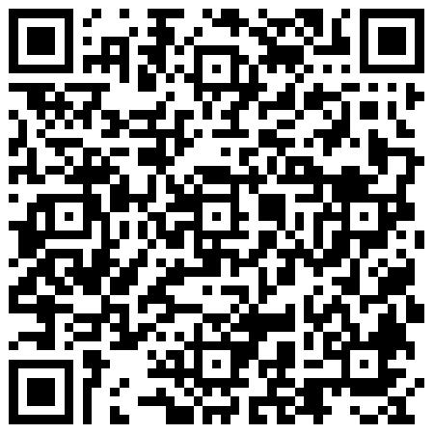

|  |  |
| --- | --- |
| Odpověď |  |

6

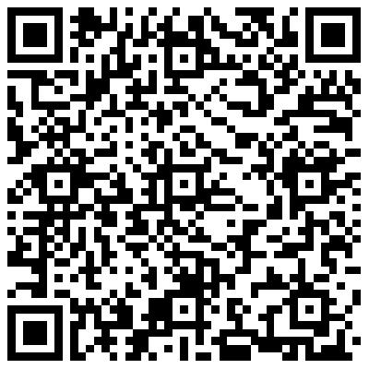

|  |  |
| --- | --- |
| 1 |  |

7

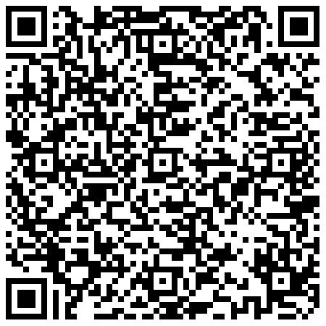

|  |  |
| --- | --- |
| 1 |  |
| 2 |  |
| 3 |  |
| 4 |  |

8

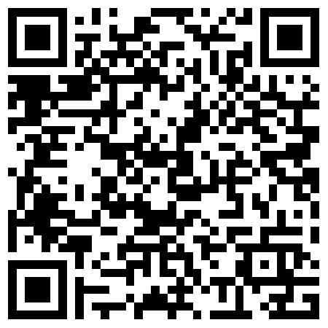

9

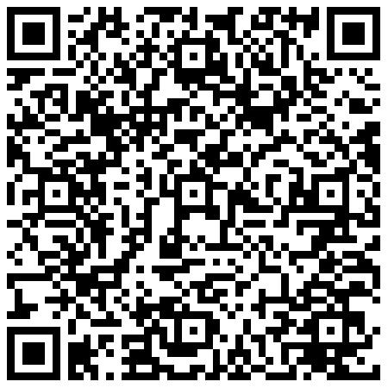

10

