NEW GYM CONSTRUCTION PROJECT BEGINS AT „ĐURO ESTER“ PRIMARY SCHOOL

After 60 years of waiting the school finally gets a gym

„Đuro Ester“ Primary School, also known as the „school without a gym“, becomes the school with the most modern gym in the Town of Koprivnica

On 12 October 2020 the construction of the new gym began on the outdoor playground behind "Đuro Ester" Primary School in Koprivnica. The project of the new gym is financed by the Town of Koprivnica and the construction is managed by Radnik d.d., a company from Križevci.

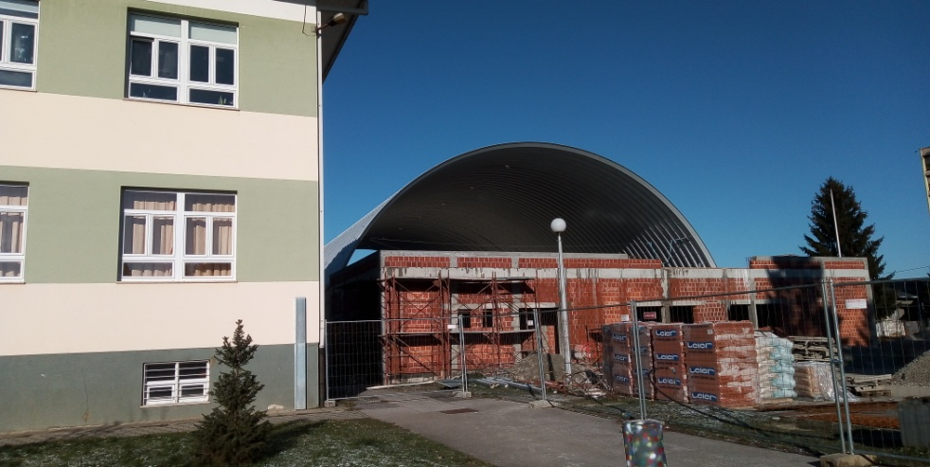

We asked the school headteacher Mrs Sanja Prelogović what the future gym will look like and whether it will be possible to use a part of the existing playground for outdoor activities after the construction. The gym will take up 1420 square meters. Next to the gym there will be an outdoor basketball court. The gym will have a modern arched shape and it will be among the first gyms in Croatia constructed of aluzinc. Traditional masonry construction will be used for locker rooms and ancillary area. Inside there will be a basketball and handball court as well as a movable grandstand with 168 seats. –Mrs Prelogović said.
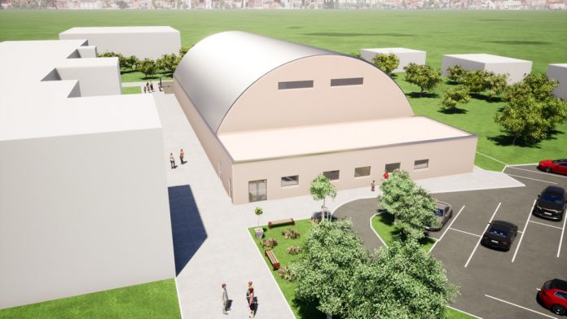
Since 1959, a year when „Đuro Ester“ Primary school was founded, until today the school has been operating without a gym. Physical education classes, school plays, concerts and similar activities have been taking place in a bigger classroom that is 10 x 10 m in size. Despite lack of space, we have been achieving outstanding results in sports competitions such as table tennis, handball and badminton. For several consecutive years the students of our school won the second and the third places in the state badminton competition. Most of the PE classes take place on the outdoor playground behind the school – Mrs Vesna Hižman-Perošić, a PE teacher, pointed out.
Since there are 740 students who attend our school in two shifts, cold and rainy days are a big problem as the students can't exercise outside and the organisation of classes, workshops, lectures and cultural events becomes quite complicated. Students often exercise in their classrooms or in the hallway then. COVID-19 epidemic further complicates the organisation of classes and limits us in providing enough space for students to exercise and move as they are not allowed to spend time in the hallway or exercise in the classrooms while the existing „gym“ is too small to maintain the prescribed distance between the students.
Mrs Prelogović says that the construction of the new gym should be completed by June 2021 and she is very happy that, with this investment, the Town of Koprivnica has made it possible to improve working conditions and the quality of education in „Đuro Ester“ primary school. It took 60 years to make it possible for our students to have proper PE classes, more space for exercise, especially in winter, as well as space for matches and sports competitions – the headteacher pointed out.
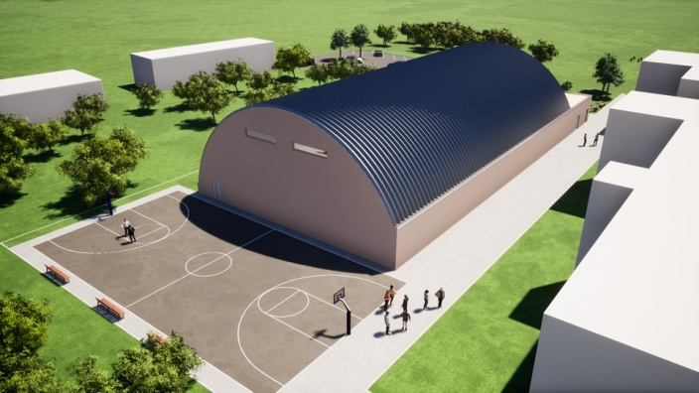

„Đuro Ester“ primary school will no longer be the only school in the Town of Koprivnica without a gym. With the new gym the town will get another space for the organisation of sports events. The gym will also be used by associations and sports clubs that promote healthy lifestyle and spread the name of Koprivnica in various regional and state meetings.

Gala Knežević, 5.a
School Newspaper Group
Primary school „Đuro Ester“ Koprivnica

