AROUND US - INTANGIBLE CULTURAL HERITAGE FROM KOPRIVNIČKI IVANEC

Why is Ivanec embroidery on the list of intangible cultural goods?

In 2011 'The Ministry of Culture and Media' inscribed the art of making Ivanec embroidery into the national 'Registry of Intangible Cultural Goods'. Mrs Nedeljka Vrhoci from Koprivnički Ivanec, who is very skillful at making Ivanec embroidery, reveals what makes it unique and whether it will be preserved in the future. As the head of the embroidery section of 'The Society of Authentic Folklore of Koprivnički Ivanec’ she is engaged in preserving this intangible cultural heritage as well as transfering the skill and love of making the embroidery onto younger generations.
What makes Ivanec embroidery unique and original?
Ivanec embroidery is unique because it is made without any patterns or designs. This makes each embroidery distinctive and special.
What are the characteristics of Ivanec embroidery?
Ivanec embroidery requires great skill, practice, patience, devotion and imagination of the embroiderer. Its unique beauty is defined by destinctive motifs inspired by nature and countryside, the way they are combined, arranged and complemented by different colours. Red is a predominant colour in making Ivanec embroidery but vivid orange, green, purple, blue, black and white are also used.
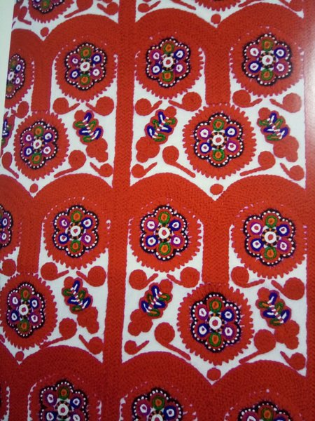

How is Ivanec embroidery made and what skills are required to make it?
Ivanec embroidery is characterized by precision and various combinations of colours. At the beginning of sewing, no knot is made at the end of the thread, but the thread is simply passed through the fabric all the way to its end to strengthen the starting point of the stitch. After that, the chosen motif is sewn without any patterns. While sewing, the embroiderer must make sure that everything is neat and that the motif is of acceptable size. Ivanec embroidery requires a lot of patience and it must be done calmly, slowly and precisely so the time devoted to making it adds to its value. An experienced embroiderer who sews for about three to four hours a day, takes up to two months to make ‘poculica’ (a woman's embroidered cap) or a year for embroidered sleeves on a female blouse 'plečak'. Therefore, to make Ivanec embroidery it takes a lot of patience and love.

What was decorated with Ivanec embroidery?
First of all, Ivanec embroidery was used as a decoration on various parts of traditional costumes of Koprivnički Ivanec, recognizable throughout the region of Podravina and beyond. Recently, thanks to the imagination of embroiderers, it is used as a decoration on tablecloths, handbags, canvas bags, jewelry, paintings, ties, dolls as well as pens, pagers, and a stamp, which we are especially proud of.
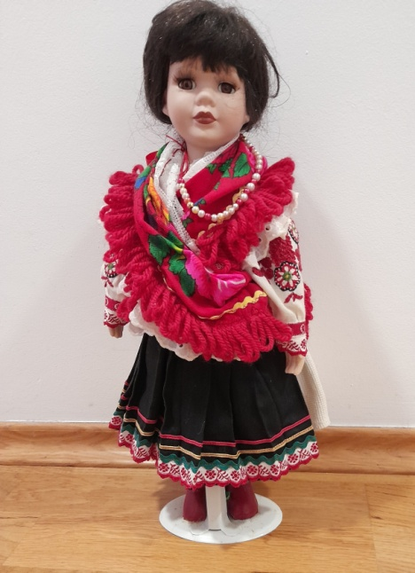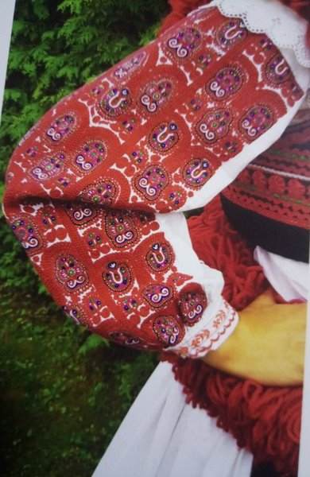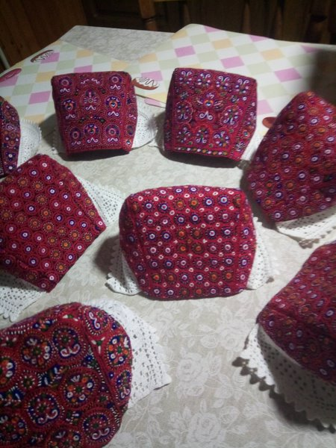
Who made Ivanec embroidery in the past?
In the past, Ivanec embroidery was sewn by women, most often during the winter days when they did not have work around the house or in the field.
Where can Ivanec embroidery be seen today?
Ivanec embroidery can be seen on festive traditional costumes of Koprivnički Ivanec worn by the dancers of 'Lado', the National Folk Dance Ensemble of Croatia, ‘The Society of Authentic Folklore of Koprivnički Ivanec’ (DIF) and 'Folk Dance Ensemble Koprivnica' (FAK).
Who taught you to make Ivanec embroidery?
Doroteja Jakupić and Željkica Marčec taught me to make the embroidery while my grandma gave me the first sewing lessons and she inspired my love for handicrafts. In my free time I do handicrafts and embroidery. I particularly enjoy making unique jewelry, paintings, ties and other artwork with the motifs of Ivanec embroidery.
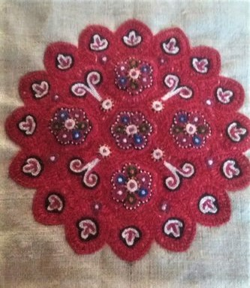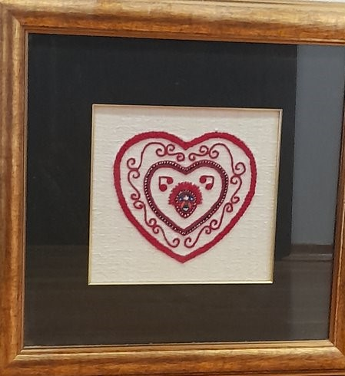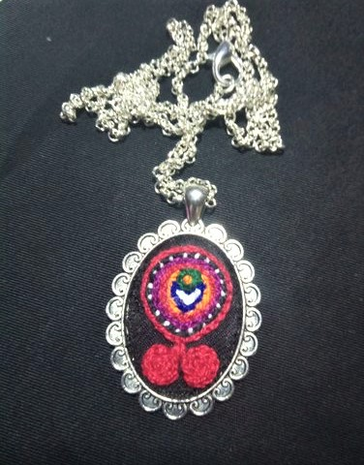

What do you do to preserve this intangible cultural heritage?
In cooperation with kindergarten teachers I have been able to work with preschool children and pass on my love for the cultural heritage of our village and Ivanec embroidery to them. I enjoy seeing that I have interested them in our heritage and my greatest pleasure is when those children later join my embroidery section at ‘The Society of Authentic Folklore of Koprivnički Ivanec’and improve their skills of making Ivanec embroidery.
Who can still make Ivanec embroidery today? Will this art dispappear in the future?
Thanks to the engagement of all the members of 'The Society of Authentic Folklore of Koprivnički Ivanec’, the art of making Ivanec embroidery has been passed on to younger generations. A few hard-working women do their best to keep it alive and preserve it. Their enthusiasm and love for it make me think that it will not be forgotten and I sincerely hope that younger generations will succeed the hard-working embroiderers who are active today.
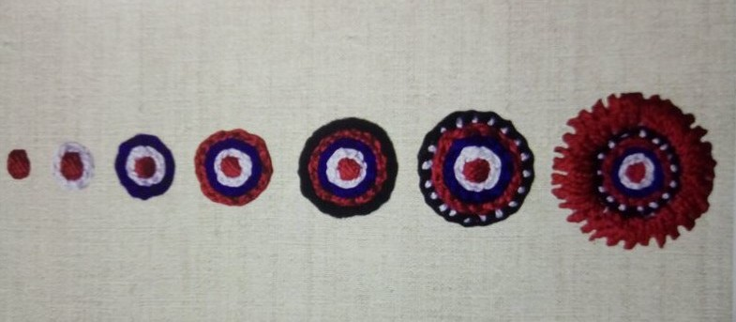
How could Ivanec embroidery as intangible cultural heritage be better promoted in our region and throughout Croatia?
Today, Ivanec embroidery as protected intangible cultural heritage is well accepted in our village and beyond. However, there is always room for improvement. It is necessary to educate younger generations, make them aware of its value and encourage them to be creative in applying the embroidery on unique souvenirs that would be recognizable around the world. Young people should be motivated to love and respect the tradition of the region they come from, participate in local folk ensembles, embroidery section, events and exhibitions. I hope that this treasure of our region will not be forgotten and that we will preserve it through various events, education activities and good will.

Marija Petrović, 5.a
School newspaper group
Primary School „Đuro Ester“ Koprivnica

