The modern factory of water on the mountainsides of Maljen

Radojko Milinković from the place Bogdanica at the bottom of Maljen ,while digging a well,found that his property is located on the real natural resource.
He found on his property the healing water and all the necessary examinations were done at the University of Medicine in Belgrade, and they confirmed the amazing quality of this water.
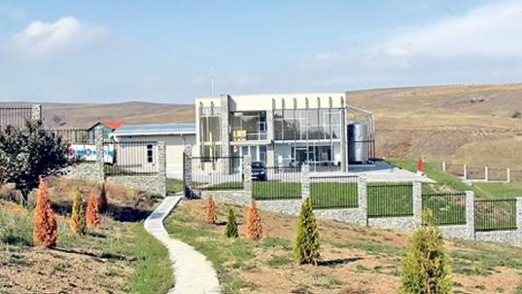
This man from Serbia, who acquired his capital by working abroad, decided to invest the money in Serbia and help in that way his birthplace and that deserted villages come to life again and the people get a job.
The factory of water was built on the sea level of 800 metres on the area of 43 hectares and is called Crystal Field . It was opened in 2014,and the workers from China were engaged in the material for its construction.
There are nine workers in the factory at the moment , and the plan is that about 30 local people get the job.
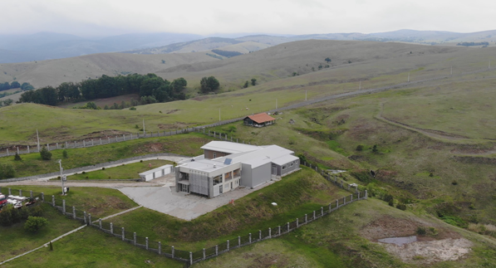

The people who report: Ognjen, Ivana, Milena, Milan and
Dragoslav

