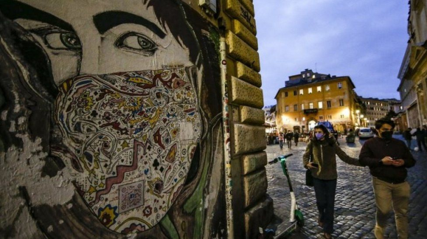

Covid-19 pandemic: Italy to shut shops and schools amid infection spike
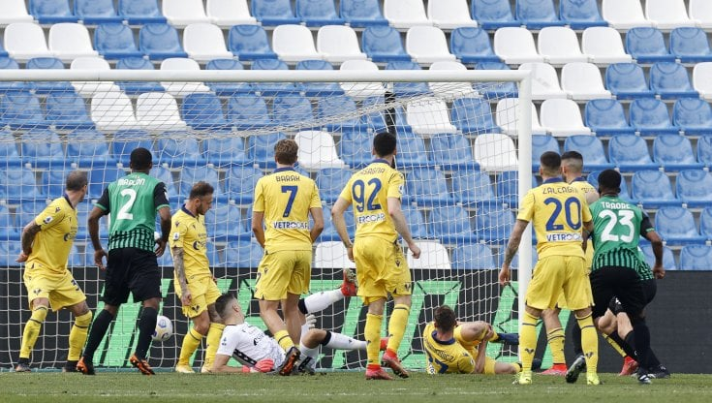Sassuolo 3 - 2 Verona
Result of the championship football match
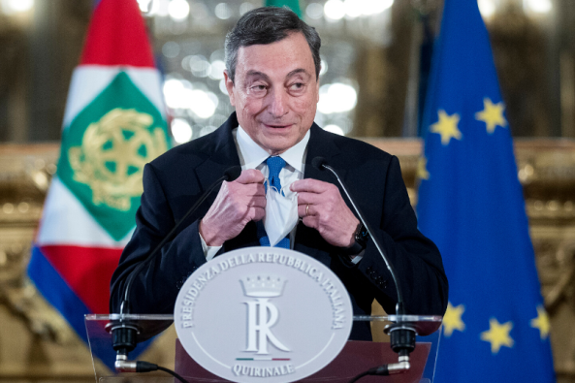
Italian minister,Draghi, triple the vaccines and 20 millions of new helpers
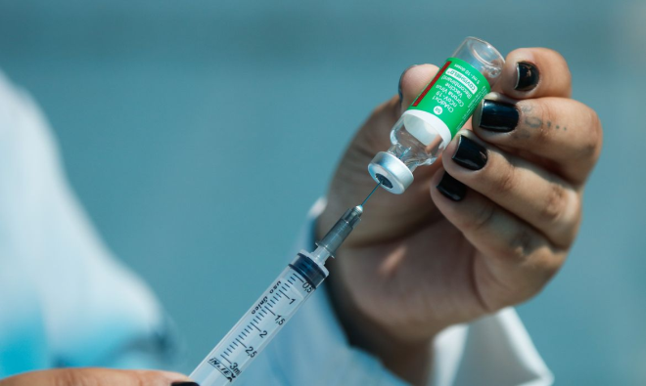 Vaccine mass campaign in Italy

superbonus, extension until 2023

