NEWS
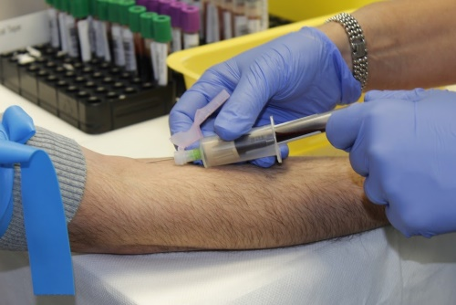
The COVID-19 vaccine is ready to be used for those over 70 in Italy.

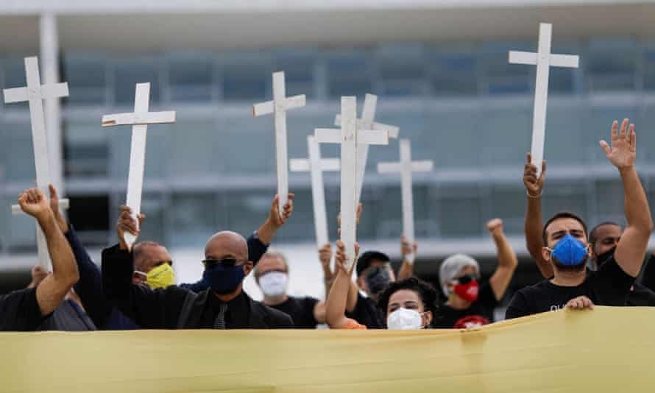

Bolsonaro uses Brazil's dictatorship-era law as protesters depict him as a Nazi.

UK vs EU - Grants for activities dealing
Import and export for the first time
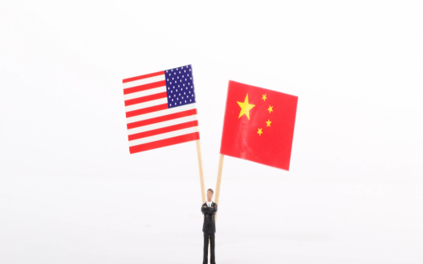
Biden and the dilemmas of interdependence
between China and the USA
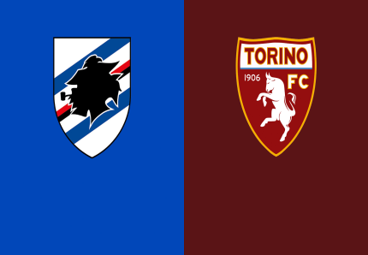Italian football Championship: Turin FC lost the match against Sampdoria
Guernsey, one of the Channel island, confirmed its exit from lockdown.

